



**DOCS DRAW SOP**

**POLICIES & PROCEDURE**

**Version-1**

Abstract This document will explain in details about the process flow/steps of drawing final docs package.

All Western Mortgage| Branch NMLS # 14210 | 8345 W. Sunset Road #380 | Las Vegas, NV 89113

**Revision History**

|  |  |  |  |  |  |
| --- | --- | --- | --- | --- | --- |
| Sr# | Version**#** | Change Summary | Section# | Approved By & Date | Released By & Date |
| 1 | 1.0 | Affixation of affidavit for Manufacturing home | Page #44-45 | Lisa Smith 05/08/2019 | Raj Sumani 05/08/2019 |
| 2 | 2.0 | Update on Florida HHF DPA Program loans | Page #103 | Lisa Smith 05/08/2019 | Raj Sumani 05/08/2019 |
| 3 | 3.0 | Update on NBS Requirement on Refinance Primary | Page #103 | James Medina 06/19/2019 | Raj Sumani06/19/2019 |
| 4 | 4.0 | Update on Payoff(s) creditor name & account numbers | Page #88 | Lisa Smith 06/05/2019 | Raj Sumani 06/05/2019 |
| 5 | 5.0 | Update on Pricing adjustment not needed except Overage on VA loans. | Page #18 | Tory Teunis 06/11/2019 | Raj Sumani 06/11/2019 |
| 6 | 6.0 | Update on checkpoints to review on Docs redrawn Request | Page #103 | Tory Teunis 07/03/2019 | Raj Sumani 07/03/2019 |
| 7 | 7.0 | Update on US MRBP – NV HIP / HAL Products | Page #104 | Raj Sumani 06/25/2019 | Raj Sumani 06/25/2019 |
| 8 | 8.0 | Update on VA IRRRL loan | Page #105 | Susan 06/28/2019 | Raj Sumani 06/28/2019 |
| 9 | 9.0 | Update on Early Release DOCS (Without CTC) | Page #105 | Tory Teunis 07/16/2019 | Raj Sumani 07/16/2019 |
| 10 | 10.0 | Update on Closing Conditions | Page #29 | Lisa Smith 07/19/2019 | Raj Sumani 07/19/2019 |
| 11 | 11.0 | Update on Loan discount Points | Page #65 | Susan 07/19/2019 | Raj Sumani 07/19/2019 |
| 12 | 12.0 | Update on VA Cash Out Refinance | Page #105 | Naresh Kumaran 8/1/2019 | Raj Sumani 8/1/2019 |
| 13 | 13.0 | Update on FHA MIP Refund | Page #105 | Naresh Kumaran 8/20/2019 | Raj Sumani 8/20/2019 |
| 14 | 14.0 | Update on TAX Collection for Non-disclosed taxes | Page #105 | Karl Anderson 8/20/2019 | Raj Sumani 8/26/2019 |
| 15 | 15.0 | Update on MI Cert Process | Page #106 | James Medina 8/28/2019 | Raj Sumani 8/28/2019 |
| 16 | 16.0 | Change in FHA MIP Table & Click on GET MI Button on FHA loans | Page #57 | Karl Anderson 9/11/2019 | Raj Sumani 9/11/2019 |
| 17 | 17.0 | Update on Principal Reduction | Page #106 | James Medina 9/16/2019 | Raj Sumani 9/16/2019 |
| 18 | 18.0 | Seller Credit Update | Page #74 | Tory Teunis 10/29/2019 | Raj Sumani 10/29/2019 |
| 19 | 19.0 | ARM Docs Review Process | Page #106 | Tory Teunis 11/05/2019 | Raj Sumani 11/05/2019 |
| 20 | 20.0 | Vesting Update | Page #106 | Karl Anderson 11/12/2019 | Raj Sumani 11/12/2019 |
| 21 | 21.0 | Verify Impounds | Page #69 | Tory Teunis 11/15/2019 | SubhenduDey 11/15/2019 |
| 22 | 22.0 | Update on HOI Renewal Policy | Page #106 | Karl Anderson 11/18/2019 | Raj Sumani 11/18/2019 |
| 23 | 23.0 | VA IRRRL – Max Cash back limit | Page #107 | Karl Anderson 12/06/2019 | Raj Sumani 12/06/2019 |
| 24 | 24.0 | Revised VA Funding fee on or after 01/01/2020 NOTE Date | Page #47 | Lisa Smith 12/17/2019 | Raj Sumani 12/17/2019 |
| 25 | 25.0 | Hold Harmless disclosure& Closing Letter to attach when DOCS sent without CTC | Page #99 | James Medina 12/17/2019 | Raj Sumani 12/17/2019 |
| 26 | 26.0 | 1-4 Family rider update on FHA with Primary Occupancy | Page #42 | Eric Gut 06/27/2019 | Raj Sumani 12/23/2019 |
| 27 | 27.0 | USDA Technology fee announcement | Page #107 | Raj Sumani 01/08/2020 | Raj Sumani 01/08/2020 |
| 28 | 28.0 | Updated on Vesting verbiage | Page #22 | Karl Anderson 02/07/2020 | Raj Sumani 02/07/2020 |
| 29 | 29.0 | Update on Prosperity Branch | Page #107 | Karl Anderson 02/12/2020 | Raj Sumani 02/12/2020 |
| 30 | 30.0 | Mavent report update | Page #107 | Karl Anderson 02/14/2020 | Raj Sumani 02/14/2020 |
| 31 | 31.0 | Update on SIDS Impounds | Page #107 | Karl Anderson 03/20/2020 | Raj Sumani 03/20/2020 |
| 32 | 32.0 | Update on Metro DPA with Lakeview | Page #107 | Raj Sumani 04/07/2020 | Raj Sumani 04/07/2020 |
| 33 | 33.0 | Update on CHFA & US BANK MRP with Manufacture Home Loans | Page #108 | Raj Sumani 04/13/2020 | Raj Sumani 04/13/2020 |
| 34 | 34.0 | Update on Pre-NOTE VVOE | Page #108 | Tory Teunis 05/21/2020 | Raj Sumani 05/21/2020 |
| 35 | 35.0 | DOCS Redraw Update | Page #108 | Tory Teunis 07/01/2020 | Raj Sumani 07/01/2020 |
| 36 | 36.0 | ARM loan with TIAA Investor Assumptions as Yes | Page #92 | Susan 07/09/2020 | Raj Sumani 07/09/2020 |
| 37 | 37.0 | Update on Escrow Balance | Page #108 | Tory Teunis 08/28/2020 | Raj Sumani 08/28/2020 |
| 38 | 38.0 | Update on HOI for Purchase loans | Page #109 | Tory Teunis 10/15/2020 | Raj Sumani 10/15/2020 |
| 39 | 39.0 | Check Approval Expiration date | Page #109 | Tory Teunis 12/15/2020 | Raj Sumani 12/15/2020 |
| 40 | 40.0 | HOI or Flood Insurance Paid Receipt requirement | Page #109 | Tory Teunis 01/11/2021 | Raj Sumani 01/11/2021 |
| 41 | 41.0 | HOI Renewal PTF on Refi.loans | Page #110 | Tory Teunis 02/16/2021 | Raj Sumani 02/16/2021 |
| 42 | 42.0 | Update on Florida branch loans | Page #110 | Karl Anderson 03/19/2021 | Raj Sumani 03/19/2021 |
| 43 | 43.0 | Update on Trust Checklist | Page #110 | Tory Teunis 03/29/2021 | Raj Sumani 03/29/2021 |
| 44 | 44.0 | Update on 1003-URLA-Lender form | Page #110 | Karl Anderson 04/05/2021 | Raj Sumani 04/05/2021 |
| 45 | 45.0 | Update on Cut off (Cancel at) for Conventional loans > 80% LTV | Page #111 | Karl Anderson 04/07/2021 | Raj Sumani 04/07/2021 |
| 46 | 46.0 | Update on HOI on refinance loans for renewal collection | Page #111 | Tory Teunis 04/27/2021 | Raj Sumani 04/27/2021 |
| 47 | 47.0 | Update on FHA Streamline Refinances | Page #112 | Tory Teunis 04/27/2021 | Raj Sumani 04/27/2021 |
| 48 | 48.0 | Update on Random fee restriction on Sec-A (Lender fees) | Page #112 | Tory Teunis 05/13/2021 | Raj Sumani 05/13/2021 |
| 49 | 49.0 | Do not Allow Successor Trustee on Trust loans | Page #112 | Tory Teunis 05/13/2021 | Raj Sumani 05/13/2021 |
| 50 | 50.0 | Update Purchase Contract Date on FHA Purchase loans | Page #113 | Eric Gut 05/18/2021 | Raj Sumani 05/18/2021 |
| 51 | 51.0 | LO name to remove from Affixation of affidavit for Manufacturing home | Page #45 | Tory Teunis 05/19/2021 | Raj Sumani 05/19/2021 |
| 52 | 52.0 | Remove Unsigned Copy of Initial / COC CD’s | Page #114 | Eric Gut 05/20/2021 | Raj Sumani 05/20/2021 |
| 53 | 53.0 | Update on Tax Proof receipt where county shows due but it is paid per LO | Page #114 | Tory Teunis 06/04/2021 | Raj Sumani 06/04/2021 |
| 54 | 54.0 | Send 4506-C form with Closing package whenever it is needed | Page #114-116 | Eric Gut 06/08/2021 | Raj Sumani 06/08/2021 |
| 55 | 55.0 | Signature pages on Business / Personal Tax returns to extract and send with DOCS | Page #117 | Eric Gut 08/25/2021 | Raj Sumani 08/25/2021 |
| 56 | 56.0 | Update On Refinance loans to validate "Refinance with Original Creditor" | Page #117 | Amit Vij 09/09/2021 | Raj Sumani 09/09/2021 |
| 57 | 57.0 | Verification of accurate Property type for pricing purpose | Page #41 | Eric Gut 09/17/2021 | Raj Sumani 09/17/2021 |
| 58 | 58.0 | Texas Specific update on Attorney package review | Page #118 | Amit Vij 09/20/2021 | Raj Sumani 09/20/2021 |
| 59 | 59.0 | Update on Elective Insurance | Page #118 | Tory Teunis 10/20/2021 | Raj Sumani 10/20/2021 |
| 60 | 60.0 | Final Call for correct Property address validation is with DOCS Team | Page #80 | Tory Teunis 11/05/2021 | Raj Sumani 11/05/2021 |
| 61 | 61.0 | Certify / Ready to Ship to check for Initial and COC CD’s | Page #119 | Md. Basheer 11/09/2021 | Raj Sumani 11/09/2021 |
| 62 | 62.0 | Update on Use Simple Interest Accrual on RegZ – CD | Page #119 | David Moser 1/26/2022 | Raj Sumani 1/26/2022 |
| 63 | 63.0 | Update on Closing Method | Page #121 | Tory Teunis 2/23/2022 | Raj Sumani 2/23/2022 |
| 64 | 64.0 | Revised Update on MI Cert Process | Page #106 | Tory Teunis 3/15/2022 | Raj Sumani 3/15/2022 |
| 65 | 65.0 | Update on Personal 4506-C (1040) | Page #121 | Tory Teunis 4/6/2022 | Raj Sumani 4/6/2022 |
| 66 | 66.0 | Update on Loan Modification Agreement Disclosure on any ARM loan files | Page #121 | Md. Basheer 4/12/2022 | Raj Sumani 4/12/2022 |
| 67 | 67.0 | Update to verify MI Coverage % between MI Cert and UW’s AUS | Page #122 | Tory Teunis 4/25/2022 | Raj Sumani 4/25/2022 |
| 68 | 68.0 | Update on Separate 4506-C form requirement in Package. | Page #121 | Tory Teunis 5/3/2022 | Raj Sumani 5/3/2022 |
| 69 | 69.0 | Two LE’s cannot be issued on same day | Page #123 | David Moser 5/26/2022 | Raj Sumani 5/26/2022 |
| 70 | 70.0 | Update on POA | Page #123 | Lisa Smith 6/9/2022 | Raj Sumani 6/9/2022 |
| 71 | 71.0 | New Update on 4506-C | Page #124 | Tory Teunis 6/10/2022 | Raj Sumani 6/10/2022 |
| 72 | 72.0 | Update on COC Verbiages for 0 & 10% tolerance fees | Page #125 | Raj Sumani 6/21/2022 | Raj Sumani 6/21/2022 |
| 73 | 73.0 | Update on Pre-Funding QC Form | Page #125-126 | Tory Teunis 7/13/2022 | Raj Sumani 7/13/2022 |
| 74 | 74.0 | Update on to review COC form comment for Docs team | Page #126 | Raj Sumani 7/28/2022 | Raj Sumani 7/28/2022 |
| 75 | 75.0 | Update on 0 and 10% tolerance fee verification for DOCS Team | Page #126 | David Moser 7/28/2022 | Raj Sumani 7/28/2022 |
| 76 | 76.0 | Update on Private Money loans | Page #126 | David Moser & Richard Whelan 8/10/2022 | Raj Sumani 8/10/2022 |
| 77 | 77.0 | Update on Cash to Close on CD to match with 2015 itemization for El Paso and Prestige branch | Page #127 | Raj Sumani 8/15/2022 | Raj Sumani 8/15/2022 |
| 78 | 78.0 | NBS / NBP requirement in Texas | Page #127 | Raj Sumani 8/25/2022 | Raj Sumani 8/25/2022 |
| 79 | 79.0 | Update on 4506-C form | Page #127 | Md. Basheer 9/16/2022 | Raj Sumani 9/16/2022 |
| 80 | 80.0 | Update on Buy-down Mortgage | Page #128 | Raj Sumani 9/16/2022 | Raj Sumani 9/16/2022 |
| 81 | 81.0 | Update on Fees | Page #129 | Tory Teunis 10/13/2022 | Raj Sumani 10/13/2022 |
| 82 | 82.0 | Update on CD Acknowledgement | Page #129 | Tory Teunis & David Moser 10/26/2022 | Raj Sumani 10/26/2022 |
| 83 | 83.0 | Update on Construction to Permanent Loan type | Page #129 | David Moser 11/02/2022 | Raj Sumani 11/02/2022 |
| 84 | 84.0 | Update on TEXAS Attorney review fee on VA loans | Page #130 | David Moser 11/14/2022 | Raj Sumani 11/14/2022 |
| 85 | 85.0 | TEXAS Cash-Out Refinance Non-Homestead loans | Page #130 | Raj Sumani 01/19/2023 | Raj Sumani 01/19/2023 |
| 86 | 86.0 | Update on 4506-C form | Page #131 | Md. Basheer 02/09/2023 | Raj Sumani 01/19/2023 |
| 87 | 87.0 | Revised FHA Annual MIP update & chart | Page #57 | Announcement 02/27/2023 | Raj Sumani 02/27/2023 |
| 88 | 88.0 | Appraisal Company’s email & phone update | Page #131 | Tory Teunis 02/28/2023 | Raj Sumani 02/28/2023 |
| 89 | 89.0 | Revised VA Funding fee update & chart | Page #57-58 | Announcement 03/02/2023 | Raj Sumani 03/02/2023 |
| 90 | 90.0 | Update on FHA ADP code for Buydown funds loans | Page #132 | Tory Teunis 04/03/2023 | Raj Sumani 04/03/2023 |
| 91 | 91.0 | Update on ARM loans | Page #132 | Tory Teunis 12/28/2022 | Raj Sumani 12/28/2022 |
| 92 | 92.0 | Update on Short Pay | Page #132 | Tory Teunis 05/02/2023 | Raj Sumani 05/02/2023 |
| 93 | 93.0 | Update on 4506-C forms | Page #133 | Tory Teunis 05/08/2023 | Raj Sumani 05/08/2023 |
| 94 | 94.0 | Update on Texas state loans | Page #134 | Lisa Smith 05/17/2023 | Raj Sumani 05/17/2023 |
| 95 | 95.0 | Update on CHFA DPA loans | Page #135 | Raj Sumani 05/31/2023 | Raj Sumani 05/31/2023 |
| 96 | 96.0 | Update on Proctor, Plano & P Moore branch | Page #135 | Tory Teunis 06/16/2023 | Raj Sumani 06/16/2023 |
| 97 | 97.0 | Update of MH Affixation of Affidavit rider | Page #45 | James medina 07/21/2023 | Raj Sumani 07/21/2023 |
| 98 | 98.0 | Update on QC to be done on Non-QM Docs | Page #136 | Eric Gut 08/04/2023 | Raj Sumani 08/04/2023 |
| 99 | 99.0 | Update on TDHCA / THDA loans on HOI Deductible | Page #136 | Raj Sumani 08/07/2023 | Raj Sumani 08/07/2023 |
| 100 | 100.0 | Introduction of NOTE LLC and changes on Docs | Page #137 | Raj Sumani 09/05/2023 | Raj Sumani 09/05/2023 |
| 101 | 101.0 | Tax Update on TX Builder loans for Shelton Becnel and his LO’s | Page #138 | James Medina 06/15/2023 | Raj Sumani 06/15/2023 |
| 102 | 102.0 | Attorney change for Proctor, Plano and P Moore branch | Page #138 | Tory Teunis 09/13/2023 | Raj Sumani 09/13/2023 |
| 103 | 103.0 | 2nd level review on DPA loans for Investor fees | Page #139 | Raj Sumani 09/14/2023 | Raj Sumani 09/14/2023 |
| 104 | 104.0 | All Private money loans are Non-MOM loans | Page #139 | Tory Teunis 10/19/2023 | Raj Sumani 10/19/2023 |
| 105 | 105.0 | Update on VA loans only - VA 26-1820 Loan disbursement | Page #139 | Mhd. Basheer 10/26/2023 | Raj Sumani 10/26/2023 |
| 106 | 106.0 | Update on Temporary Buydown disclosure | Page #140 | Tory Teunis 10/30/2023 | Raj Sumani 10/30/2023 |
| 107 | 107.0 | Update On Non-QM Builder loans for Taxes | Page #140 | Tory Teunis 11/13/2023 | Raj Sumani 11/13/2023 |
| 108 | 108.0 | Borrower paid Full or partial buydown 2nd level review | Page #140 | Eric Gut 11/13/2023 | Raj Sumani 11/13/2023 |
| 109 | 109.0 | NOTE LLC – Govt loans update | Page #140 | Tory Teunis 12/01/2023 | Raj Sumani 12/01/2023 |
| 110 | 110.0 | Update on Property Construction loans | Page #142 | Tory Teunis 01/24/2024 | Raj Sumani 01/24/2024 |
| 111 | 111.0 | Update on Pre-Payment penalty loans | Page #143 | Eric Gut 02/13/2024 | Raj Sumani 02/13/2024 |
| 112 | 112.0 | Update to review Property type on Flood Policy | Page #143 | Tory Teunis 03/14/2024 | Raj Sumani 03/14/2024 |
| 113 | 113.0 | Update on Construction loans | Page #144 | Tory Teunis 06/12/2024 | Raj Sumani 06/12/2024 |
| 114 | 114.0 | Updated Buydown Agreement | Page #144 | Tory Teunis 07/25/2024 | Raj Sumani 07/25/2024 |
| 115 | 115.0 | General Lender credit | Page #144 | Tory Teunis 07/25/2024 | Raj Sumani 07/25/2024 |
| 116 | 116.0 | Update on Bridge to sale / Private money | Page #145 | James Medina 07/26/2024 | Raj Sumani 07/26/2024 |
| 117 | 117.0 | Update on ARC – DSCR Investor Product | Page #145 | Jeff Kauffman 08/02/2024 | Raj Sumani 08/02/2024 |
| 118 | 118.0 | Update on CHFA Product | Page #146 | Mhd. Basheer 08/14/2024 | Raj Sumani 08/14/2024 |
| 119 | 119.0 | Buydown letter of Servicing | Page #146 | Tory Teunis 08/14/2024 | Raj Sumani 08/14/2024 |
| 120 | 120.0 | Credit fee with Xactus | Page #146 | Tory Teunis 01/06/2025 | Raj Sumani 01/06/2025 |
| 121 | 121.0 | Update on HOI / Flood / Master policy for NBS | Page #147 | Mhd. Basheer 02/04/2025 | Raj Sumani 02/04/2025 |
| 122 | 122.0 | Update on DSCR Loan programs | Page #147 | Lisa Smith 03/13/2025 | Raj Sumani 03/13/2025 |
| 123 | 123.0 | Update on CHASE Investor | Page #148 | Mhd. Basheer 04/16/2025 | Raj Sumani 04/16/2025 |
| 124 | 124.0 | Appraisal Acknowledgement Verification | Page #148 | Mhd. Basheer 04/25/2025 | Raj Sumani 04/25/2025 |
| 125 | 125.0 | Update for ILLIONOIS State Only | Page #148 | Tory Teunis 04/25/2025 | Raj Sumani 04/25/2025 |
| 126 | 126.0 | Update on Credit fee for VA loans | Page #149 | Jeff Kauffman 05/14/2025 | Raj Sumani 05/14/2025 |
| 127 | 127.0 | Update on Hybrid E-signing fee | Page #149-150 | Tory Teunis 06/26/2025 | Raj Sumani 06/26/2025 |
|  |  |  |  |  |  |
|  |  |  |  |  |  |
|  |  |  |  |  |  |
|  |  |  |  |  |  |
|  |  |  |  |  |  |
|  |  |  |  |  |  |
|  |  |  |  |  |  |
|  |  |  |  |  |  |
|  |  |  |  |  |  |

**Index**

|  |  |  |
| --- | --- | --- |
| **S.No** | **Topic** | **Page no** |
| **1** | **Process Overview** | **5** |
| **2** | **Steps to follow once docs ordered** | **7** |
| **3** | **Documents to be checked** | **12** |
| **4** | **Borrower Summary Origination** | **16** |
| **5** | **Closing Conditions** | **24** |
| **6** | **Property Information** | **37** |
| **7** | **REGZ CD** | **48** |
| **8** | **Aggregate Escrow Account** | **56** |
| **9** | **2015 Itemization** | **60** |
| **10** | **Fee Variance** | **72** |
| **11** | **Verifying CD Pages 1 to 5** | **74** |
| **12** | **Compliance Review** | **94** |
| **13** | **How to send docs** | **95** |
| **14** | **Notes and updates** | **100** |

**Process Overview**

* Systems:

1. Encompass - [Login](https://idsdoc.net/net/start/login.aspx) to Encompass App
2. Outlook 365 - [Outlook 365 Login](https://login.microsoftonline.com/)

* The Docs drawing process can be best summarized into below steps,

1. Verification of Documents
2. Validation and Updation of Accurate data in Encompass
3. Validate Accurate data in Encompass
4. Prepare Closing Package

* Process Flow:

1. Once a file is CTC (Clear to Close) by UW then file hits to Docs Ordered queue in Encompass and CD status in Encompass must says CD Approved in order to start DOCS Draw.
2. Docs Team lead to monitor Docs Ordered Queue is approved by UW or not (UW CTC/ UTR), if the CD Status is approved and acknowledged by Borrower/ALL or not before assigning the loan to team members.
3. Team lead needs to review “Docs Ordered” queue and assign loans to respective team members. Team members then work on these loans on the basis of CD acknowledge time/closing time/date/priority.
4. Provide data inputs / validation of required information in Encompass while verifying this data with available docs in Encompass (Documents + Encompass)
5. Validation of required information in Encompass while verifying this data with available docs in Encompass.
6. Input “at closing” conditions. Verify all fees and Order AUDIT / Compliance (Encompass)
7. Pass‐ If Yes, Send Closing Package to Title Company via DIRECT.
8. Pass‐ If No, Notify Supervisor with all audit error details. Once it is cleared/short out then Send Package to Title Company via Encompass.

* **Process TAT: 6** Business Hours from the time loan hits to DOCS order queue and all the Closing Disclosure Status is updated as CD approved & ACK by Borrower(s).
* **NOTE:** All Concerned Parties & Management to be informed 2 hours in advance regarding any delay on files.
* **Steps to be followed once Docs order is requested on a loan,**

**STEP-1**: Open the Encompass application that is installed to your desktop.

**STEP-2**: Enter ID & Password and hit “Login” to enter **Encompass**

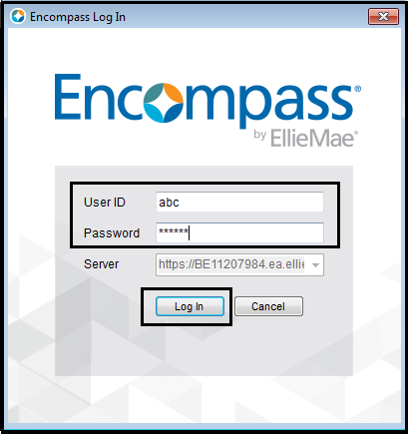

Encompass Login Page

**STEP-3**: As you login in “Encompass” you will see the below Home page.

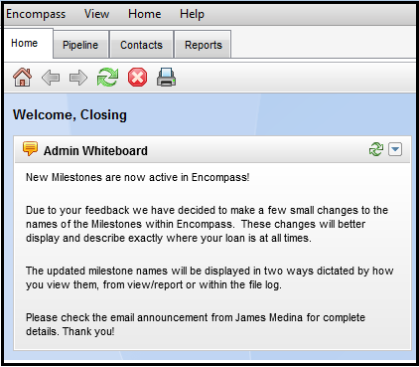

Encompass Home Page

**STEP-4**: Now click on “**Pipeline View”** to access the “**Closer – Docs Ordered**” queue,

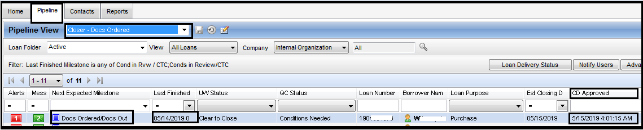

Encompass

Team Lead will assign loans by the **Docs order & CD Approved Date &Time**.Loans will be worked on FIFO basis. ,

**STEP-1 –** Once you login to Encompass, Select Docs Ordered from Pipeline View in order to identify number of loans that to work on as below:

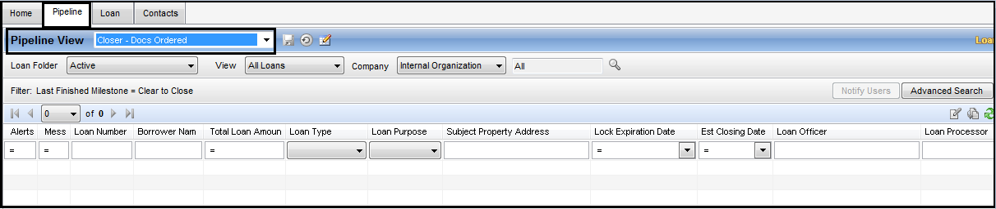Encompass >> Pipeline >> Pipeline View >> Closer – Docs Ordered

-🡪 Double Click on loan to start a work with

-🡪 Before you start to work on file, Identify Milestone that reads as “**Clear to Close**” in **Boldwritings**to make sure file is UW CTC. See below screen shot where you can find the same. You can also check Alerts & Messages if any related to Docs draw.

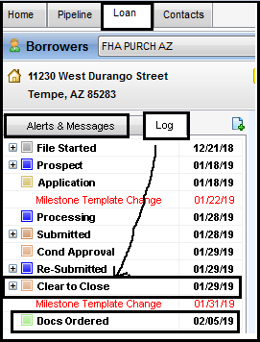

-🡪 Click on “**Docs Ordered**” milestone in order to assign your name as Closer. See below screen shot to refer.

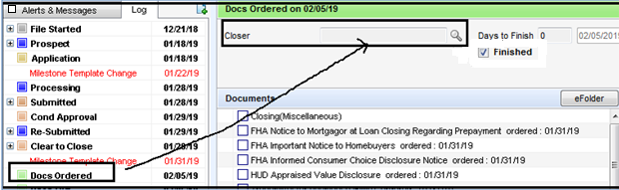

-🡪 In Addition, Docs team can update / refer comments updated by any previous departments under “Docs Order Milestone” as below:

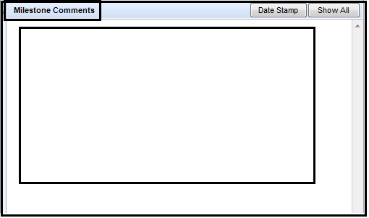

-🡪 Now, you have to go through below forms where required details related to process needs to be verified / updated:

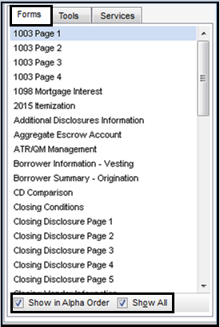

**IMP NOTES**: Make sure “**Show in Alpha Order**” and “**Show All**” button is checked before you start to verify required forms to initiate the Process.

**STEP-2 –** Download all required documents from “e-Folder” section in order to process for any file. You can also see “**Save**” button on right corner which you have to perform frequently during review of your file.



Encompass >> Borrower loan >> Top Corner right side

**STEP-3**: Below is the list of document to be downloaded &reviewed from Documents tab,

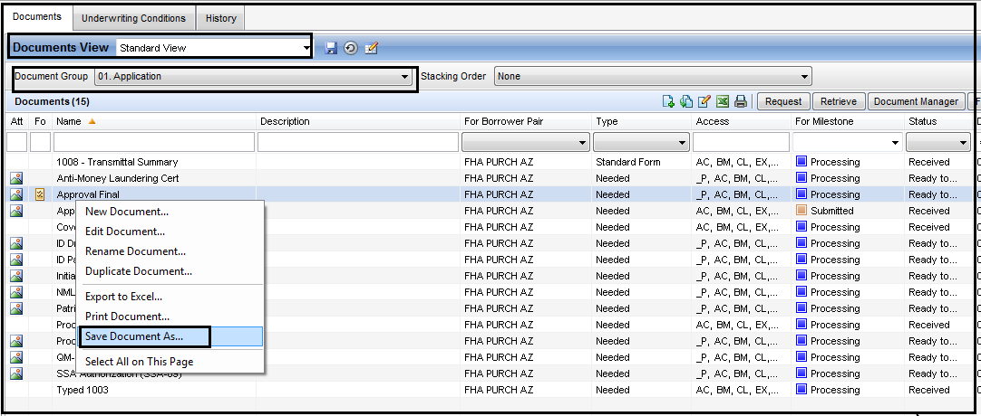Encompass >>e-Folder>> Documents Group >> Download Category wise

* Application Section –

1. Initial 1003
2. Approval Final
3. MI Certificate (If Applicable)
4. Borrower ID’s (DL, SSN Card)
5. SSN Verification

* Government Section –

1. FHA Case Assignment (FHA transactions)
2. FHA Refinance Authorization (FHA Refinance transactions)
3. VA Case Assignment &VA Certificate of Eligibility (VA transactions)

* Credit Section –

1. Credit Report
2. Payoff (Refinance transactions)

* Property Section –

1. Title Report
2. Appraisal Report
3. Purchase Agreement &Addendums (Purchase transactions)
4. Tax Summary (Recent)
5. USPS ZIP Search
6. Evidence of Insurance(HO6,HO3,Master)& paid receipt
7. Flood Certificate
8. Flood Insurance (If Applicable)
9. Power of Attorney (If Applicable)
10. Seller Real Property Disclosure (Only Applicable in Nevada) Non Builder deal

* Disclosures Section –

1. Initial Loan Estimate
2. Last Disclosed Loan Estimate

* Closing Section –

1. Appraisal Report Invoice
2. Credit Report Invoice
3. Final Inspection Invoice (If Applicable)
4. Invoice Pest Inspection (If Applicable)
5. Home Inspection (If Available)
6. Closing Disclosure – Initial / COC CD
7. Borrower’s acknowledgement of Closing Disclosure / COC CD ACK
8. Final 1003 / 92900 Addendum
9. Escrow Wire Instructions
10. Closing Protection Letter (CPL)
11. Pre-Note VOE
12. Additional Docs to be Signed (If Given)
13. Lender fee sheet (if required)

**\*\*IMP NOTES** -** When you download any documents from “E-folder”, Docs team need to check if any additional comments updated by Processor / UW under Tracking Section of the document as below:

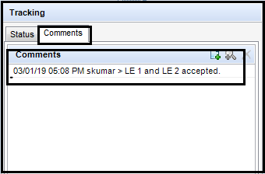

Encompass >>E-folder>> double click on Document >> Tracking >> Comments

**\*\*NOTES\*\***: If Status says “Ready to Ship” it means file is locked / certified. See below screen shot to identify LE’s are locked. ALL LE’s mostly would be uploaded & locked in single category and under “e-Disclosure”.

**\*\*NOTES\*\***: 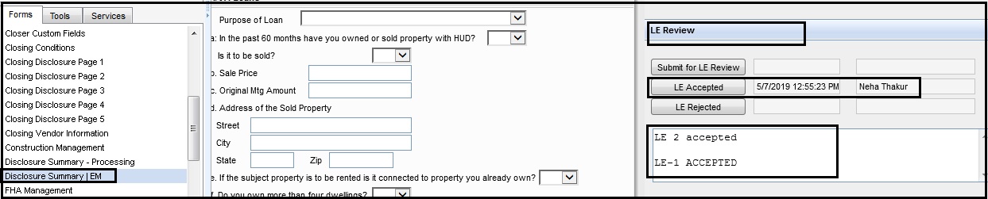Check Disclosure Summary / EM form and LE Review section where it be updated by QC team whether any LE’s are accepted or not which is the trigger for Docs team to identify LE’s are certified by QC team

**STEP-4**: Before we start with verifying required forms, below are the primary details to verify with attached documents:



Encompass >> Borrower loan >> Top of Encompass Screen

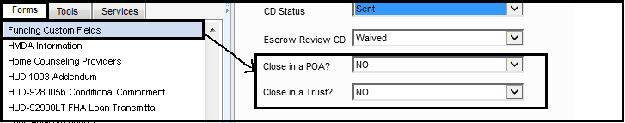In Addition, Docs team need to identify whether File is approved to “Close in a POA” and “Closing in a Trust” by UW or not under Funding Custom field form so can update Borrower’s POA text and Trust Section accordingly.

Encompass >> Forms >> Funding Custom fields

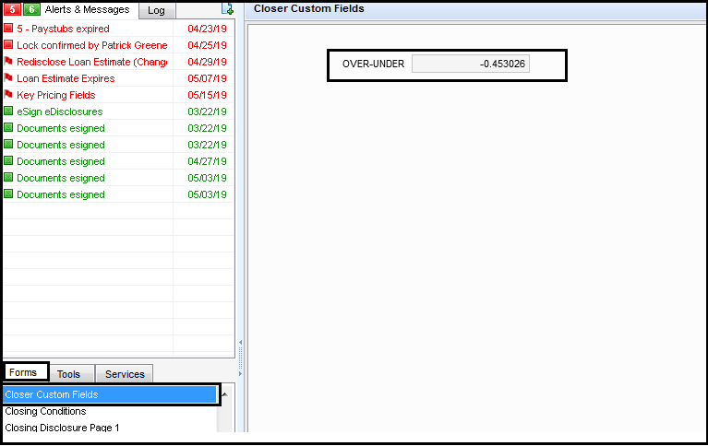**Pricing –Overage adjustment –** Docs team will no longer request Overage or Shortage to Pricing on any type of transactions except **VA Loans with Overage** under “**Closer Custom Fields**”. If there is any overage then reach out to pricing team onshore in their slack channel to get it adjusted. If the amount is in positive then Overage will be considered on pricing, this need to be adjusted to “ZERO” to be able to proceed with the loan.

Encompass >> Forms >> Closer Custom fields

**STEP-5**: **Borrower Summary – Origination –**First Form in Encompass where only highlighted details related to Loan is verified with attached documents.

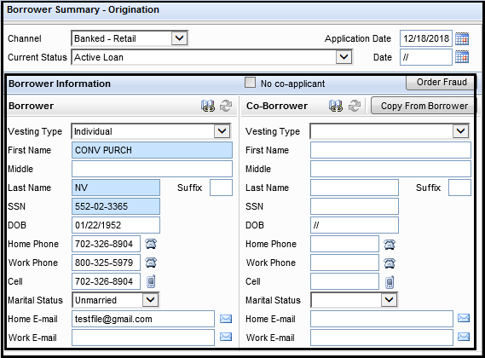

Encompass >> Forms >> Borrower Summary – Origination

1. Verify Borrower’s Information – AWM Loan number, Borrower’s name, SSN number, DOB, Phone numbers, Marital Status & Email ID with attached Final 1003, Approval Final, Driving license & SSN Card / SSN Verification documents.

**REMARKS** – Borrower name to be used in DOCS / ENCOMPASS has to be the exact as what used in Approval Final and Final 1003. Ex, if there is no Middle initial of the borrower used in Final 1003 then Encompass to read same Borrower name without Middle initial.

**REMARKS – SSA Authorization / Validation–**

Effective immediately social security number validation is only required when:

A. A social security number discrepancy has been identified:*

a. Credit reporting for the borrower is under 2 different social security numbers

b. There is a mismatch of the social security number between credit, pay stubs, and/or W2 (any Tax Forms)

c. Other discrepancies related to the social security number

B. There is an AUS alert or “Potential Red Flag” is issued. Loans that receive Social Security number Verification messages from DU or LP

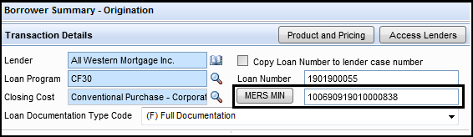

Encompass >> Forms >> Borrower Summary – Origination

\*\***NOTE**\*\* - Click on “MERS MIN” box to generate identical MIN Number for the loan and re-verify with MERS website whether it is duplicate or unique one.

1. Verify if the generated “**MIN #**” is unique and not a duplicate on MERS site. In Addition, DOCS team will also search by SSN Number of borrower & co-borrower both. Here is the MIN Search website that Docs team has to refer: <https://www.mersonline.org/>

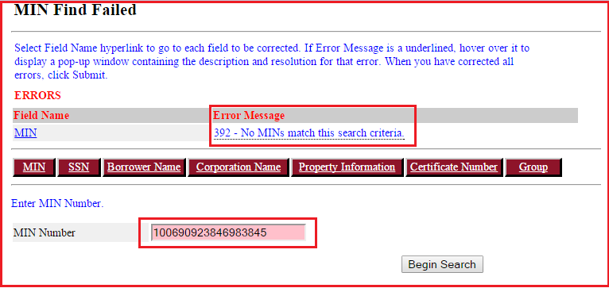

Min Verification Website

\*\***REMARKS**\*\* - Docs team to PDF the MIN search & SSN Search file and to upload it in Encompass under Category “MIN-SSN Summary”

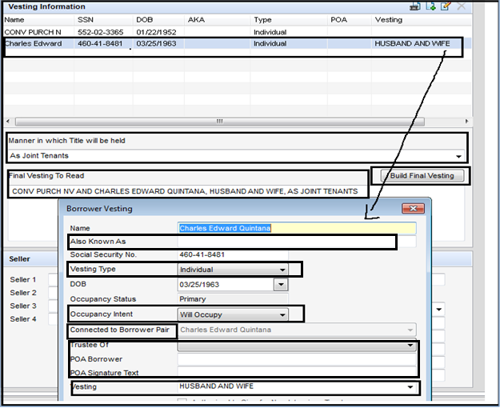**STEP-6**: **Borrower Information – Vesting –**Next Form in Encompass where only highlighted details related to Loan is updated / verified with attached documents.

Encompass >> Borrower Information – Vesting Form

1. Docs Team will verify the Borrower(s) vesting with Processor on Slack or through vesting task which is done by Processing. Docs Team to ensure it is updated correctly.
2. If there is a change in Vesting identified at Docs stage then update the vesting information in Encompass matches with 1003 form and Title report.
3. Purchase – The vesting needs to be verified from 1003 form in Encompass.
4. Refinance – The vesting needs to be verified from the Title Report and from 1003 form.
5. Also Know As (AKA) – Update Borrower’s possible AKA names then fetch the other AKA’s from Credit report, Fraud report, ID card and enter the same in Encompass
6. Vesting Type – There are many options available for Vesting Type and Docs team to ensure correct Vesting Type is selected.

Ex; -Individual – means borrower will be both on NOTE & DOT

* Co-Signor – means Borrower will be on NOTE Only (not under DOT / vesting line)
* Title Only – means Borrower will be on DOT only(not under NOTE)
* Settlor Trustee – means Borrower representing as Trust & Settlor both. (This needs to be selected when file is approved to draw on Trust name. Trust section will be explain later on this form)

1. Occupancy Intent – Make sure it has been selected correctly whether Borrower will Occupy (On Purchase), Will not or Already Occupy the property (On Refinance).
2. Trustee Of – Select the Borrower is belong to which Trust name –(Only when file is approved for Trust Docs)
3. POA Borrower – Verify if POA is applicable or not by verifying information with Encompass and available Borrower’s Power of attorney document (Must be Certify by UW)

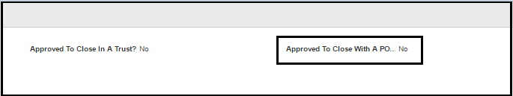Encompass >>Funding Custom Field

**REMARKS:** If any of the borrower is constitute/appointing a person as his/her attorney and then attorney name need to be update exactly from Power of attorney document to ENCOMPASS and POA must be certify by UW and POA button checked as YES in Encompass in order to apply POA procedure.

1. POA Signature text – No need to update anything here as Encompass will take default POA verbiage as per state requirements.

**REMARKS:** Vesting is not considered complete without Borrower’s marital status and gender.In CA and NV states, when borrower is taking title as Married and the non-borrowing spouse is not on title then vesting verbiage must include “Married Man / Woman as his/her Sole and Separate property”.

**REMARKS FOR COLORADO STATE:** If Property is located in Colorado State then Marital status is not required to update under Borrower’s vesting. Only Borrower / Co-Borrower’s name will be updated as vesting.

* **Texas law for Vesting**:

1. On Texas properties the Deed of Trust need not be drafted with additional verbiage like “Joint tenants” or “Joint tenants with rights of survivor ship” prior to sending it for Attorney review.
2. Attorney’s policy is to reference only the borrowers’ marital status in the vesting clause for Texas closings.  The reasons for our policy are:
3. The borrowers’ marital status will determine whether a spouse’s signature is required on the Deed of Trust to create a valid lien on homestead under Texas law
4. Adding the verbiage “Joint Tenants with Rights of Survivorship”, alone, is insufficient under Texas law to create a joint tenancy with right of survivorship.  The borrowers must enter into a separate “Survivorship Agreement” pursuant to the Texas Estates Code in order to create a joint tenancy with right of survivorship
5. Creating a joint tenancy with right of survivorship is contrary to the common practice in Texas, and may impact the borrowers’ estate planning objectives without their knowledge
6. The manner in which title is held by the borrowers has no impact on the validity of the lien created by the Deed of Trust.
7. If the Processor has updated vesting with Joint Tenancy verbiage, Doc drawer will update it as per Attorney policy in Encompass

\*\***REMARKS – UPDATE 01/03/18**\*\* - Docs Draw team need to confirm below points when property is under Texas state and transaction is Cash out Refinance with Primary Occupancy i.e Texas Home Equity

1. Notice Concerning Extensions of Credit (12 Day Notice) – A Texas Equity loan may not be closed before the 12th calendar day after the later of (i) loan application date on Initial 1003 or (ii) the date Buyer signs the Notice Concerning Extensions of Credit disclosure.
2. Docs Drawer need to make sure and verify Deed of Trust / Mortgage is in Form No. 3044.1 and Texas Home Equity Affidavit and Agreement is in Form 3185 only.

* **Trusts**:

1. Trust information is required to update when property is approved to draw in trust name by Underwriter. Trust approval to check in Encompass and verify Trust name with attached Trust paper work in e-Folder (Trust Paper work must be certify by UW) Update the same Trust information in Encompass under Trust Section and Borrower’s vesting. Revocable Trust rider will require when Docs are approved to draw on trust name.

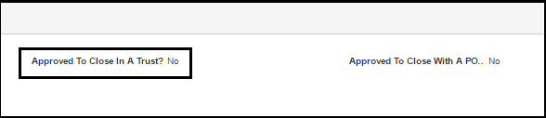

Encompass >>Funding Custom Field

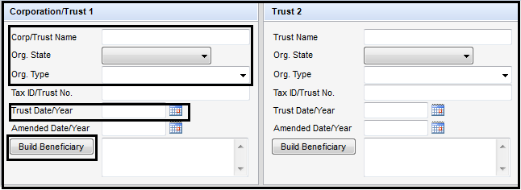Encompass >> Borrower Information – Vesting Form

1. Trust verbiage should always reflect as mentioned in below format under the signature line,

***“Borrower name, Trustee / Trustees of the TRUST NAME dated TRUST DATE”***

1. Update Trust name as per attached Trust document. If there are multiple Trusts you can updated it under Trust 2. If Co-Borrower is vested with different Trust name than what Borrower is in then Co-Borrower has to go in Second trust and “TRUSTEE OF” to be selected as “Trust 2” under Vesting Box of Co-Borrower.
2. If any restated or amendment dates are given on Trust agreement, Trust vesting must reflect Amended / restated dates as well along with Original Trust date under Trust vesting & signature line.
3. Docs team will add PTF Condition in Encompass for files are drawing on Trust name as below: This will apply only when Settlor information is not identified at DOCS Stage.

“**TRUST Revocable Rider – Title Company to update Settlor(s) information on Trust rider (Section – C) prior of recording**.”

1. **Org. State & Org. Type** :Select Trust State as per Trust Document where Trust is located. Org. Type is usually selected as “An Inter Vivos Trust”
2. Trust Date / Year – Select Trust Date as per Trust Document.
3. Build Beneficiary – Update only when there is any beneficiary given on Trust document.
4. Click on “Build Final Vesting” once all above information is updated.

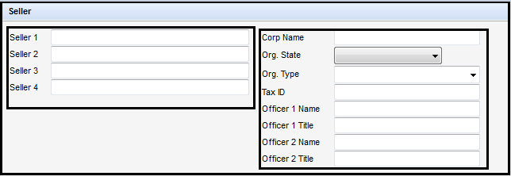

Encompass >> Borrower Information – Vesting Form

**(Only for Purchase Transactions) –** When you verify the Seller Section, make sure you check Seller address is updated by Processing team under “**Tools tab**” with sub folder as “**File Contacts**”. See below screen shot for reference:

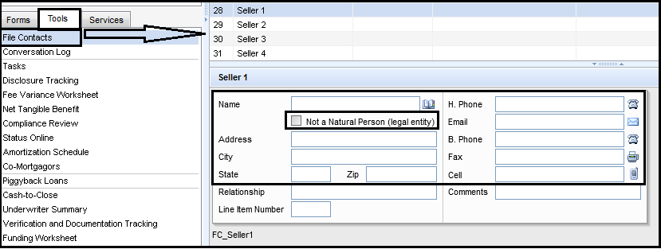

Encompass >> Tools >> File Contacts >> Seller

\*\***REMARKS**\*\*

1. If there is a discrepancy in seller info on Purchase Agreement & Preliminary Title report, reach out to Processor to confirm the correct Seller name to be use on DOCS and add PTF Condition accordingly to correct Seller name.
2. If Seller is any entity and not the individual then “NON-PERSON” button has to checkright above on Encompass Screen.

**STEP-7**: **1003 Page-3–**Next Form in Encompass where only highlighted details related to Loan are verified. **Do not change anything on this details as it directly reflects to Final 1003 form. You will see Lender’s branch address too which doesn’t need to be changed on this form. Keep it as what it shows.**

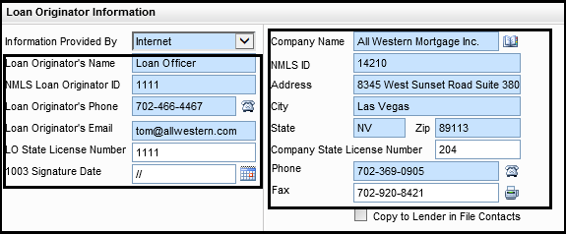

Encompass >> 1003 Page-3 >>Loan Originator Information

* **Lender Section**

1. Verify Lender name equals to “**ALL WESTERN MORTGAGE, INC.**”

* **Loan Officer**

1. Verify LO Name, NMLS #, Email id, Phone and LO State License number from Mavent report under Tools >> Compliance Review. If Phone is not updated for LO then update AWM Corporate office phone number in Encompass.
2. 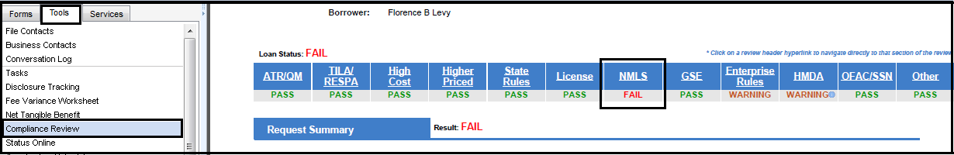Verify LO information for completeness and accuracy with LO details on Mavent report in Encompass and Report must says it is “**PASS**” from NMLS review. We won’t have NMLS attached in Encompass to verify the information.

Encompass >> Tools >> Compliance Review >> NMLS line

**STEP-8**: **Closing Conditions –**Next Form in Encompass where you have to add Closing Conditions as per loan type & purpose. You can update additional conditions manually as well under Yellow Box.

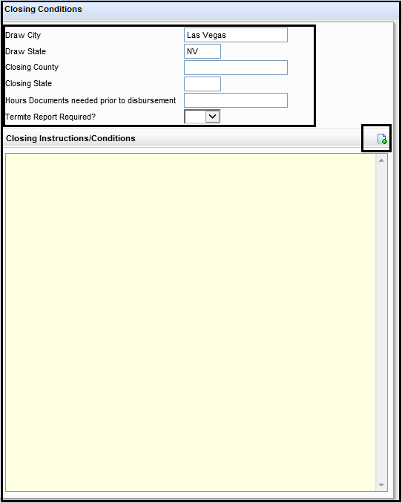

Drawn City – Location of the Lender i.e. Las Vegas

Draw State – Location of the Lender i.e. NV

Closing County – County name of the subject Property

Closing State – State of the subject property

Hours Documents needed prior to disbursements – Leave Blank

Termite report required – Leave Blank

Encompass >> Forms >> Closing Conditions

\*\***REMARKS**\*\*

1. Click on “Add” button to add up Closing Conditions as per Loan Type & Purpose
2. 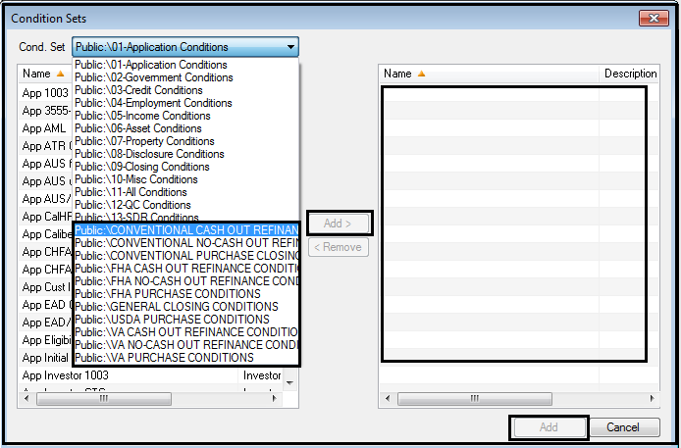Select Correct Condition set from dropdown and Add it on right side and click on “Add” button
3. Below are few common conditions which need to be updated as per the docs,
4. TitleReportExpirationDateshouldbe60thdayofEffectiveDateofTitleReport.
5. CPLExpirationDateshouldbe30thdayofEffectiveDateofCPL.
6. Consummation date on or After : Closing / Signing date of the DOCS
7. Pay 1 YR Hazard at closing : Due Amount from Hazard insurance
8. Property any Tax installment within 60 days of the first payment date : QTR / HALF / Yearly to be paid at closing (if any installment is due within first payment date)
9. 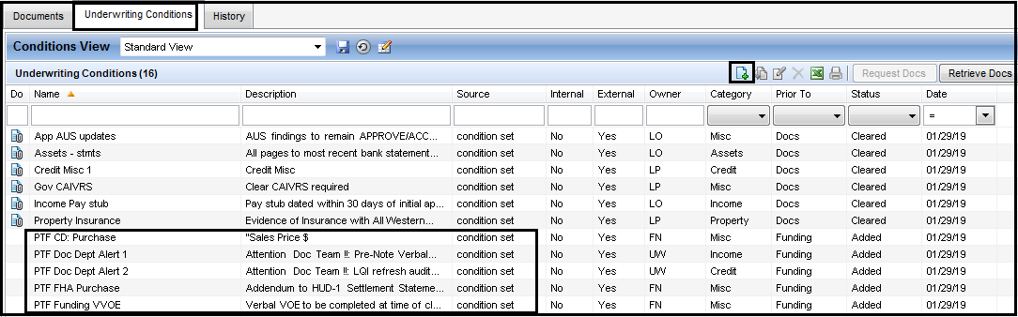Rest of the conditions need to be taken from Encompass under UW Condition tab from “e-folder” and copy those entire **“PTF conditions” (starts with word PTF only – see attached screen shot – highlighted section)** to Encompass under Closing Conditions.

Encompass >>e-Folder>>UW Conditions>>PTF Conditions

1. Below are few examples of Conditions given in below format and can be used whenever it is applicable and to add up in Encompass. See above screen shot “Add” button where you can add additional conditions.

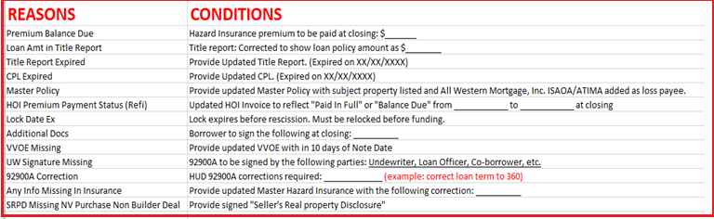

Conditions List

Attached is the sample Condition excel sheet for reference.



\*\*\***REMARKS**\*\*\* - Docs team to add PTF Condition for missing Signed Page-3 ofFinal92900-A for FHA Files only when it is not attached under Encompass.

\*\***REMARKS**\*\* - Docs team will not add PTF Condition for missing Co-Borrower name on Appraisal report for VA transaction as only the veteran borrower’s name is required on the Appraisal report.

\*\***REMARKS**\*\* - IF UW Says to move forward with PTF Condition for Correction in monthly Hazard Insurance, monthly property taxes or monthly MI on Approval Final / Final 1003, Contact your TEAM LEAD Immediately.

You need to discuss the discrepancies with UW what they have on their approval and how much it is coming up in Encompass and need to get the revised Final Approval / 1003 Corrected and Certified by UW for the same prior to releasing DOCS if they are wrong BUT NO PTF CONDITION FOR THE SAME !!

**\*\*REMARKS** - Update on Refinance loan –** When you collect Renewal HOI Premium on DOCS , make sure you add below PTF Condition as well along with the renewal policy premium that you are already adding it currently;

**Current Year HOI Policy is expiring within 2 Months of First Payment date. Expiration Date of Current policy is: __________**

\*\***REMARKS**\*\* - DOCS Team do not have to add below unnecessary conditions if they find discrepancy on these topics

1. Purchase contract – If contract miss any property address suffix like DR, AVE, ST. You don’t need to add condition for the same. It’s fine if contract miss this info.  If there is a spelling mistake on contract in the address, you can add the condition
2. Do not add condition for HOI / Contract / Appraisal doesn’t have Borrower’s middle initial / names. We are okay with this.

**STEP-9**: **Review / Update required Information from Tools tab >> File Contacts –** Next tab in Encompass where only highlighted details related to Loan is updated / verified with attached documents.

1. 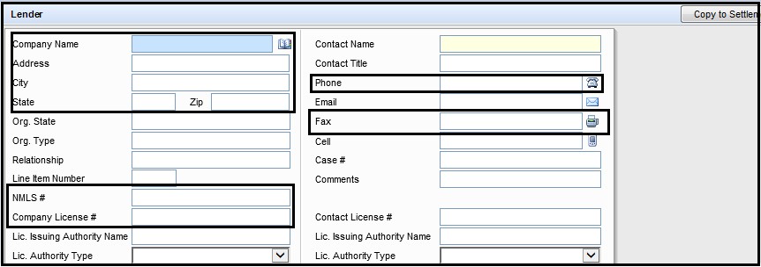**Lender**–

Encompass >> Tools >> File Contacts >> Lender

**Lender name**: ALL WESTERN MORTGAGE, INC.

**Address**: 8345 WEST SUNSET ROAD, SUITE 380, LAS VEGAS, NV 89113

**Org. State**: Nevada (always)

**AWM NMLS**: 14210

**AWM LIC ID**: 204

**Phone**: 702-369-0905

**Email**: LO’s email id

**Fax**: 702-920-8421

**\*\*NOTE** -** Docs team need to ensure Lender information is updated under File Contacts. If not then select the lender information (All Western Mortgage Inc.) from Business contacts.

1. **Investor –**

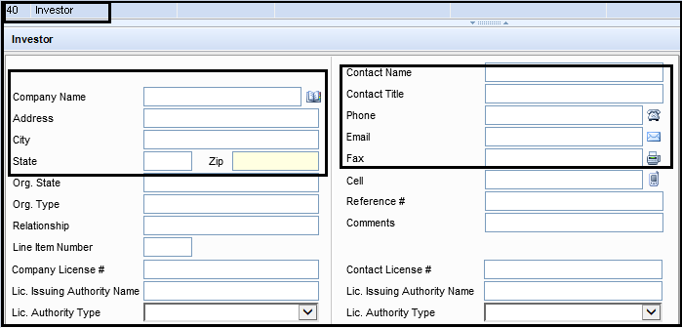Encompass >> Tools >> File Contacts >> Investor

**\*\*NOTE** -** Docs team need to ensure Investor information is selected from Business Contact when there is any investor selected / locked in file under Reg-Z CD form. No need to update Information if there is No Investor.

1. **Title Insurance Company** – 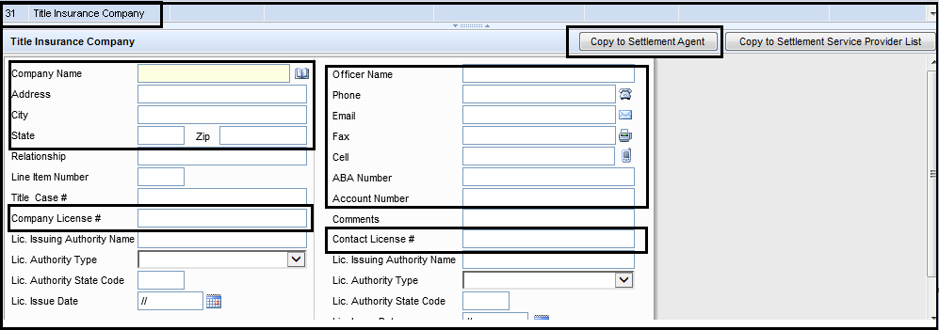

Encompass >> Tools >> File Contacts >> Title Insurance Company

\*\***NOTE**\*\* - You can copy the same information to “Settlement Agent” by checking the box “**Copy to Settlement Agent**” on above screen shot. It needs to be checked only when Settlement & Title Company are one and the same. This Information needs to be updated by Processor either under Settlement Agent Contact or Escrow Company or Title Insurance Company. Docs Team has to verify the same address with Title report.

* **Title Company section**

1. Verify the Title Company details found on the preliminary title report.
2. Ensure that Correct Title Company is identified from Title report if Title Company details of doesn’t match with the “Escrow Company”.
3. Verify Title Officer and Email information from Title report.
4. Ensure Loan amount on Title Report matches with Direct and the ALTA/ATIMA clause has Lender name as “ALL WESTERN MORTGAGE, INC.”
5. 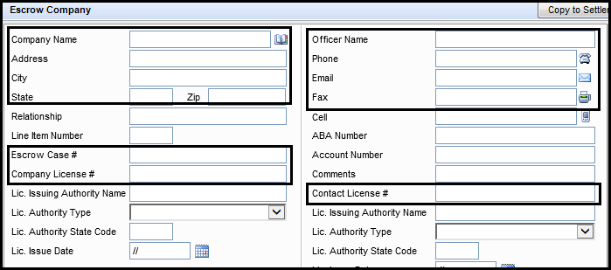**Escrow Company** –

Encompass >> Tools >> File Contacts >>Escrow Company

\*\***NOTE**\*\* - You can copy the same information to “Settlement Agent” by checking the box “**Copy to Settlement Agent**” on above screen shot. It needs to be checked only when Settlement & Title Company are one and the same. If Title & Escrow Company is different then “Escrow Company” Information will be Copy to “Settlement Agent” field. This Information needs to be updated by Processor either under Settlement Agent Contact or Escrow Company or Title Insurance Company. Docs Team has to verify the same address with Title report.

* **Escrow Company section**

1. Verify the Escrow company details from Title report.
2. Update Bank ABA and Bank Account from Escrow wire instruction
3. Verify Escrow Company License ID# and Contact (Escrow officer) License# are updated.
4. Verify Escrow Company Name, address, Officer Name, Escrow Case# , Phone & Email as mentioned in Prelim Title report
5. **Settlement Agent** –

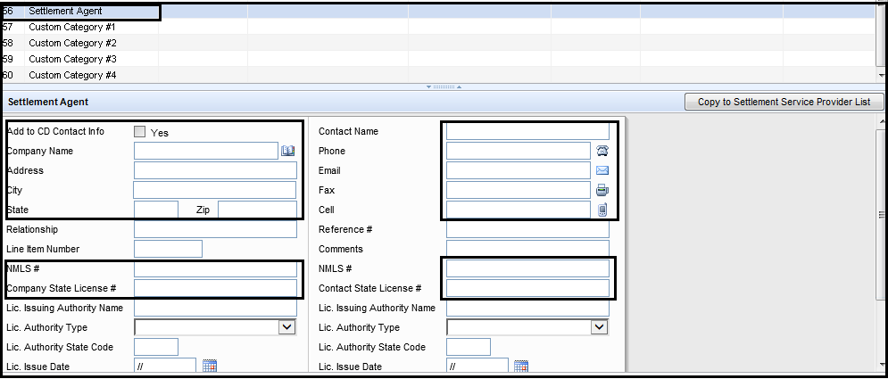Encompass >> Tools >> File Contacts >> Settlement Agent

\*\***NOTE**\*\* - Make sure this has been checked “**Add to CD Contact Info**” as YES and verify the updated information which are highlighted only.

1. **Buyer’s Agent** – **Skip this section it has to be updated / verified by CD Team**
2. **Seller’s Agent** – **Skip this section it has to be updated / verified by CD Team**
3. **Hazard Insurance Company** – Docs team to verify highlighted Information from attached Hazard Insurance policy.

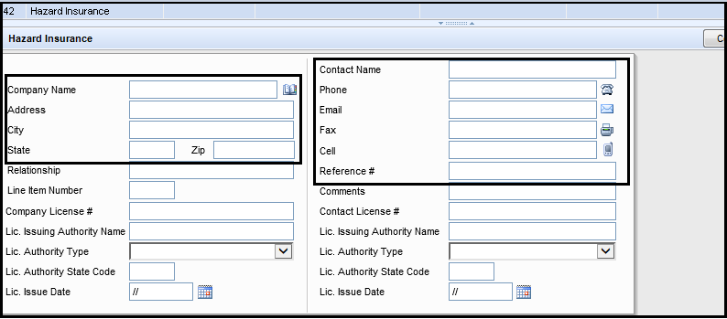

Encompass >> Tools >> File Contacts >> Hazard Insurance

* **Hazard Insurance section**

1. Verify all fields with reference to the HOI(EOI) policy & paid receipt(invoice).
2. Agents Name and Email canbe Blank if no information is provided on HOI.
3. Insufficient coverage/dwelling: HARDSTOP. Reach out to processor and request for to provide updated HOI with sufficient coverage.
4. To determine coverage amount, locate Dwelling amount and add any replacement cost to it.
5. 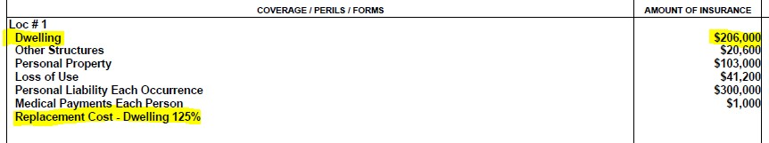Total of these two figures equals your total Dwelling coverage.

Evidence of Insurance >> Coverage Section

1. Example: (Dwelling) $206,000 + 125% (Replacement Cost) = Total Coverage of $257,500 which should cover the total loan amount. **Please IMP note** that “Building Ordinance or Law Coverage” should not be considered towards additional replacement cost.

\*\***REMARKS**\*\* - **HOI Master Policy** –

If Master policy doesn’t shows Property address, Borrower name or loss payee.

**Step-1** – Docs team to check if there is any PTF / PTD Condition added by UW or not. If Condition is added by UW, Docs team will proceed for the Docs.

**Step-2** – If PTF / PTD Conditions are not updated in direct then reach out to processor for the same to provide updated master policy and add PTF Condition in Direct as,

“**Processor to provide Updated Master policy showing Borrower name / Property address / Loss payee name (All Western Mortgage) and loan number**”

**Step – 3**–Docs team will not hold the Docs for incomplete master policy. They will proceed with the Docs drawing with applicable PTF in direct and request it to the processor on Slack to provide it prior to funding.

1. How to verify the insurance company details from the **Evidence of Insurance(EOI)**

Ex:$471,000(Dwelling coverage on HOI)X125%ERC (if given)=**$588,750.** This result should be equal to or more than loan amount to proceed with Docs Request.(If the EOI shows a Guaranteed Replacement Cost “GRC”, then total loan amount will be considered as Coverage)

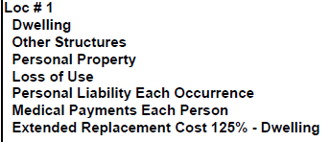

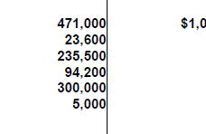

1. Dwelling Coverage should be equal or greater than loan amount
2. If Dwelling calculated above is not enough to cover loan amount then check the estimated cost of Appraisal on Appraisal Report. If coverage is greater than estimated cost then we are good, else reach out to Processor for Insufficient Dwelling and Hold DOCS drawing request.
3. 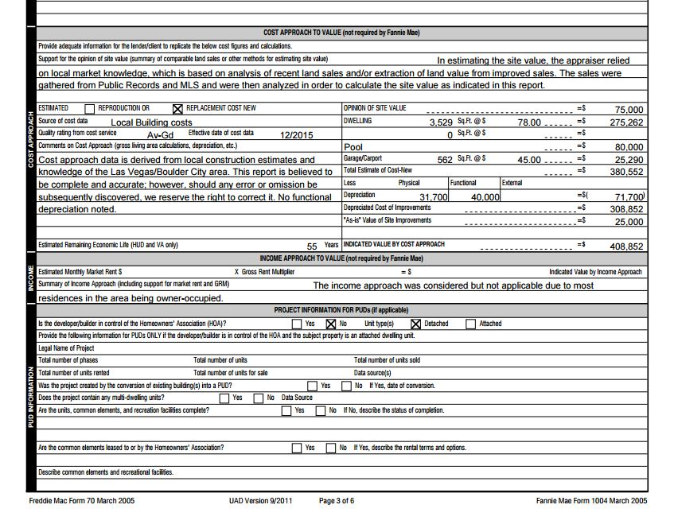This is the place where you can locate “**Total estimate of cost of appraisal”** from page-3 of Appraisal report,

**NOTES**: For MH Property Transactions, Check below snap From Appraisal report page-2 to identify Replacement cost calculation on Appraisal as it will be located differently.

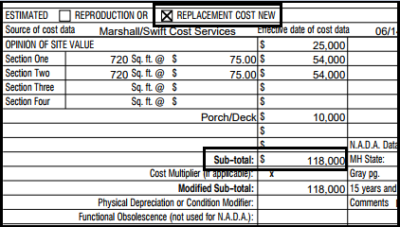

1. On Purchase Transaction, HOI term must be effective from the month file is closing.
2. Verify Mortgagee Clause on Evidence of Insurance. Mortgagee name has to be read Lender name as“ALL WESTERN MORTGAGE, INC” with Lender address and AWM Loan #. If there is any discrepancy in this date, reach out to processor for correction in Mortgagee clause.

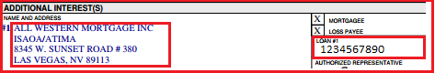

Evidence of Insurance

\*\***REMARKS**\*\* - We do not require Dwelling Coverage to be sufficient on HO6 Policy to cover 20% of appraised value as per FNMA guideline . REMEMBER – This is only for Conventional Condo loans having master policy and HO6 with it. We are okay and can proceed if Coverage is not sufficient on HO6 policy.

1. **Flood Insurance** – **(if property is in Flood Zone) –** Docs team to update highlighted Information from attached Flood Insurance policy. (if applicable)

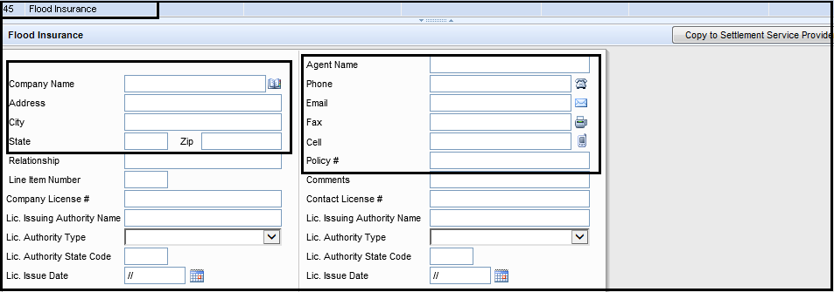

Encompass >> Tools >> File Contacts >> Flood Insurance

* **Flood Insurance section**

1. Verify Borrower information on Flood certificate (Borrower name, Property address, AWM Loan #)
2. Verify if Subject property is in Flood Zone(Code: A,V) per flood certificate.
3. If Yes, Verify all fields with reference to the Flood Insurance policy & paid receipt (invoice).
4. Agent Name and Email may remain blank if not available on the FLOODpolicy.
5. Max Allowable Coverage limit on Flood Insurance is $250k.
6. If loan amount is greater than $250k- Max coverage on Flood Insurance to be $250K
7. If loan amount is less than $250k – Ensure the Dwelling coverage on flood insurance covers at least the loan amount.
8. If **Flood Zone and NFIP MAP number** from Flood certificate doesn’t match either with Flood Insurance or Appraisal report then PTF as below & proceed with Doc’s,
9. “UTR – Correct Flood Map # on appraisal report/flood insurance to match Flood Certificate”
10. 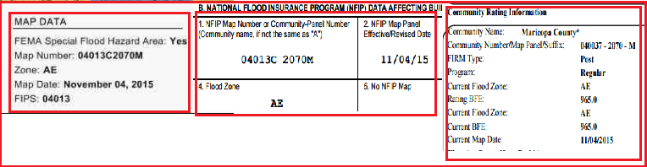“UTR – Correct Flood zone on appraisal report/flood insurance to match FloodCertificate”

Appraisal report Flood Certificate Flood Insurance

**REMARKS:** If property is Condo & in Flood zone and there is no HO6 available for Flood insurance then Docs draw to verify whether Master policy is combined with Hazard and Wind (flood) or not. If master policy is covering Hazard and flood both then no need of HO6 is required for Flood insurance separately. Only Hazard HO6 premium will be collected at closing if due and impounded to Escrow.

1. **Docs Prepared by –** Docs team to verify highlighted Information if CD team has correctly updated it or not.

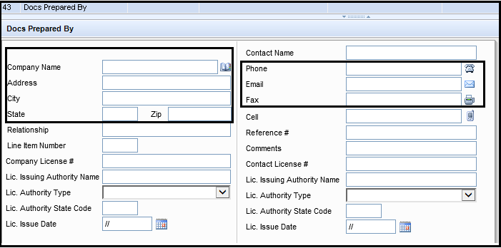

Encompass >> Tools >> File Contacts >> Docs Prepared By

**\*\*NOTE\*\***Docs Prepared By – Select Lender name & address (All Western Mortgage Inc.)from Business Contact for all states except **Texas state** where Docs Prepared by address will be “**Black Mann & Graham, LLP**” which need to be selected from Business contacts >> Attorney category.

**STEP-10**: **Closing Vendor Information –**Next Form in Encompass where only highlighted details related to Loan is updated / verified with attached documents. Once File Contacts form is finished as per **Step-9 from SOP**, You will see all the required information will be auto-populated here. Docs team need to ensure each screen has the information updated. Verify “**Trustee**” section and re-update if incorrectly selected from Business contact by clicking on the Rolodex.

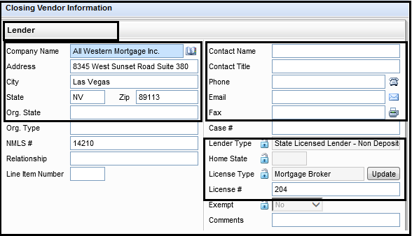

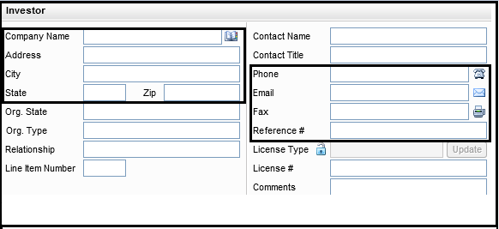

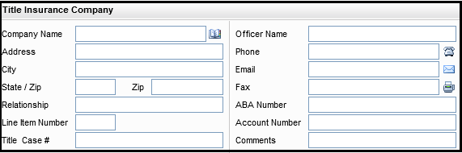

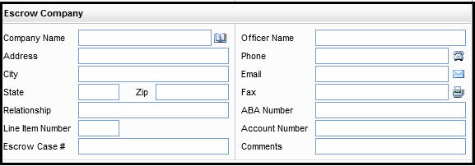

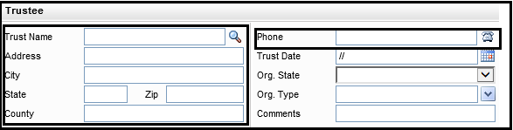

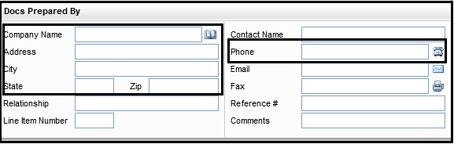

Encompass >> Forms >> Closing Vendor Information

1. Lender – Auto-populated if it is updated under File Contacts
2. Investor – Auto-populated if it is updated under File Contacts
3. Title Insurance Company – Auto-populated if it is updated under File Contacts
4. Escrow Company – Auto-populated if it is updated under File Contacts
5. **Trustee** –

a) Trustee will be same as Title Company for listed states – Nevada, California, Arizona, Washington, Utah, Oregon etc

b) Trustee will be as County name & address when subject property is in Colorado state (Select from Business contacts >> No Category).

c) Trustee will be as Attorney (*Thomas E Black Jr.*) address to be used as Trustee address when property is located in Texas state. (Select from Business contacts >> Attorney Category)

d) **NO** Trustee Information to update for states such as Florida & Michigan

1. Docs Prepared By – Auto-populated if it is updated under File Contacts

**STEP-11**: **Property Information –**Next Form in Encompass where only highlighted details related to Loan is updated / verified with attached documents.

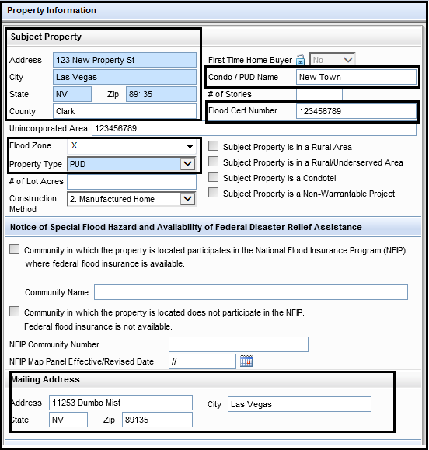

Encompass >> Forms >> Property Information

\*\***NOTE**\*\* - Please note that Encompass reads & pulls required “Rider” as per selected Property type and Occupancy. There are no other options to add up riders and same as for Occupancy

1. Property Type – Verify the property type in Encompass (Property Information tab) & Appraisal report and ensure it is selected correctly in order to system reads the correct “**RIDER**” that required for file like PUD, CONDO, 1-4 FAMILY & SECOND HOME Riders as per Property type and occupancy type as well as for the accuracy of pricing that is based on correct Property type that is selected under Property Information tab.

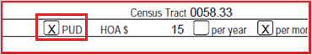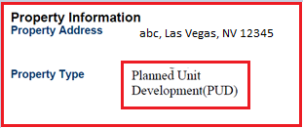 Appraisal report Final Approval (DU)

1. Project Name (Condo / PUD Name) – If Property type is PUD/CONDO, Ensure correct Project name is updated from Legal Description (Exhibit A) in Prelim Title report & verify as below :
2. If the PUD name on the underwriters 1008 and in Encompass match the PUD name on the appraisal (Neighborhood name), it will be the same PUD(Project) name used on Appraisal for docs
3. If the PUD name on the underwriters 1008 and in Encompass doesn’t match the appraisal but does match the prelim, we will use the same PUD name on the prelim for docs. Either is acceptable.
4. PUD/Condo name on UW Final Approval docs will match with either Prelim or Appraisal report.

Prelim Report >> Legal Description (Exhibit A)

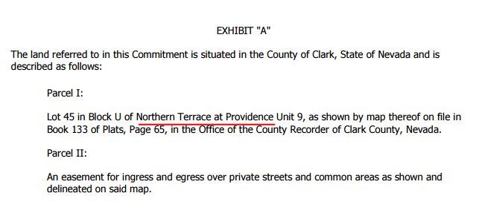

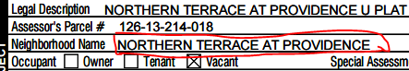

Appraisal Report >> Neighborhood Name

* Below are the Riders which possibly used in the various kind of transaction.

1. PUD: PUD Rider is required when Property Type is “PUD”
2. CONDO: CONDO Rider is required when Property Type is “CONDO”
3. 1-4 FAMILY: 1-4 Family Rider is required when Occupancy Type is “Investment”
4. Second Home: Second Home Rider is required when Occupancy Type is “Secondary”
5. Manufacturing Home: MH Rider and Affixation of Affidavit are required when Property Type is “Manufacturing Home”
6. When docs are drawn in Trust Name then “**Revocable Trust Rider**” is required.
7. When Special program is 203K then “**203K Rehabilitation rider**” is required
8. When docs are drawn on Second Lien Loan then “**Second Lien Rider**” is required.

\*\***REMARKS**\*\* - **Update for Tax Exempt Financing Rider** – US MRBP no longer requires “Tax Exempt Financing rider” to be added with Deed of Trust for Government (FHA/VA) HIP Programs.

* **Important checkpoints to note regarding Riders:**

1. If the Property type per Appraisal Report &Encompass is ***SFR(Detached)*** and there are NO Monthly HOA fees listed on Final 1003/Approval then property type on AUS should read as “**Detached**”
2. If the Property type per Appraisal Report &Encompass is ***SFR(Detached)*** and there are **Monthly HOA fees**listed on Final 1003/Approval then property type in AUS (Final Approval) should read as “**PUD**”. Doc drawer will select Property type as PUD in Encompass no matter what Appraisal says.
3. If the Property type in Encompass is PUD and monthly HOA fees apply then property type on AUS (Final Approval) should read as “**PUD**” and Doc drawer has to ensure Property type is selected as PUD even if the property is a detached SFR per Appraisal.
4. If the Property type as per Appraisal report is: **2-4 Units** then the property type on AUS must read Detached even if Appraisal show it as Attached. If 2-4 units were attached to another structure then it would be attached. 1-4 family rider is compulsory to be drawn on DOCS even if occupancy is Primary residency. Docs Draw team to ensure 2-4 Units are selected under “**FHA LT or Conventional LT form”** in order to pull up1-4 Family rider on loan. **IMP**: If File is FHA with Occupancy as Primary and there are multi-units (2-4) property as per Approval Final & Appraisal report then **1-4 Family Rider** is not mandatory to add on FHA loan. This is only required in Conventional files.
5. Flood Zone – Update / Verify Flood Zone as per attached Flood Cert.
6. Mailing Address – Update mailing address if it is different than present address. Review attached Final 1003 for the same.

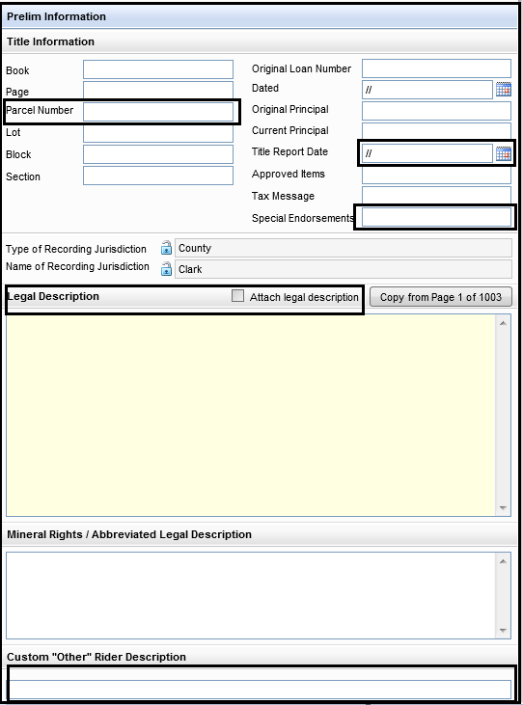

Encompass >> Forms >> Property Information

\*\***NOTE**\*\*

1. Special Endorsement – Update / Verify Endorsement list that is required as per transaction –

**Standard Endorsement –**

**For SFR / Detached / Attached – 8.1, 9.10-06**

**For PUD – 8.1, 9.10-06, 5.1-06, 115.4**

**For Condo – 8.1, 9.10-06, 4.1-06, 116.2**

**For ARM and Detached – 8.1, 9.10-06, 111.5**

**For ARM and PUD – 8.1, 9.10-06, 111.5, 5.1-06, 115.4**

**For ARM and Condo – 8.1, 9.10-06, 111.5, 4.1-06, 116.2**

**For Manufacture – 8.1, 9.10-06, ALTA7**

**For Manufacture and PUD – 8.1, 9.10-06, ALTA7, 5.1-06, 115.4**

1. Parcel Number – Update / Verify Parcel Number as per attached Tax Summary / Tax cert / Preliminary Title report.
2. Title Report Date – Update / verify Effective Date of Title report as per attached Title report.
3. Legal Description –Click on “**Copy from Page 1 of 1003**” button which will take up the legal description from 1003 that would be updated by UW. If it is not updated then paste the legal description details from Title Report- Exhibit-A under Yellow box or write up “**See Prelim**”
4. Custom “Other” Rider Description – Type up the rider names which are pulled up separately from Investor portals or provided by Attorney. It will update Additional rider names check boxes on 2nd page of DOT by doing that.

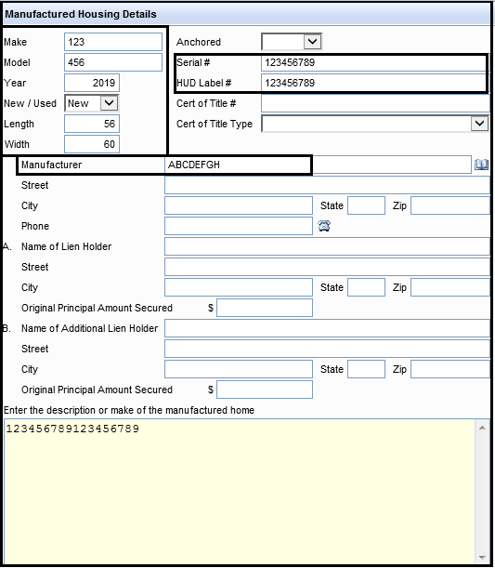

Encompass >> Forms >> Property Information

1. 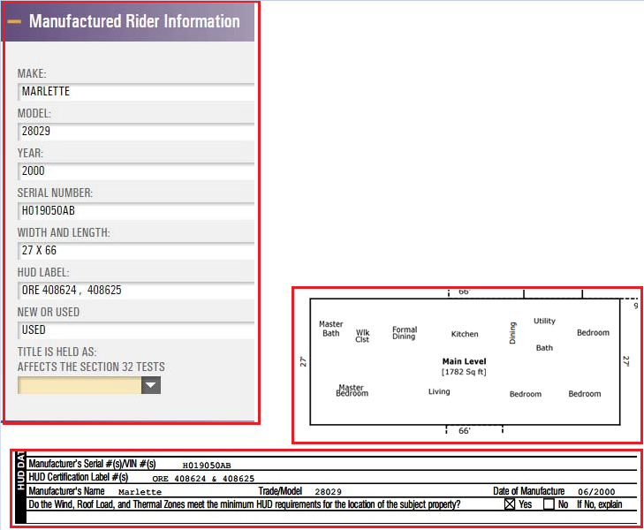**Manufactured Housing Details** – Enter highlighted details from Appraisal report on above screen shot only if property type is Manufactured home in Encompass & Appraisal report.

Appraisal report Page-1

1. Ensure manufacturing home rider and Affixation of affidavit regarding manufacturing home riders is added on the transaction.
2. Affixation of affidavit regarding MH is compulsory to add on purchase transaction but for refinance, it can’t be if it is already recorded as per Preliminary title report with previous lender on Previous Deed of trust / Mortgage
3. Docs team to verify the Correct Width and Length of the property on MH loan from House map given on Appraisal report. Length and Width will be counted only for Bedroom part and not for Garage or Parking. Above is the screenshot from Appraisal map given for reference.

**REMARKS:** Docs Team need to pull / download Affixation of affidavit from the closing package on any manufactured loan & Send it to Joshua Shearer with Escrow officer’s information. In Addition, Docs Team need to remove LO’s name from Signature line on last page of this rider before emailing it Joshua Shearer. Additional Notes for email **Subject line: Borrower name, Loan number & NOTE Date**

**STEP-12**: **HUD 92900ALT FHA Loan Transmittal (Only FHA) –**Next Form in Encompass where only highlighted details related to Loan is updated / verified with attached documents. Only for FHA Transaction.

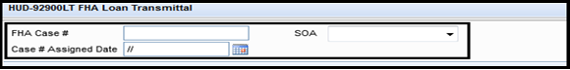

Encompass >> Forms >> HUD 92900ALT FHA Loan Transmittal

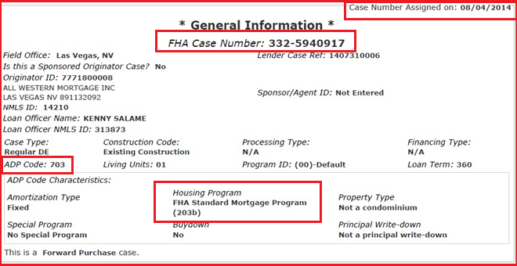FHA Case Assignment number document

\*\***NOTE**\*\* -

1. FHA Case# , Case Assigned Date & SOA – Verify / Update as per attached FHA Case assignment document
2. Attached is the FHA ADP Code list which Docs team can refer to identify the correct one to use on the basis of loan program.



**STEP-13**: **FHA Management (Only FHA) –**Next Form in Encompass where only highlighted details related to Loan is updated / verified with attached documents. Only for FHA Transaction.

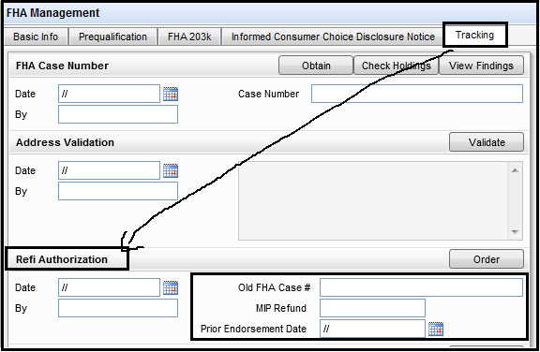

Encompass >> Forms >> FHA Management >> Tracking >>Refi Authorization

\*\***NOTE**\*\* - Docs Team need to verify Refi authorization which is only required when transaction is FHA Refinance as MIP Refund only applies in refinance transaction (if there is any). Docs Team need to review MIP Refund amount & Prior Endorsement date with attached Refinance authorization in Encompass efolders. Docs Team will ensure MIP Refund is updated here in positive (+) sign. Do not input minus opposite to amount as system consider it in minus figure by the field name. MIP Refund needs to be consider for the month file is closing in and If Encompass amount &Refi authorization doesn’t match then DOCS team need to request UW to have the amount corrected in Encompass and update UW’s Final Approval / 1003. Once MIP Refund is updated on above screenshot, it will directly reflect on **1003 page -3**. Docs Team need to make sure the amount reflects there too. See attached for reference.

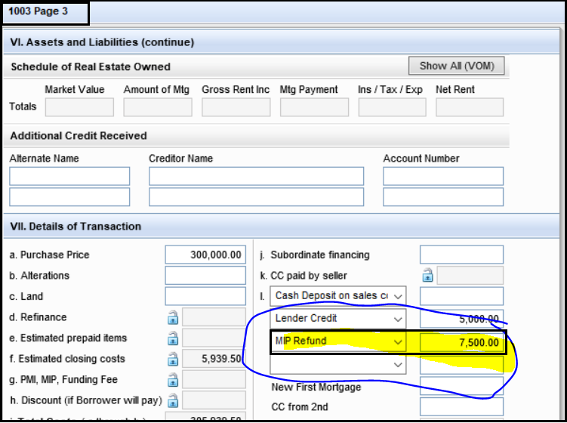

>>**How to update / verify MIP Refund on Final CD will be explained under Closing disclosure page-3 form on SOP.**

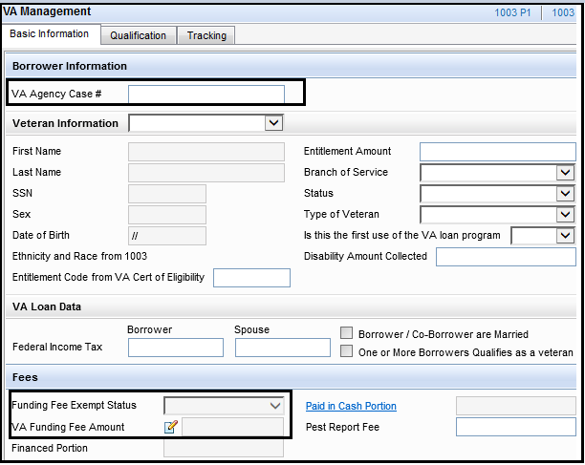**STEP-14**: **VA Management (Only VA) –**Next Form in Encompass where only highlighted details related to Loan is updated / verified with attached documents. Only for VA Transaction.

Encompass >> Forms >> VA Management

\*\***NOTE**\*\* -

1. VA Agency Case# - Verify / Update as per attached VA Case assignment, Final Approval & Final 1003/92900A
2. Funding Fee Exempt Status – Verify / Update as per attached Certificate of eligibility
3. VA Funding Fee amount – Verify / Update with attached Final Approval / 1003 and according to the fee structure shown below,See below revised VA Funding table for the loans that are closing **on or after Jan 1, 2020**. **MOST IMP**: New VA Funding fee chart applies the same % for “Regular Military, Reserves and National Guard” officers. There will be no separate % for Military & Reservist. All has the same % of VA Funding fee.

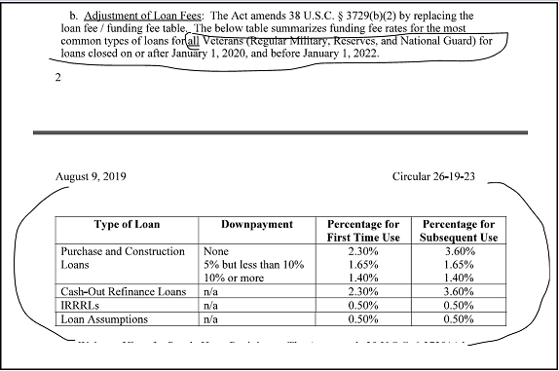

Funding Fee Chart

**REMARKS**: On VA Transactions, there is no Option for NO C/O deals. The only options we have to select the Loan type is: 1) VA Purchase 2) VA IRRRL 3) VA C/O.   
VA doesn’t have a rate and term Option (No C/O). They only allow for an IRRRL and Cash out however we have a few investors that will allow for the loan to be locked as RATE and TERM for price but file will always need to be processed and underwritten as Cash out. So In this Case, Encompass will reflect as No Cash out however all UW docs will shows CASH out as Loan purpose due to VA Guidelines.

**STEP-15**: **USDA Management (Only USDA) –**Next Form in Encompass where only highlighted details related to Loan is updated / verified with attached documents. Only for USDA Transaction

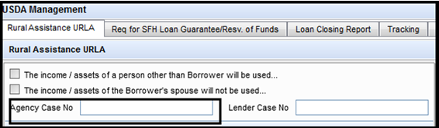

Encompass >> Forms >> USDA Management

\*\***NOTE**\*\* -

1. Verify / Update Agency Case No as per attached USDA Commitment form.
2. If file is locked with USDA government program then Docs team need to verify & update in Encompass from USDA Conditional Commitment (if available) with Last LE, Initial CD, Final 1003 & Approval Final (GUS);

* Borrower name, Mortgage Clause, Loan Amount, Commitment number (9 digits) and Funding fee factor for Upfront Guarantee fee and Annual Renewal Premium. (under RegZ CD Form – Mortgage Insurance Section)

**STEP-16**: **VA 26-1820 Loan Disbursement –**Next Form in Encompass where only highlighted details related to Loan is updated / verified with attached documents. **(Only for VA Loan)**

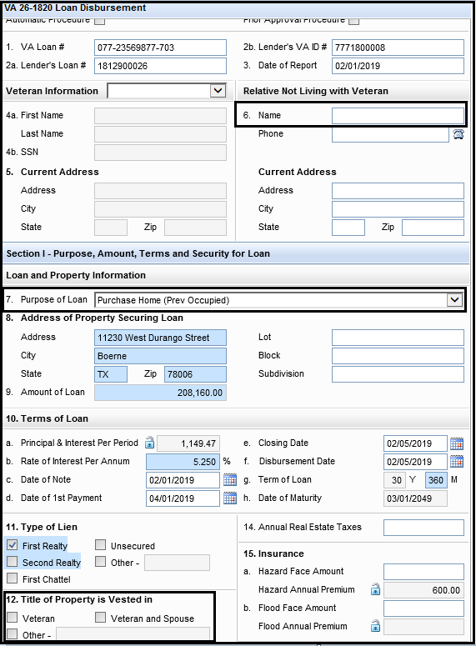

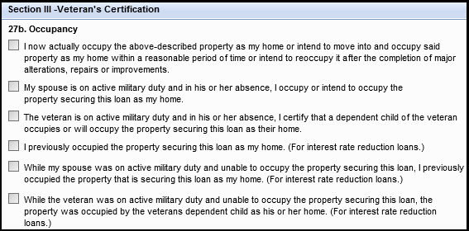

Encompass >> Forms >> VA 26-1820 Loan Disbursement

DOCS team need to fill up Section – 6, 7, 12 and 27B under this form in Encompass on all VA loans. Attached is the snip and information from where you can find information.

#6 – RELATIVE – Update from – Disclosures – VA Nearest Living Relative3

#7- Loan Purpose – Refer Final VA 92900A – page no.1 & 2

#12 – Vested – Refer Final VA 92900A – page no.1 & 2

#27B – Occupancy – Refer Final VA 92900A – page no.1 & 2

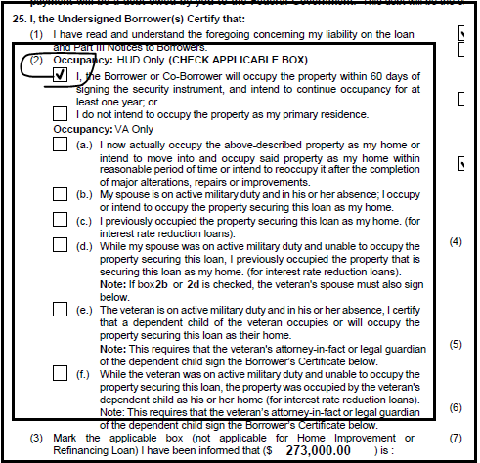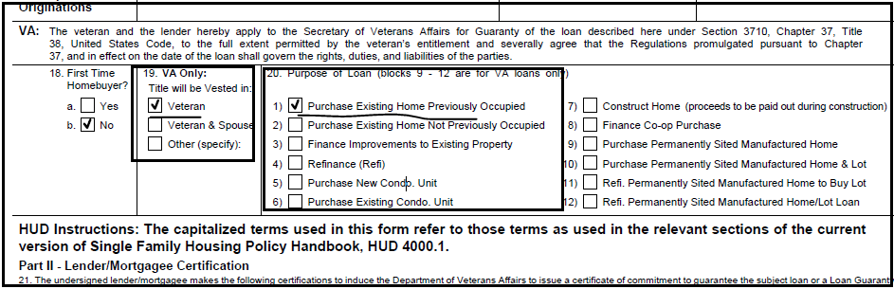

eFolder>>9.Closing >> VA 92900A document

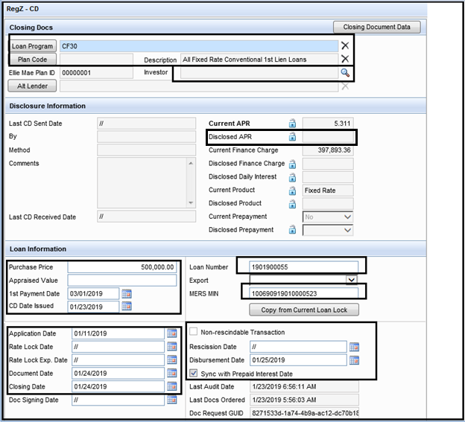**STEP-17**: **RegZ – CD –**Next Form in Encompass where only highlighted details related to Loan is updated / verified with attached documents.

Encompass >> Forms >>RegZ – CD

\*\***Closing DOCS**\*\*

1. Loan Program & Plan Code – Select/Verify the loan program code as per Loan Transaction.

\*\***REMARKS**\*\* - TEXAS State Loan program – When Transaction is Cash out Refinance with Primary as Occupancy for Texas Property files, DOCS Drawer to select Loan program as “TX HOME EQUITY”.

1. Investor – Select / Verify the Investor if any

\*\***Disclosure Information**\*\*

1. Disclosed APR – For Docs Draw- Verify with Last disclosed CD APR

\*\***LOAN INFORMATION**\*\*

1. Purchase Price – Verify from Purchase agreement / addendum
2. Appraised Value – Verify from Appraisal report
3. 1st Payment date – Verify if it is correct. (always one month after the NOTE / Closing Date)
4. **CD Date Issued** – For Docs Draw – Select the Same Date as your Closing Date
5. Verify Application Date from Initial 1003, Rate Lock date & Lock Expiration date (Verify from last LE)

\*\***REMARKS**\*\* - If lock expiration date in Encompass and Last LE do no match and lock is extended then reach out to processor to confirm whether lock extension fee is charged to borrower or not.

1. If yes, COC CD is required. Docs will be on HOLD until COC CD request is Completed, Sent and Acknowledged by borrower.
2. If No, Proceed for DOCS and Update Comment under Docs Order Milestone.

**Remarks for Lock extension**: As Per the Compliance Partner (FIS) and investors it is confirmed AWM is allowed to add a discount point for lock extension via COC CD. Doc drawer still has to confirm with LO/Processor if there is lock extension in Encompass whether it is charged to Borrower / Seller or Lender. If there is a charged to Borrower/Seller for lock extension after Confirmation with Processor, COC CD requires and it has to identifies that the delay in closing was the result of lack of performance by the Either Borrower / Seller.

1. Document Date – Select the Same date as your Closing / NOTE Date
2. Closing Date –
3. Verify / Update the Closing Date and ensure it is after 3 days of acknowledgement of CD. Example: If Initial CD is acknowledged by borrower on 06/30/2016 then 3 days compulsory waiting starts from 06/30(Thursday) and ends on 07/02 (Saturday) so earliest Signing or NOTE date can be on DOCS is Monday 07/04/2016.
4. Sunday and Federal Holidays are not counted in three business days waiting period calculation.
5. Review Encompass UW Conditions from UW team related to either
   1. Pre Note Verbal’s
   2. LQI dates

Example:

UW Comment –*“Attn. Doc Team If docs are dated after 02/11 please reach out to UW as an updated LQI report is required”*

**i.e.**–*If docs are being prepared on 02/12 then doc processes must be hard stopped until an ALL CLEAR is received from the UW*

1. Rescission Date – Update Rescission end date when Transaction is Refinance & Occupancy is Primary. Rescission date includes Monday to Saturday except Sunday and Federal holidays.

Ex; 01/26/2019 is your Closing Date i.e. Saturday so your first day of rescission starts from 01/28/2019 Monday and ends on 01/30/2019 Wednesday. Your Rescission Date will be **01/30/2019.**

\*\***REMARKS**\*\* - Rescission Period is not applicable on Purchase transaction and Refinance -Secondary or Investment Occupancies. It only applies on Refinance & Primary Occupancy transaction.

1. Disbursement Date – Next day after Closing date (for dry state), Same day as Closing date (for wet state). In Refinance Primary – It will be next day after your rescission date.

Disbursement date includes Monday to Friday only (do not count Saturday-Sunday & Federal holidays)

\*\***NOTE**\*\* - If Disbursement Date is already updated in Encompass then do not change it unless the date is passed away.

1. Sync With Prepaid Interest Date – Always make sure this button is Checked.

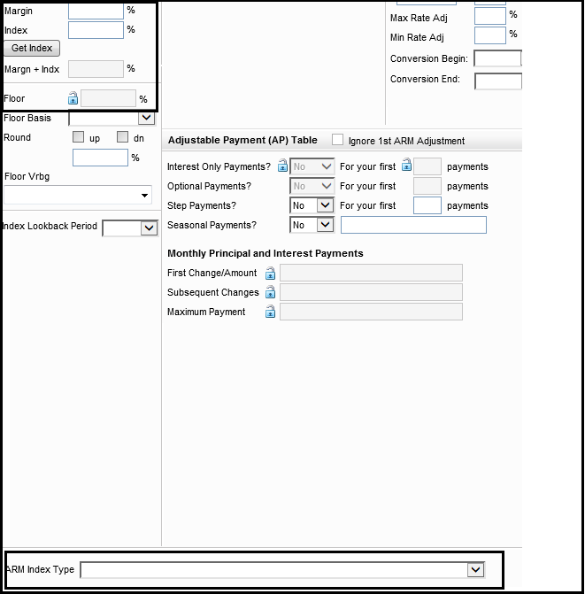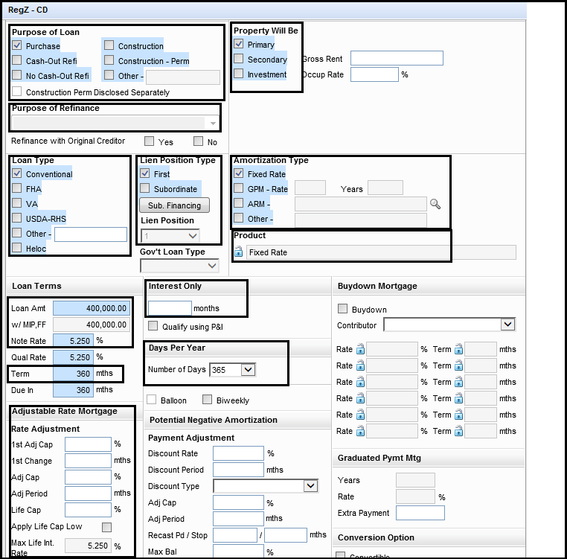Encompass >> Forms >>RegZ – CD

1. Purpose of Loan – Verify with Final Approval, Final 1003, LE and Initial / COC CD to ensure it is selected correctly
2. Property will be – Verify with Final Approval and Final 1003 to ensure it is selected correctly
3. Purpose of Refinance –when Loan Purpose if Refinance , Docs team to verify with Approval Final, Final 1003 , LE and Initial / COC CD to ensure it is selected correctly.
4. Loan Type – Verify with Final Approval , Final 1003, LE and Initial / COC CD to ensure it is selected correctly
5. Lien Position Type – Verify with Final Approval and Final 1003to ensure it is selected correctly
6. Amortization Type – Verify with Final Approval, Final 1003, LE and Initial / COC CD to ensure it is selected correctly
7. Loan Terms – Verify with attached Final Approval, Final 1003, Last LE, Initial / COC CD to ensure it is updated correctly
8. Adjustable Rate Mortgage – Verify this section with Last LE and Initial / COC CD when Transaction is Adjustable Rate Mortgage only. This data will be already updated by Secondary when loan will be locked with Investor.
9. Interest Only – Update / Verify only when Loan program is Interest Only
10. 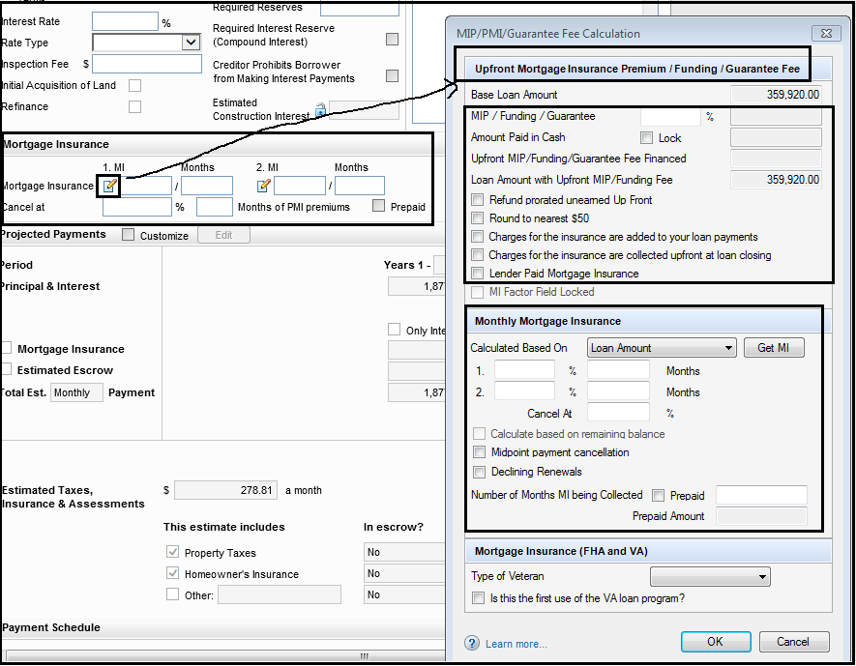Days Per Year – Must be “**365 days**”

\*\***MORTGAGE INSURANCE**\*\*

**NOTE** - Docs Team to verify Mortgage Insurance section as per the loan type and attached are the reference of Conventional loan (More than 80% LTV), FHA & VA

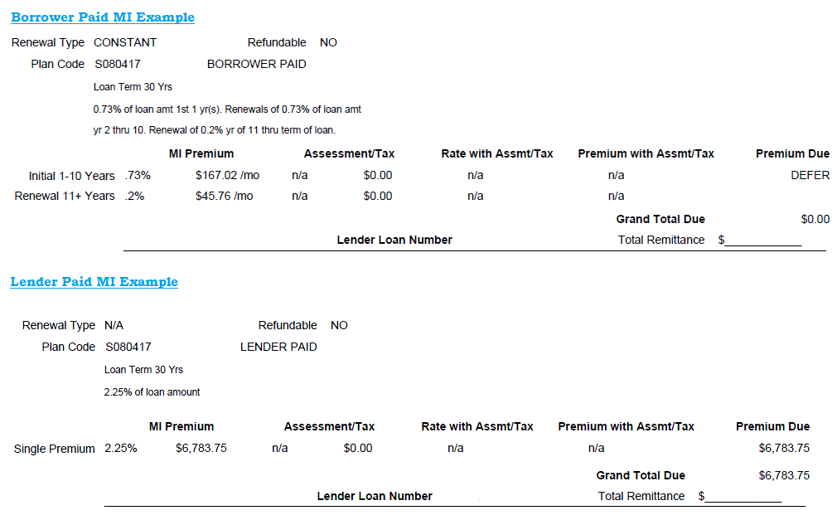

MI Certificate Examples

**Mortgage Insurance section:** To be updated on Conventional loans (> 80% LTV) only.

1. Upfront PMI: To be updated / verified only on “Single Premium” mortgage insurance files. Review mortgage insurance certificate to identify the Premium type and “**Charges for the Insurance are collected upfront at loan closing**” button must be checked for Conventional Single Premium MI loans.
2. 1st Renewal: 1stblock : Enter 1st renewal % found on the MI certificate

2ndblock : Enter number of months found on the MI Certificate

Quote and months will be 120 always

1. 2nd Renewal: 1stblock: Enter 2nd renewal % found on the MI Certificate which

will be most usually 0.20%

2nd block: Enter number of months which will be remaining

months of loan term

1. Renewal Calc Type: **Ensure Declining Renewals is Unchecked** on Conventional BPMI loans
2. Cancel at :Always to update as “78.000”.

\*\***IMP NOTE**\*\* - Single Upfront Premium – If Premium is not financed in the loan however need to show Premium amount on Sec-B (CD) then ensure we first update % of Single premium then click on “lock” check box and then manually update the same Premium amount under “Paid in cash” box and Click Ok. Your base & total loan amount will remain same and your premium amount will be collected at closing.

**FHA section**

1. UPFRONTMI%: 1stblock: Always 1.75%

1. Renewal Calc Type: always auto- checked as “**Calculate based on remaining balance**”
2. MI Renewal %: 1stblock: Auto-Populated – per below chart and verify with Last LE / Approval Final / Final 1003 and Initial / COC CD.

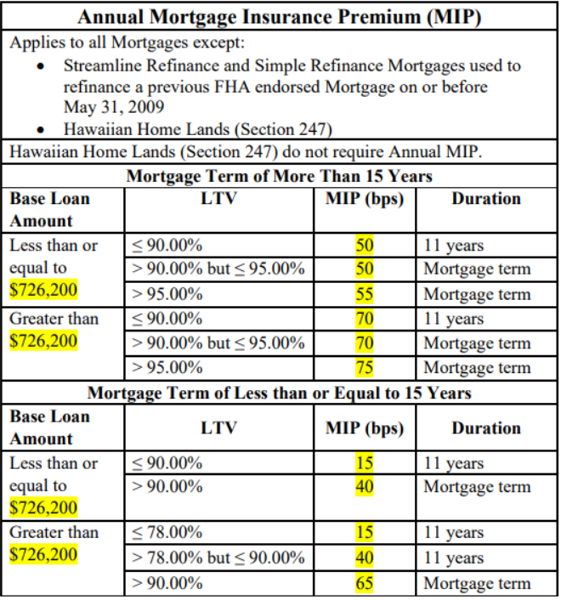

Revised FHA Annual MIP Calculation Chart (NOTE Date on or after 03/01/2023)

1. Click “GET MI” button: Please click on “GET MI” button before any DOCS are Issued on all FHA loans.

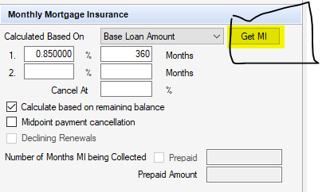

**VA Section**

1. Funding Fee: Verify if correct Funding fee % updated by previous Department and verify with Last LE , Initial / COC CD.



Attached is the Revised VA Funding table for the loans that are closing on or after April 7, 2023 for reference to verify the correct funding fee % on VA loans. **MOST IMP**: VA Funding fee chart applies the same % for “Regular Military, Reserves and National Guard” officers. There will be no separate % for Military & Reservist. All has the same % of VA Funding fee.

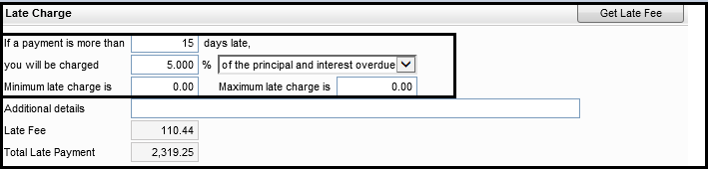Encompass >> Forms >>RegZ – CD

\*\***Late Charge**\*\*

1. If a payment is more than ______ days late – always ensure it reads 15 days.
2. You will be charged -
   1. For Conventional – it is 5%
   2. For FHA, VA and USDA – it is 4%
3. Minimum & Maximum late charge – N/A or 0.00

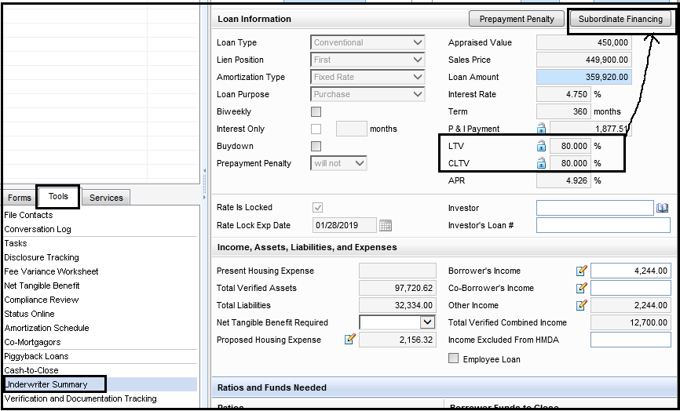**STEP-18**: **Tools>> UW Summary–** Next Form in Encompass where only highlighted details related to Loan is updated / verified with attached documents.

Encompass >> Tools >> Underwriter Summary

\*\***NOTE**\*\* - Identify LTV & CLTV % of the loan and can also check if file has any Subordinate Financing or not if DPA lock confirmation is available in Documents.

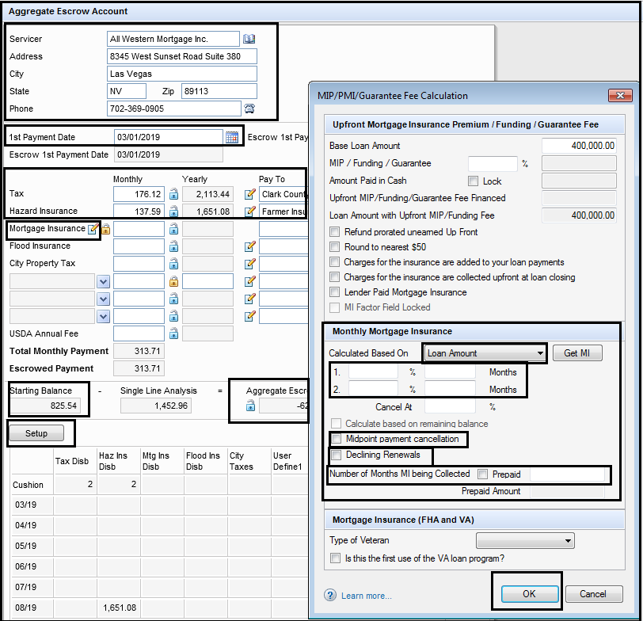**STEP-19**: **Aggregate Escrow Account –** Next Form in Encompass where only highlighted details related to Loan is updated / verified with attached documents.

Encompass >> Forms >> Aggregate Escrow Account

1. Servicer – Always Lender (All Western Mortgage Inc.) – Verify / Update the name & address details from business book or can type it down.
2. 1st Payment Date – Make sure your first payment date is correct which is one month after your Closing Date. Ex; Closing Date – 01/24/2019 so your first payment date will be 03/01/2019
3. Taxes, Special Assessments & hazard or flood Insurance (if applicable) – Update / Verify Monthly & yearly amount both for taxes & insurance as per Tax Summary , HOI Policy and also update Pay to names. Verify monthly amounts with Final Approval / 1003. If there is any discrepancy then reach out to UW for Correction.

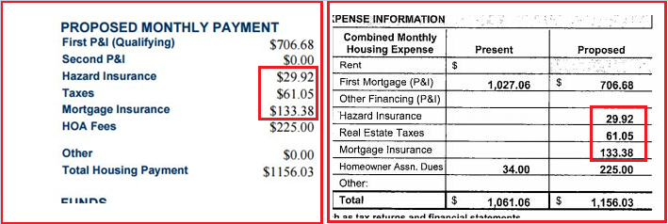

1. Mortgage Insurance (when applicable) – Verify / Update Upfront Mortgage Premium, Funding Fee, Guarantee fee and Monthly Mortgage insurance whenever it is applicable. Update details & select appropriate boxes and select OK to calculate the monthly MI.
2. 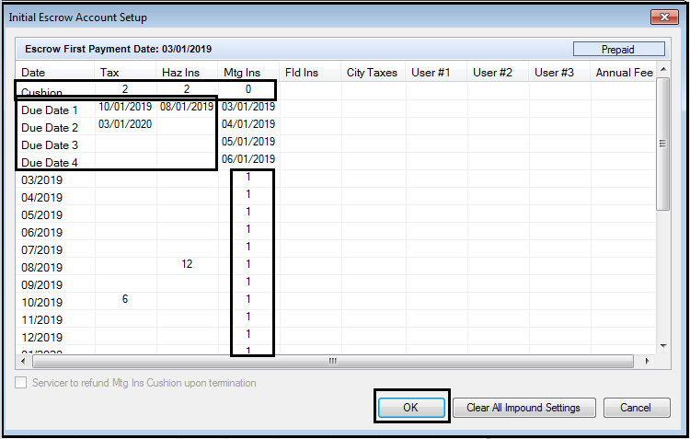Setup – Click on Set up to update your cushion months & Due dates for taxes, insurance & Mortgage Insurance.
3. Cushion – Update Cushion months as “2” for Taxes & Insurance… If there is Mortgage Insurance is applicable it will be “0” for MI.
4. Due Dates for Taxes & Insurance – Update your next due dates for Taxes & Insurance. You can notice the auto fill within chart for taxes & insurance
5. Mortgage Insurance Due Dates – Start with Fist payment date i.e. 03/2019, enter a “1” twelve times (12 mos) down the column; you have to stop at the month prior to initial first payment date for the following year i.e. 02/2020.

Please note, if you add too many “1’s” you will receive a warning message. You will not receive Warning message If there are less than twelve “1’s” so make sure you verify before continuing.

Click on Ok after everything is updated correctly under “Set Up”.

1. Starting / Initial Balance – Make sure it stays in positive only.
2. Aggregate Escrow Adjustment – it will always be in Negative or ZERO.

\*\***REMARKS**\*\* - Refer to the “Tax Impound Schedule” for the due dates to verify them in Encompass for accuracy purpose.



**Remarks –** If Property is Current year (New) construction as per appraisal or Under Construction (Builder loan) then property taxes are to be calculated on below transactions

1. For Nevada, Arizona states;

**1% of sales price / 12 = monthly tax amount**

1. For CA state (Purchase Transaction whether property is new/under construction, resale);

**1.25% of sales price / 12 = monthly tax amount Vs. Tax Summary amount – whichever is higher**

1. For Colorado state- Either Mill levy rate as per attached tax cert or 1% of Sales price whichever is used by UW on their Final Approval. We are no longer using land value for New Construction properties. Mill Levy rate Calculation just in case if UW use the same on their approval

**Mill Levy Calculation for CO New Construction if it is used by UW:**

1) Assessed value - $412,000.00 appraisal value * 7.96% tax rate = $32795.20

2) Mill rate as per Tax cert = $166.60800 / 1000 = $0.166608

3) Total tax = Assess value $32795.20 * Mill rate 0.166608 = $5463.94

4) Monthly amount = $5463.94 / 12 months = $455.33

1. On all Non-Builder Purchase, Resale(Except CA State) and Refinance transactions:

Consider Tax amount higher of what is available on UW certified Tax certificate or Preliminary Title report for Tax Calculation purpose.

**If discrepancy between your calculation and the amount appearing on the documents in Encompass loan file, you must “stop” the process and have monthly property taxes confirmed by the assigned underwriter on the loan file**

**If Impound is “NO” and property is under flood zone and Flood insurance is provided then Doc drawer to ensure that Flood Insurance is impounded to Escrow. (Flood insurance is Compulsory to impound whether Impound is Yes or NO)

**Remarks (Update for Impounds):** Impounds should not be confirmed by viewing the 1003 (initial or final); it should be confirmed by:

1. Loan Type

2. Locked information in Direct

* If loan type = FHA or VA then
* IMPOUNDS required = must be YES; impounds for both taxes and insurance are required.
* If Initial CD, LE does not reflect YES for both taxes and insurance; hard stop Docs Process and request Processor for a CofC CD to correct impounds to “YES”for both taxes and insurance
* If Final 1003 and UW LT does not reflect both taxes and insurance; hard stop Docs process and apply a condition for UW to correct Final LT and Final 1003 to reflect both taxes and insurance in proposed PITIA payment or request UW for correction.
* If Loan type = Conventional, then Impound is optional however If LTV is more than 80% then it is mandatory and above marked steps will need to followed.

CA is the only state which allows the option for “no impounds” up to 90% LTV. This is only applicable for Conventional transactions.

**STEP-20**: **2015 Itemization–** Next Form in Encompass where only highlighted details related to Loan is updated / verified with attached documents.

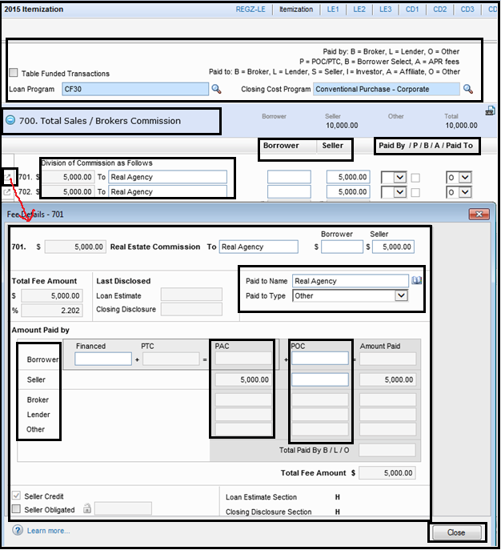

Encompass >> Forms >> 2015 Itemization

1. Firstly, Go thru the details updated on TOP of the above screen shot which shows the full form of short letters that we are going to use during our itemization.
2. Verify Loan Program & Closing Cost Program
3. **800 Section** – Items Payable in Connection with Loan
4. 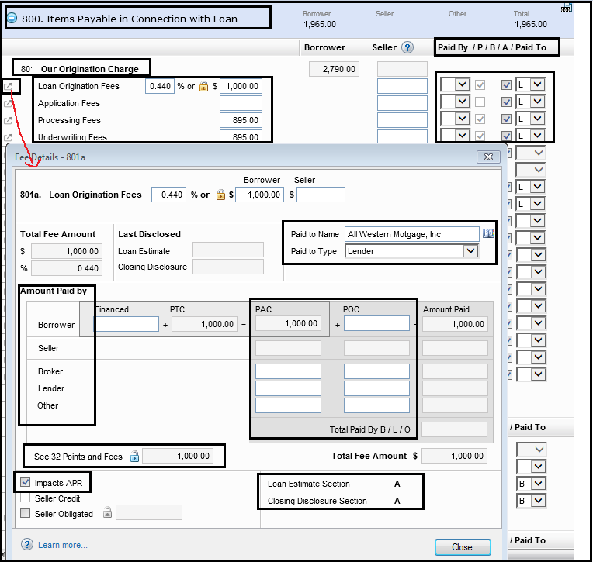**801 Our Origination Charge** – We will verify / update Lender’s Origination, Processing or UW Fees as per attached LE’s, Initial / COC CD. If there are any Investor related fees like Compliance / Admin , Funding Fees will also go under this section

Encompass >> Forms >> 2015 Itemization

1. Update / Verify Paid to name as “All Western Mortgage Inc.”
2. Update / Verify amount under Borrower or Seller Column as per LE& CD. Please note; if Origination fees are paid by Broker / Lender or Other, Select the appropriate letter from “Paid by” Dropdown. i.e. B / L / O
3. Paid to Type will always be “Lender”. Paid to type will change as “Investor” if there are any Investor related fees like Compliance / Funding Fee.
4. Letter A – stands for APR. All Origination fees are APR fees so it must be checked.
5. Click on this box to view the summary of fees and ensure you verify the highlighted details mentioned on above screen shot. PAC – stands for Paid at Closing, POC stands for Paid Out side Closing.
6. Check the bottom of screen shot which states that this fee will show in Sec-A of CD. You need to make sure that fee is going in correct section.
7. “Impacts APR” it will always checked for Origination fees.
8. 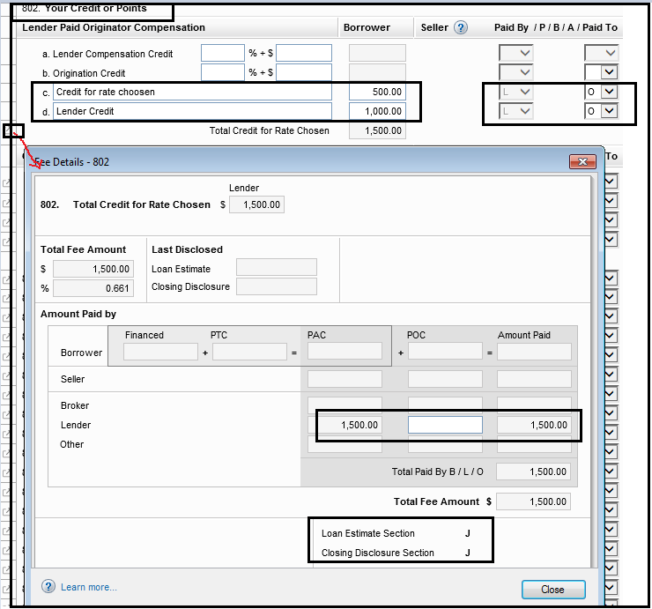**802 Your Credits or Points** – We will verify / update Lender Credit or Credit for rate chosen as per attached LE’s and Initial / COC CD.

Encompass >> Forms >> 2015 Itemization

1. Paid by Name will be as “Lender (L)”
2. Update / Verify amount under Borrower Column as per LE and Initial CD. Amount will be updated in positive (+) side. System will consider it as Negative (Credit).
3. Paid to will always be “Other (O)”.
4. Click on this box to view the summary of fees and ensure you verify the highlighted details mentioned on above screen shot. PAC – stands for Paid at Closing, POC stands for Paid Out side Closing.
5. Check the bottom of screen shot which states that this fee will show in Sec-J of CD. You need to make sure that fee is going in correct section.

\*\***REMARKS ON LENDER CREDIT**\*\* - Lender credit (not credit for rate) must be updated under 1400 series of this same form and will reflect the amount under Sec-J of CD page-2

1. **802 Your Credits or Points –** We will verify / update Loan discount points as per attached LE’s, Initial / COC CD.

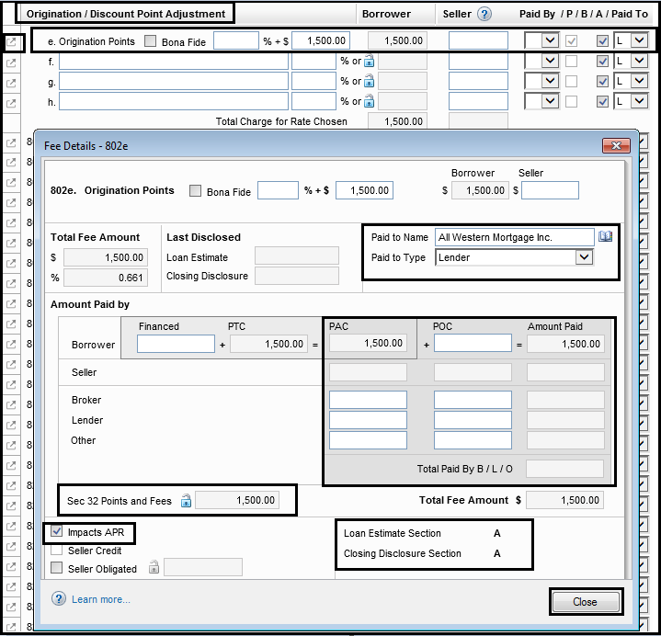Encompass >> Forms >> 2015 Itemization

1. Verify / Update Paid to name as “All Western Mortgage Inc.”
2. Update / Verify amount under Borrower or Seller Column as per LE. Please note; if Loan discount points are paid by Broker / Lender or Other, Select the appropriate letter from “Paid by” Dropdown. i.e. B / L / O
3. Paid to Type will always be “Lender”.
4. Letter A – stands for APR. Discount points fees are APR fees so it must be checked.
5. Click on this box to view the summary of fees and ensure you verify the highlighted details mentioned on above screen shot. PAC – stands for Paid at Closing, POC stands for Paid Out side Closing.
6. Check the bottom of screen shot which states that this fee will show in Sec-A of CD. You need to make sure that fee is going in correct section.
7. “Impacts APR” it will always checked for loan discount points.

\*\***REMARKS**\*\* - If there is discount / origination points on any of the loan then **“Bonafide button”** must be checked from above screen shot.

1. **803 – 835 Series –** We will verify / update Appraisal fee, Appraisal re-inspection, Credit report fee, Tax service, Upfront MI Premium whenever it is applicable as per attached LE’s, Initial CD / COC CD & Invoices.

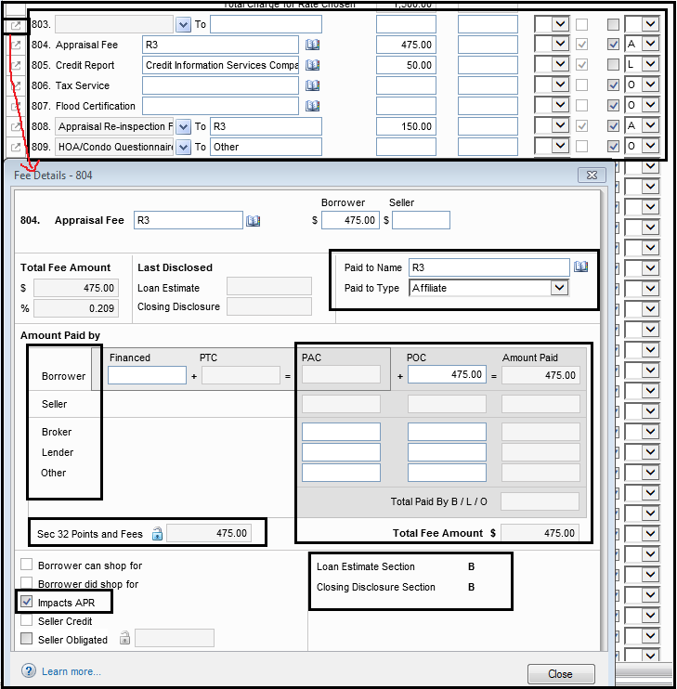

Encompass >> Forms >> 2015 Itemization

1. Update / Verify Paid to name as “the Service provider” as per attached Invoice. Update / Verify amount under Borrower or Seller Column as per Invoice. Please note; if these fees are paid by Broker / Lender or Other, Select the appropriate letter from “Paid by” Dropdown. i.e. B / L / O
2. Paid to Type can be “Affiliate (A)” or “Lender(L)” or “Other(O)”.

Ex; When AMC is R3 for Appraisal / re-inspection fees then ensure “Paid to Type” is always selected as “Affiliate (A) “ or else it will be “Others (O)” for all other AMC’s.

For Credit Report fee, Paid to Type will always as “Lender(L)”

1. Letter A – stands for APR. Appraisal fees with R3 AMC is always APR fees otherwise it will be Non-APR. Credit Report fee will be Non-APR, UFMIP will always APR checked.
2. Click on this box to view the summary of fees and ensure you verify the highlighted details mentioned on above screen shot. PAC – stands for Paid at Closing, POC stands for Paid Out side Closing.
3. Check the bottom of screen shot which states that this fee will show in Sec-B of CD. You need to make sure that fee is going in correct section.
4. “Impacts APR” it will always checked for APR related fees only.
5. **900 Section – Items required by Lender to be paid in Advance (Sec-F) –** We will verify / update Prepaid interest, Home owner insurance premium , Flood insurance Premium (when applicable) and Property / special assessment / supplemental taxes whenever it is applicable as per attached HOI / Flood Invoices or updated tax summary. These fees are always Non-APR except Prepaid interest.

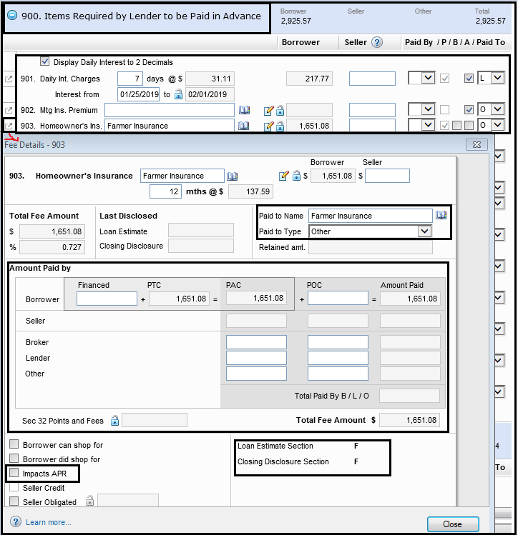Encompass >> Forms >> 2015 Itemization

1. Verify / Update Paid to name as “the Service provider” as per attached HOI / Flood Invoice. Update / Verify amount under Borrower or Seller Column as per Invoice. Please note; if these fees are paid by Broker / Lender or Other, Select the appropriate letter from “Paid by” Dropdown. i.e. B / L / O
2. Paid to Type will always as “Other(O)”except Prepaid interest which will have as “Lender (L)”.
3. Letter A – stands for APR. All fees from this section will be considered as Non-APR so button must be unchecked except Prepaid interest which is an APR Fee.
4. Click on this box to view the summary of fees and ensure you verify the highlighted details mentioned on above screen shot. PAC – stands for Paid at Closing, POC stands for Paid Out side Closing.
5. Check the bottom of screen shot which states that this fee will show in Sec-F of CD. You need to make sure that fee is going in correct section.
6. “Impacts APR” it will always un-checked for all Sec-F fees except Prepaid interest.

**\*\*IMP NOTES** -** Docs team to ensure 901. Prepaid interest – “**Display Daily Interest to 2 Decimals**” button is always **UNCHECKED.** CD must show 4 Decimals for prepaid interest.

1. **1000 Section – Reserves Deposited with Lender (Sec-G – Impounds / Escrow) –** We will verify monthly Home owner insurance premium , Flood insurance Premium (when applicable) , Mortgage Insurance Premium (when applicable) and Property / special assessment / supplemental taxes are correctly updated or not. This Section will auto fill up when we complete “**Aggregate Escrow Account**” Form in Encompass.

**\*\*IMPORTAN NOTE** -** Do not make any changes to cushions here as it auto-calculates from system when you complete Aggregate Escrow account form. Refer Step-20 from this SOP about how to complete Aggregate Escrow Account form.

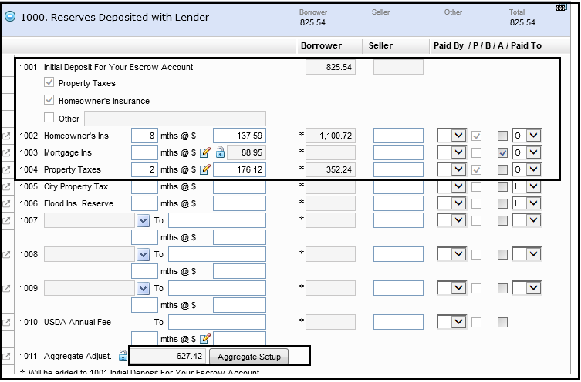

Encompass >> Forms >> 2015 Itemization

1. Paid to Type will always as “Other (O)” for all fees here.
2. Letter A – stands for APR. All fees from this section will be considered as Non-APR so button must be unchecked except Monthly Mortgage Insurance which is an APR Fee.
3. Amounts will always paid by “Borrower”
4. Click on Aggregate Set Up if you want to re-check your Tax / Insurance / Mortgage Insurance due dates and cushion months and make changes if required.

**VERIFY IMPOUNDS**

We also must verify whether LE is reflecting Impounds as Yes or No. Then we must cross verify it along with the Lock details. Please refer screenshot provided below:

Go to **TOOLS** then to **SECONDARY REGISTRATION,** then to **CURRENT LOAN INFO** and under **TRANSACTION DETAILS** you will get **IMPOUNDS** and that should match with last disclosed LE. If they are mismatch, then confirm with processor/LO and then get it corrected whichever needed.

PLEASE note that the CD must match the lock details for Impounds, if they are different then Lock desk need to correct accordingly encompass (if needed)

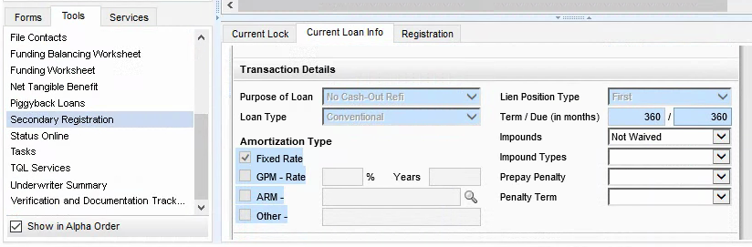

1. 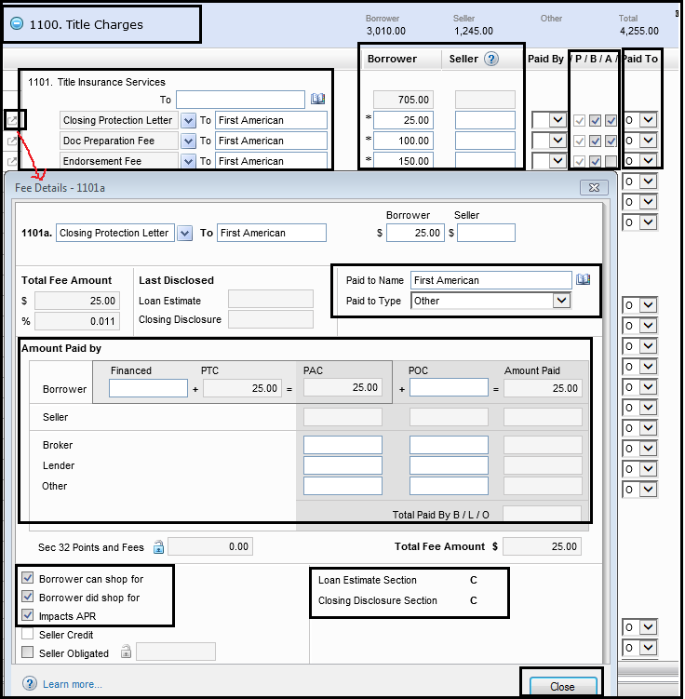**1100 Series – Title Charges (Sec-B or Sec-C Fees) –** We will only verify All Title related fees are correctly updated by CD Team as APR or not and Service provide listed on LE and Title report are same or not.

Encompass >> Forms >> 2015 Itemization

1. Paid to Type will always be “Other(O)” for this section.
2. Letter B – stands for Borrower choose the Service Provider or not.
   * + - If Title Company on Service provider list is the same as Company we are closing with, All Title fees **will fall** under 10% tolerance and will be moved to Sec-B of CD. Make sure “B” box is Unchecked in this case.
       - If Title Company on Service provider list is different than the Company we are closing with, All Title fees **will not** fall under 10% tolerance and will be moved to Sec-C of CD. Make Sure “B” box is checked in this case.
3. Letter A – stands for APR. You need to determine which fees are APR and which are not and check the “A” box accordingly. Refer attached CFPB APR Fee list for your reference.



1. Click on this box to view the summary of fees and ensure you verify the highlighted details mentioned on above screen shot. PAC – stands for Paid at Closing, POC stands for Paid Out side Closing.
2. Check the bottom of screen shot which states that this fee will show in Sec-B or Sec-C of CD, depend on Borrower did shop for or not. You need to make sure that fee is going in correct sections.
3. “Impacts APR” it will be checked or unchecked depends on which fee falls under APR / Non-APR.

\*\***IMPORTANT NOTE**\*\* - There will be Title – Owner’s Coverage Premium too under this section however it falls under Sec-H but need to updated here and system will put it under correct section on CD.

1. **1200 Series – Government Recording & Transfer Charges (Sec-E Fees) –** We will verify All Recording & Transfer tax related fees as per attached LE’s & what is taken on Initial CD to identify cures.

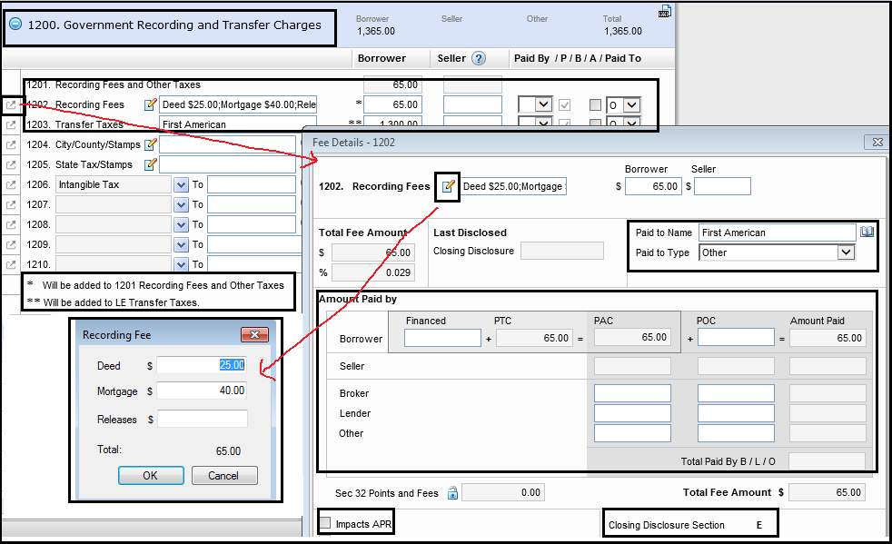

Encompass >> Forms >> 2015 Itemization

1. Paid to Type will always be “Other(O)” for this section.
2. Letter A – stands for APR. All fees will be Non-APR for this Section so it must be unchecked for all Recording & Transfer tax charges.
3. Click on this box to view the summary of fees and ensure you verify the highlighted details mentioned on above screen shot. PAC – stands for Paid at Closing, POC stands for Paid Out side Closing.
4. Click on this box  to categorize the Recording fee for Deed / Mortgage / Release or any other recording fees
5. If you see on above screen shot as there are notes for your reference.

* **\*Will be added to 1201 Recording Fees & Other Taxes – fees which have been added only One “*” star will go under Recording fee boxes**
* **\*\* Will be added to LE Transfer Tax - Make sure Transfer tax are added under fees which has two “**” stars so it goes on correct section of CD.**

1. Check the bottom of screen shot which states that this fee will show in Sec-E. You need to make sure that fee is going in correct sections.
2. “Impacts APR” it will be always unchecked as Sec-E fees are Non-APR’s.
3. 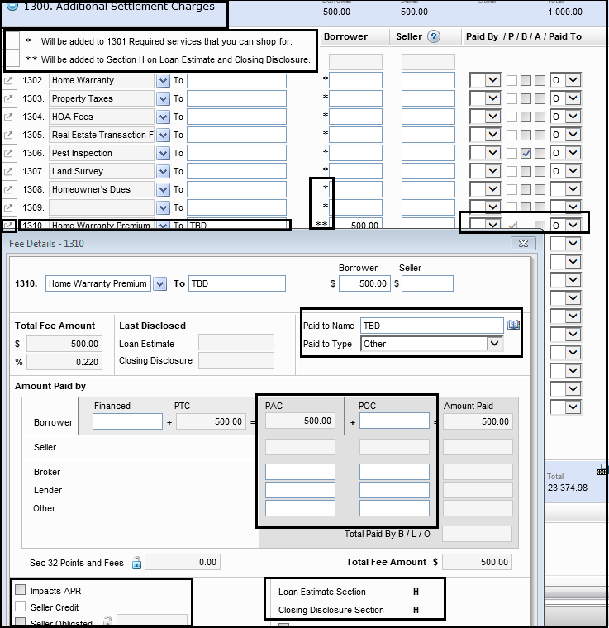**1300 Series – Additional Settlement Charges (Sec-H Fees) –** We will only verify if there is any Home Inspection / Pest Inspection / EMD Refunded or not.

Encompass >> Forms >> 2015 Itemization

1. Paid to Type will always be “Other(O)” for this section.
2. Letter A – stands for APR. All fees will be Non-APR for this Section so it must be unchecked for all these settlement charges.
3. Click on this box to view the summary of fees and ensure you verify the highlighted details mentioned on above screen shot. PAC – stands for Paid at Closing, POC stands for Paid Out side Closing.
4. If you see on above screen shot as there are notes for your reference.

* **\*Will be added to 1301 Required Services that you can shop for – fees which have been added only One “*” star will go under Sec-B / C fees depend on Letter “B” is checked or not.**
  + **\*\* Will be added to Section H on LE & CD Section.**

1. Check the bottom of screen shot which states that this fee will show in Sec-H. You need to make sure that fee is going in correct sections.
2. “Impacts APR” it will be always unchecked as Sec-H fees are Non-APR’s.

\***NOTES**\* - You will see certain boxes that will pop up that is “Seller Credit” and “Seller Obligated”. Be mindful when to check these boxes and when to not.

a) Seller Credit – If any fees are to be paid by Seller and if you want to itemize any Buyer charged cost from Seller credit especially on VA loans then this box needs to be checked.

1. Seller Obligated – this button needs to be checked when Responsible party is Seller & fee is also payable by Seller. It will not be considered from Seller credit when this button is checked. You need to mindful while any fees you are putting as charge on Seller side. You need to check this box as well if it is seller responsible fees otherwise it will be count from Seller credit.

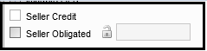

1. **1400 Series – Total Estimate Settlement Charges –** We will verify / update any Lender / Seller credit we have as per attached LE’s, Purchase Contract / addendum & Initial / COC CD.You can also check MIP Refund here under highlighted section if there is any. FYI – Only Lender / Seller credit reflects on CD if it is updated here however MIP Refund won’t go and you will need to update it manually under CD page-3 >> Liability / Payoff Statement section.

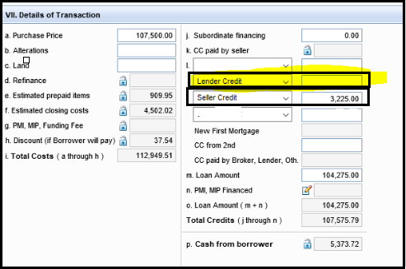**\*NOTE – Lender credit & Seller credit must be updated under highlighted section as show below and nowhere else.If you see Seller credit updated on this screen and is not mentioned on contract or any addendum given, then you have to ask processor to provide it but do not remove Seller credit without LO / Processor’s concern.**

Encompass >> Forms >> 2015 Itemization

**STEP-21**: **Fee Variance –** Next Form in Encompass where we have to identify Zero, 10% tolerance cures are to be updated / verified.

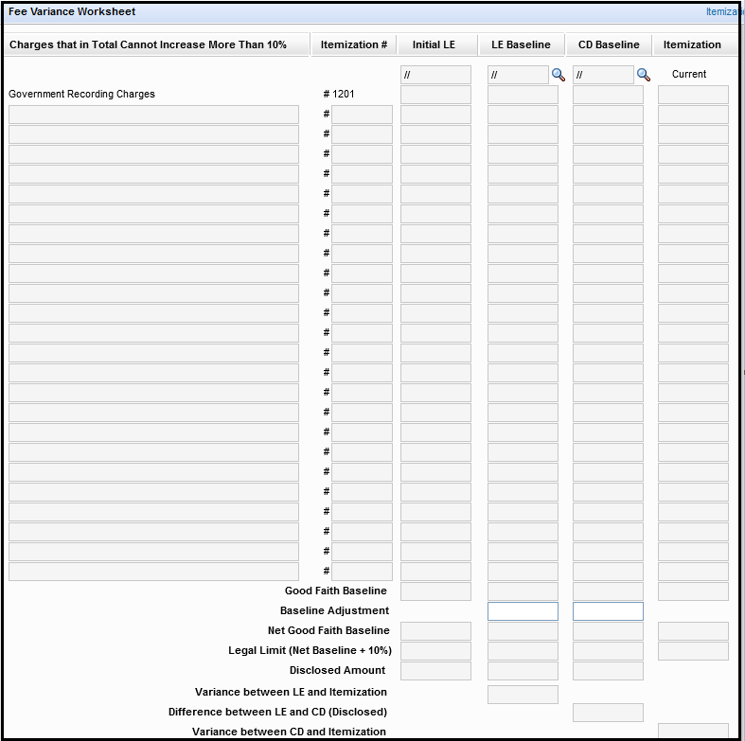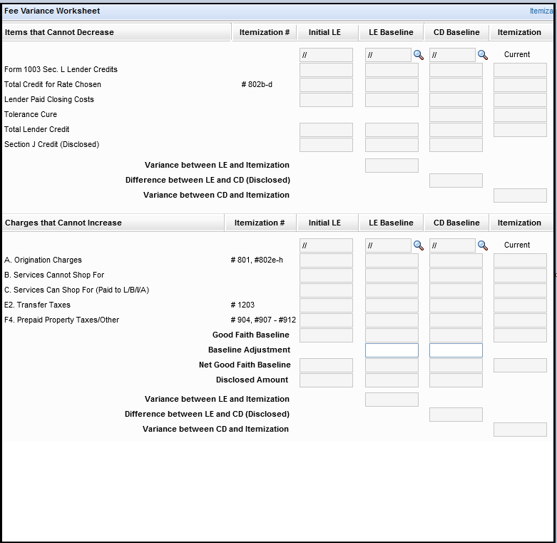Encompass >> Tools >> Fee Variance Worksheet

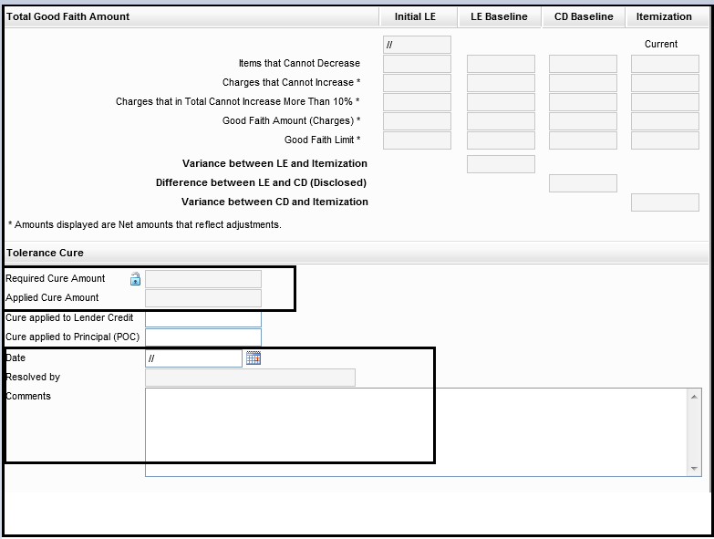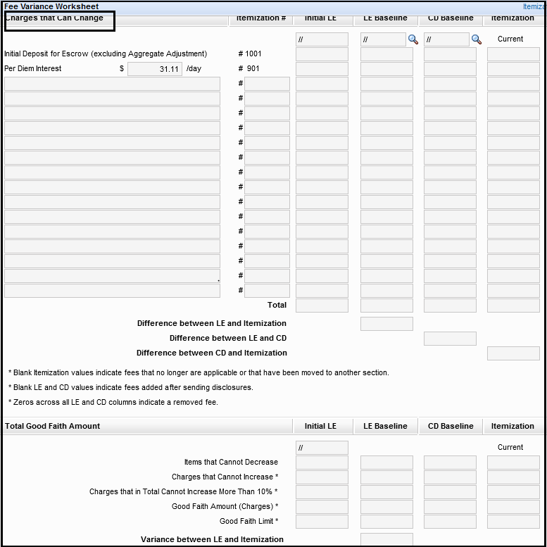Encompass >> Tools >> Fee Variance Worksheet

\*\***Tolerance Cure**\*\*

1. Identify Required Cure amount – this will auto calculate depend on fee disclosed on LE & CD. You can manually enter the amount too.
2. Applied Cure Amount – this will auto calculate depend on once you update cure under line-3
3. Cure applied to Lender Credit – Verify / Update required cure amount (per line-1) under this line.
4. Cure Applied to Principal (POC) - Only when needed
5. Date – Update the day if you apply any new cures otherwise keep the same what it shows. Do not change the date if CD team has applied cures on transaction.
6. Resolved By – Your name & Comments – Update if you apply / revise any cures with short details of for which fees cure is applied.

**STEP-22**: **Closing Disclosure – 1 –** Next Form in Encompass where only highlighted details related to Loan is updated / verified with attached documents.

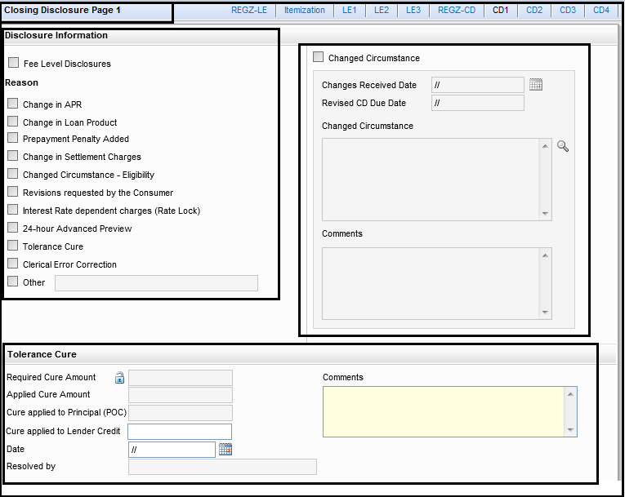

Encompass >> Forms >> Closing Disclosure – 1

\*\***NOTE**\*\* -

1. **Disclosure Information** – This section is needed only when there is any COC CD requirement comes after Initial CD is sent out to borrower. COC CD team will update this section in order to create COC CD on particular file.

**\*\*REMARKS** - 2nd COC CD requirement for Closing date extension**: If a COC CD is issued that changes the borrower costs of the loan (origination charges i.e. loan discounts) and/or changes the loan product/type before consummation of the loan. However, the loan MUST close within 7 business days of receiving the COC CD.

If the loan does not close within the 7 business days and Processor request to redraw the file for change in signing date which is after 7 days of Initial Docs drawn, Docs drawer to ensure there is an additional COC CD attached in the file identifying “borrower requested change in closing date to be extended”.

These timelines apply when a COC CD is included in the loan file. Verbiage required on the COC CD Details:

“**Extension to the closing date per borrower request**”.

**Remarks – COC CD requirement–**

* **There is NO required 3 day waiting period when**:

A COC (CIC) CD is issued that:

1. Renders the APR “inaccurate”

Inaccurate = decrease in APR from Initial CD

* **There IS a required 3 day waiting period when**:

A COC (CIC) CD is issued that:

1. Renders the APR “inaccurate”

(increase in APR of >.125%)

1. Changes the loan “product” =
2. switch from Jumbo to Conforming (or vice versa), Conforming to Government (or vice versa), FHA to VA (or vice versa).
3. Any change to amortization: Fixed to Arm (or vice versa)
4. Change from an Interest only fixed rate to normal Fixed rate loan

OR

1. Adds a prepayment penalty
2. **Tolerance Cure** – You will see Tolerance cure details here which were updated in Fee Variance Worksheet. Docs team needs to double check this if cures are correctly applied or make any changes if needed so.

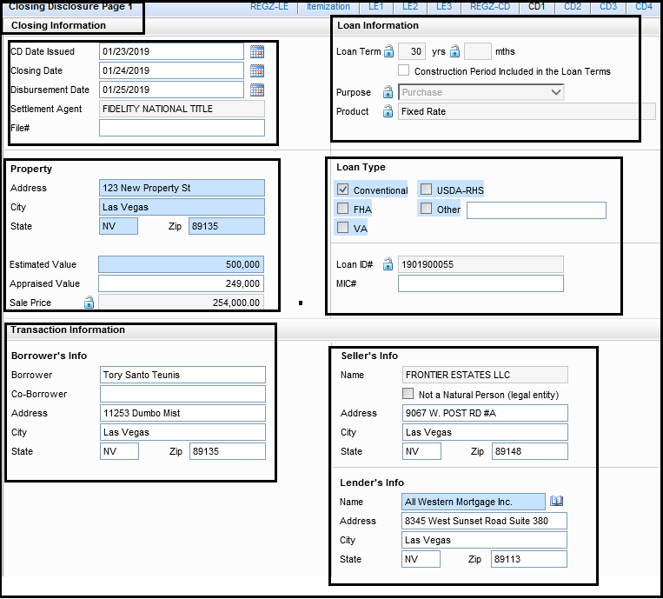Encompass >> Forms >> Closing Disclosure – 1

Below are the details that to verify while working on this section:

1. **Closing Information**:
2. **CD Date Issued** – Update the same date as your Closing Date.
3. Settlement Agent – Verify If settlement agent name is updated correctly
4. File# - Verify Escrow order number as per attached Title report
5. **Loan Information**:
6. Loan Term – Verify if loan term is correctly updated in (yrs). Please make sure you **do not** check the Box updated as “**Construction Period included in the Loan terms**”. Consult with you team lead when it applies only on Construction loans.
7. Purpose – Verify / Update Purpose as “Purchase” or “Refinance” or “Construction” or “Home Equity” as per transaction.
8. Product: Verify if Product is updated correctly whether Fixed Rate / Adjustable rate as per transaction.
9. **Property** :
10. Property address – Verify Property address with all attached documents (like Initial 1003, USPS, Tax Summary, HOI, Title report, Purchase Contract, Appraisal report etc…)

If there is any discrepancy, it will be Docs Team’s final call for correct address and to add required PTF Condition for Incorrect documents. Final address should be valid as per Tax certificate, USPS and as per County records.

1. Appraised Value – Verify / Update Appraised value with attached Appraisal report& Last CD.
2. Sales Price – Verify / Update Sales Price with attached Purchase Contract / addendum & last CD.

**\*\*NOTE\*\***- If there is AM West Builder loan and if Base Sales Price is updated under CD page-1 & 3 then DOCS team have to re-update the Final / Contract Sales price as per attached Purchase agreement / addendum under CD page-1 & 3 in order to show the same on Final CD.

1. **Loan Type** :
2. Loan Type – Verify Loan type as per transaction and with Initial CD.
3. Loan ID# - It will be AWM Loan number. Just verify it is correctly updated.
4. MIC# - It will be your FHA / VA Case number and for Conventional >80% - it will be your Mortgage Certificate number whichever applies per transaction.
5. **Transaction Information** :
6. Borrower’s Info – Verify Borrower & Co-Borrower name and their present address with attached Final 1003 / Approval.
7. Seller’s Info – Make sure Seller’s name & address is updated here and it will come up from File Contacts under Tools tab.
8. Lender’s Info – Make sure Lender’s name & address is updated here and it will come up from File Contacts under Tools tab or you can select it from Business contacts too.

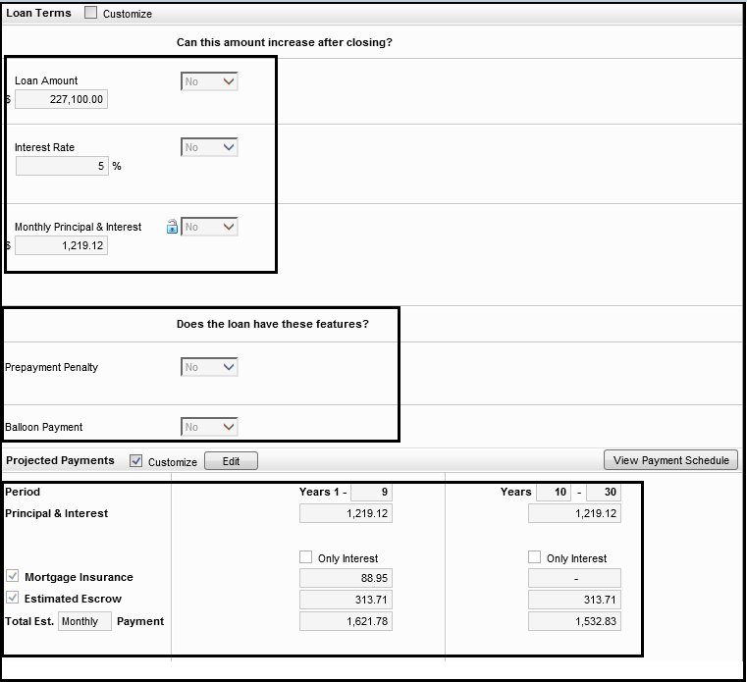Encompass >> Forms >> Closing Disclosure – 1

1. **Loan Terms** :
2. Loan amount, Interest rate, Monthly Principal & Interest – Verify loan amount , interest rate & monthly principal & interest with attached last LE, Initial CD / COC CD, Approval Final / 1003.

Please note that “Can this amount Increase after Closing? – will always selected as “**NO**” on all transactions.

1. Prepayment Penalty & Balloon Payment – always selected as **NO.**

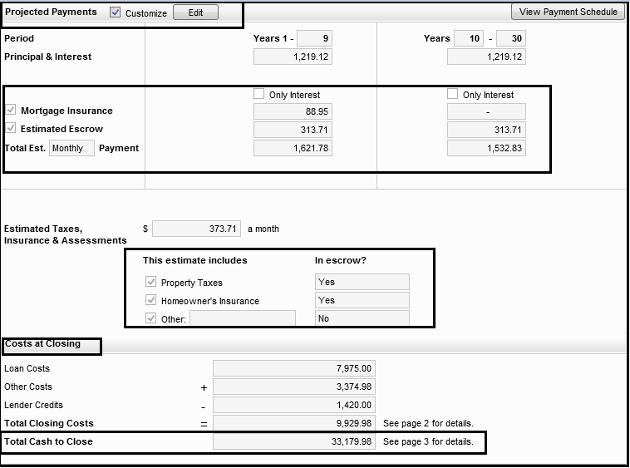Encompass >> Forms >> Closing Disclosure – 1

1. **Projected Payments** :
2. Projected Payments – Verify your monthly Mortgage Insurance (if applicable), Estimated Escrow are populated correctly as per what you have updated in your Aggregate Escrow account form.
3. Estimated Taxes, Insurance & Assessments – Boxes would have been checked as per what is Impounded and what is not on your Aggregate Escrow statement and have to verify the same with your Last LE.
4. Costs at Closing – it includes your loan & other costs, lender credit, Total Closing Cost and lastly Total Cash to Close which needs to be verify before Sending DOCS to all parties..

**STEP-23**: **Closing Disclosure – 2 –** Next Form in Encompass where only highlighted details related to Loan is updated / verified with attached documents.

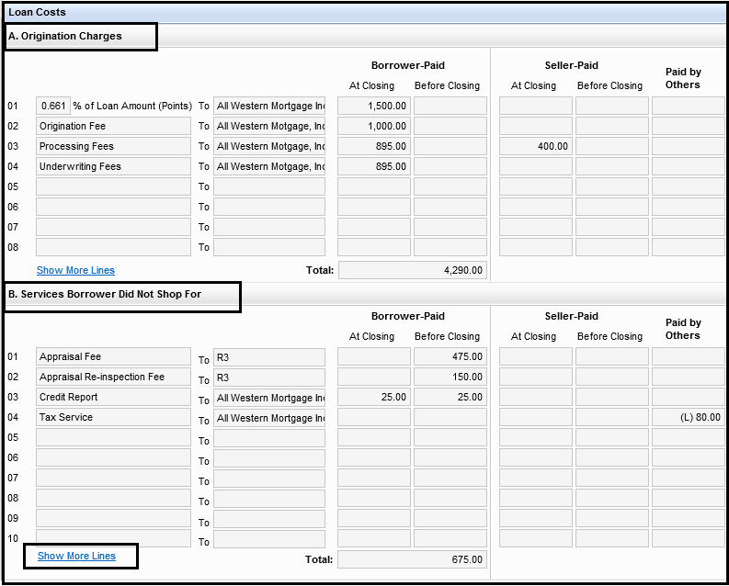Encompass >> Forms >> Closing Disclosure – 2

1. **Loan Costs**:
2. A. Origination Charges – All sec-A fees will be populated here as per what you have updated / verified on 2015 Itemization form. You just need to verify if all your fees are having correct amounts at Closing(PAC) or Before Closing (POC) and updated under correct paid by Parties Column.
3. B. Services Borrower did not Shop for – All Sec-B fees will be populated here as per what you have verified / updated on 2015 Itemization form. You just need to verify if all your fees are having correct amounts at Closing(PAC) or Before Closing (POC) and updated under correct paid by Parties Column.

\*\***NOTE**\*\* - You can click on “**Show More Lines**” button if you are having more fees updated under any of the sections. Title fees will fall under Sec-B when Title Company on service list provider &Title Company you are closing with one and the same.

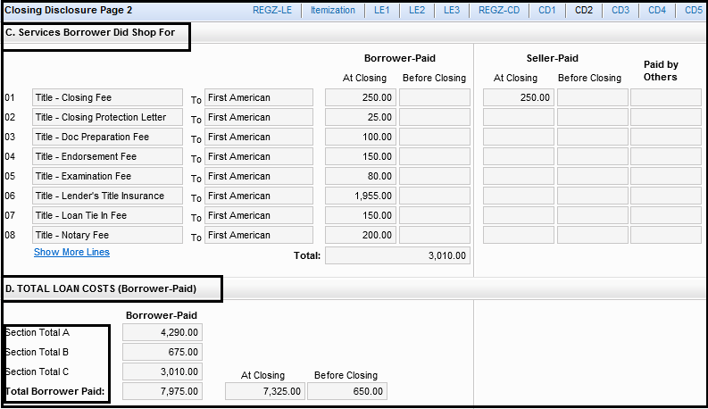

Encompass >> Forms >> Closing Disclosure – 2

1. C. Services Borrower Did Shop for – All Sec-C fees will be populated here as per what you haveverified / updated on 2015 Itemization form. You just need to verify if all your fees are having correct amounts at Closing(PAC) or Before Closing (POC) and updated under correct paid by Parties Column.

\*\***NOTE**\*\* - You can click on “**Show More Lines**” button if you are having more fees updated under any of the sections. Title fees will fall under Sec-C when Title Company on service list provider & Title Company you are closing with are not same.

1. D. Total Loan Costs: this section shows your Total summary of Sec- A to C.

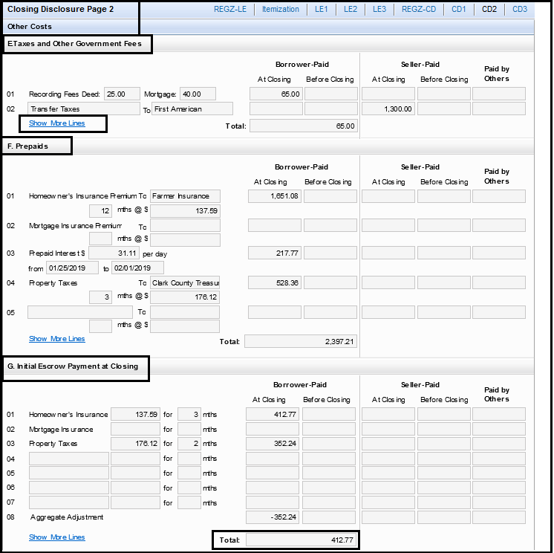Encompass >> Forms >> Closing Disclosure – 2

1. **Other Costs**:
   1. E. Taxes & Other Government Fees – All sec-E fees will be populated here as per what you have verified / updated on 2015 Itemization form. You just need to verify if all your fees are having correct amounts at Closing(PAC) or Before Closing (POC) and updated under correct paid by Parties Column.
   2. F. Prepaids – All Sec-F fees will be populated here as per what you have verified / updated on 2015 Itemization form. You just need to verify if all your fees are having correct amounts at Closing(PAC) or Before Closing (POC) and updated under correct paid by Parties Column.

\*\***NOTE**\*\* - You can click on “**Show More Lines**” button if you are having more fees updated under any of the sections.

* 1. G. Initial Escrow Payment at Closing – All Sec-G fees will be populated here as per what you have verified / updated on 2015 Itemization and Aggregate Escrow Account form. You just need to verify if all your fees are having correct amounts at Closing(PAC) or Before Closing (POC) and updated under correct paid by Parties Column.

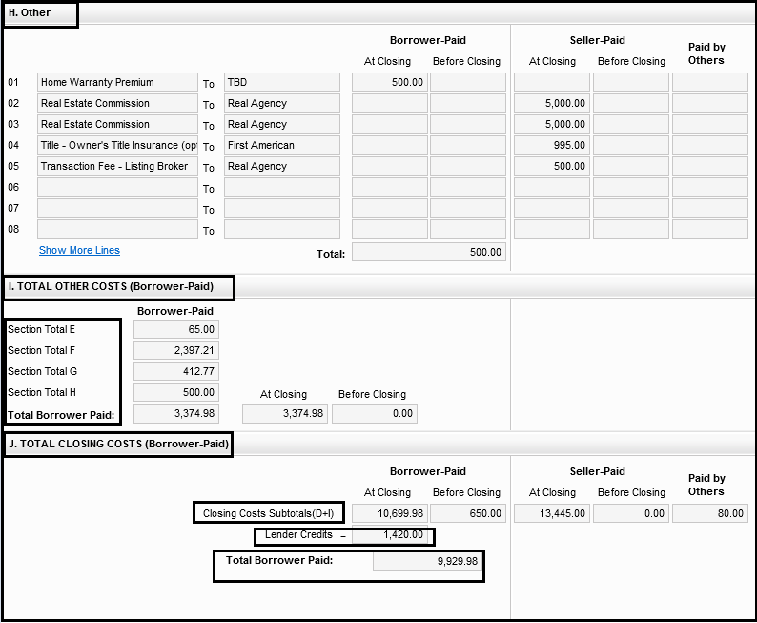

Encompass >> Forms >> Closing Disclosure – 2

* 1. H. Other – All Sec-H fees will be populated here as per what you have verified / updated on 2015 Itemization form. You just need to verify if all your fees are having correct amounts at Closing(PAC) or Before Closing (POC) and updated under correct paid by Parties Column.
  2. I. Total Other Costs – this section shows your Total summary of Sec- E to H.
  3. J. Total Closing Costs: this section shows your Total summary of Sec- D + I and if Total Lender credits (includes cost to cure) if any.

**STEP-24**: **Closing Disclosure – 3 –** Next Form in Encompass where only highlighted details related to Loan is updated / verified with attached documents.

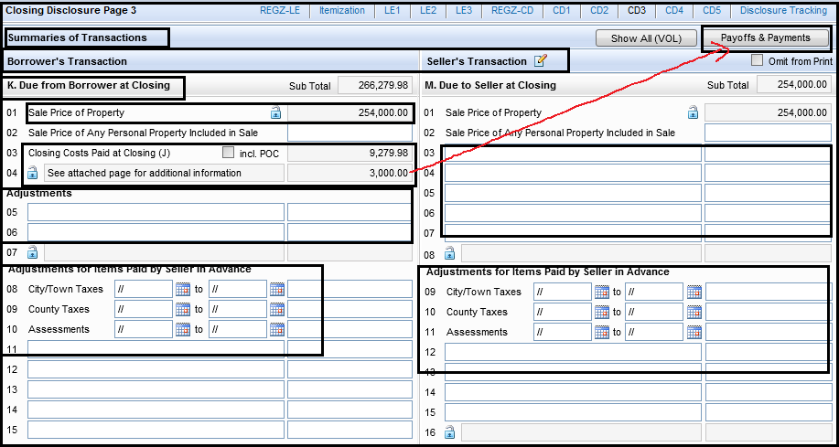

Encompass >> Forms >> Closing Disclosure – 3

1. **Summaries of Transactions:** We will start with “Summary of Transactions” first when we reach at CD page-3 during review. FYI – If Transaction is refinance then this page will be only showing Liabilities / Payoff section.
2. **Section – K& M – Due from Borrower at closing& Due to Seller at Closing** –
   1. Line – 4 – This is usually to add if any “Principal reduction to Borrower”

(When needed) or “Additional Payoff or debts” to add on transaction as per UW’s Condition.

\***How to Add Principal reduction to Borrower**?*

- Click on “Payoffs & Payments” button from above screen shot

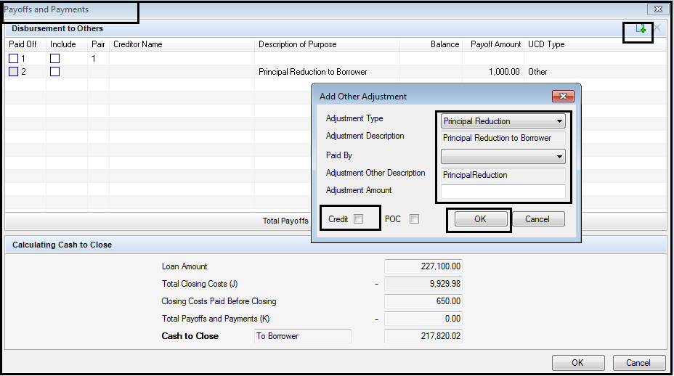- Click on “Plus” icon on right corner of the below screen and update Principal reduction details and Click Ok. FYI – You will check “Credit” box if we are adjusting Principal reduction from Excess Credit rate otherwise not.

\***How to Add Additional debts or payoff(s)**?*

- Go to Calculation Cash to Close Section and select the Pen box under “Adjustment and Other Credits” show under below screen.

- Go to UCD side tab and you will find line – 4 – Due from Borrower at Closing where you can add up multiple debts or Payoff as per UW Conditions.

- Find the location of “UW Conditions” from Encompass>>e-Folder>> UW Conditions.

**IMP UPDATEon Payoff(s)**-When the PTF condition(s) identify debt payoff is required through closing, the following steps must be followed:

1. At Con / Final CD must reflect full name of creditor and full account numbers for any item listed as a required payoff. Until the payoff’s (if applicable) are received in the file, the creditor name and account number from ENC form 1003 must be displayed on the CD.
2. Lenders Instructions to Escrow: must identify ALL PTF conditions, to include, but not limited to any/all required debt payoff. The Lenders Instructions to Escrow must also identify the creditor name and full account number.

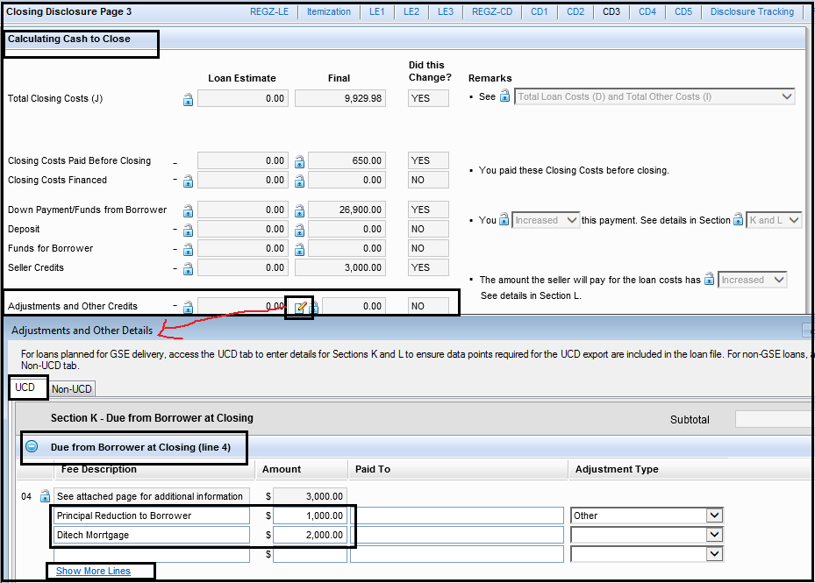

1. 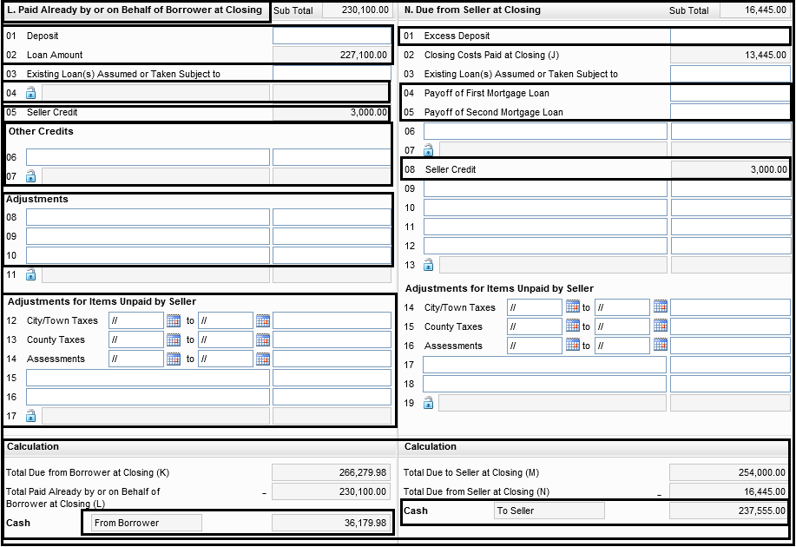**Section – L&N – Paid already by on or behalf of Borrower at Closing (Due to Borrower at closing ) & Due from Seller at Closing** –

Encompass >> Forms >> Closing Disclosure – 3

* 1. Line -1 – Deposit / Excess Deposit – Verify Deposit / EMD / Options if any as per UW’s Condition and Last CD.
  2. Line – 4 (Sec-L) – This is usually to add if you have Subordinate Financing. You can click on lock button in order to verify / update manually
  3. Line – 5 (Sec-L) & Line – 8 (Sec-N) – Seller Credit – This one will be populated as per what you have updated under 2015 Itemization form under Sec-1400 series.
  4. Line 6- 7 – You can add if any Other Credits to Borrower (Sec-L) or Seller (Sec-N) is to provide as per UW’s Condition or Agreement addendum Ex; Gift Funds , Buyer’s agent credit to Borrower.

1. **Calculation** – Verify entire UW’s Cash to Close Condition in Encompass to identify if Borrower is coming with enough Cash at Closing & meeting the minimum / maximum investment requirement or not on Final CD.

In Addition, DOCS Drawer must have to check IPC Max Credit limits from UW’s Cash to Close condition to ensure the current credits (Seller / Agent) doesn’t exceed than allowable limit. (refer guidelines for IPC Max Credit limit based on loan types)



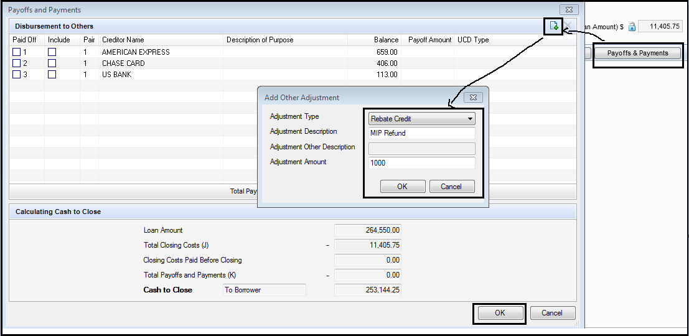\***How to Add / Verify Additional debts or payoff(s) or MIP Refund in Refinance Transaction**?*

Encompass >> Forms >> Closing Disclosure – 3 >> Payoff & Payments

1. Click on Payoffs & Payments
2. Click on Add New Icon
3. 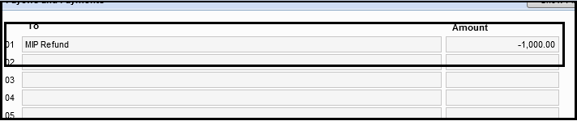Select Adjustment Type as “Rebate Credit”, update Adjustment Description as **MIP Refund** and the amount as per refinance authorization document.
4. Click OK and this is how it will reflect on your CD page-3.
5. If you want add **Additional Debt(s) or Payoff** as per UW’s Condition then add it up under Adjustment Type “**Other**”, Update description field and amount. Make sure “**Credit**” button is not checked when you add any additional debt(s) on CD under “Others”
6. 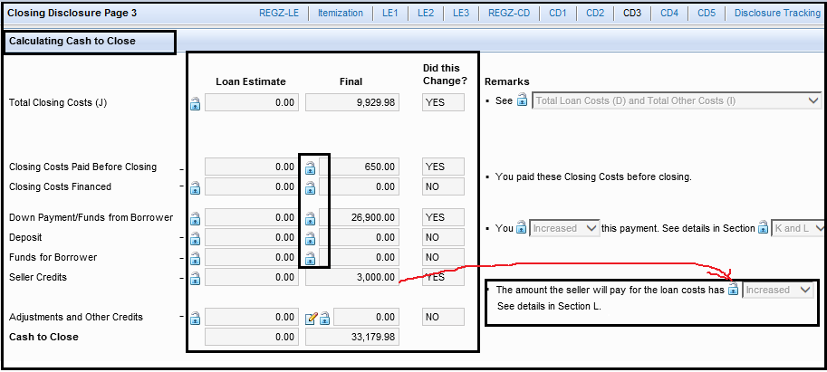**Calculating Cash to Close:** The last Section to verify on CD page-3 as follow:

Encompass >> Forms >> Closing Disclosure – 3

1. Total Closing Costs (J) – This will be auto populated – Do not make any changes to it (on Purchase Transaction). Verify / Update Last LE figure on LE side and ensure “Did this Change” is updated correctly
2. Closing Cost Paid Before Closing – NO review required for this section
3. Closing Costs Financed – Verify / Update amount on LE side from last LE if given. No changes on CD side to be done
4. Down Payments / Funds from Borrower – Verify / Update amount on LE side from Last LE. No changes on CD side to be done and ensure “Did this Change” is updated correctly
5. Deposit – Verify / Update amount on LE side from Last LE. No changes on CD side to be done and ensure “Did this Change” is updated correctly
6. Funds for Borrower – Verify / Update amount on LE side from Last LE. No changes on CD side to be done and ensure “Did this Change” is updated correctly
7. Seller Credits – Verify / Update amount on LE side from Last LE. No changes on CD side to be done and ensure “Did this Change” is updated correctly
8. Adjustments and Other Credits – Verify / Update amount on LE side from Last LE. No changes on CD side to be done and ensure “Did this Change” is updated correctly.

**STEP-25**: **Closing Disclosure – 4 –** Next Form in Encompass where only highlighted details related to Loan is updated / verified with attached documents.

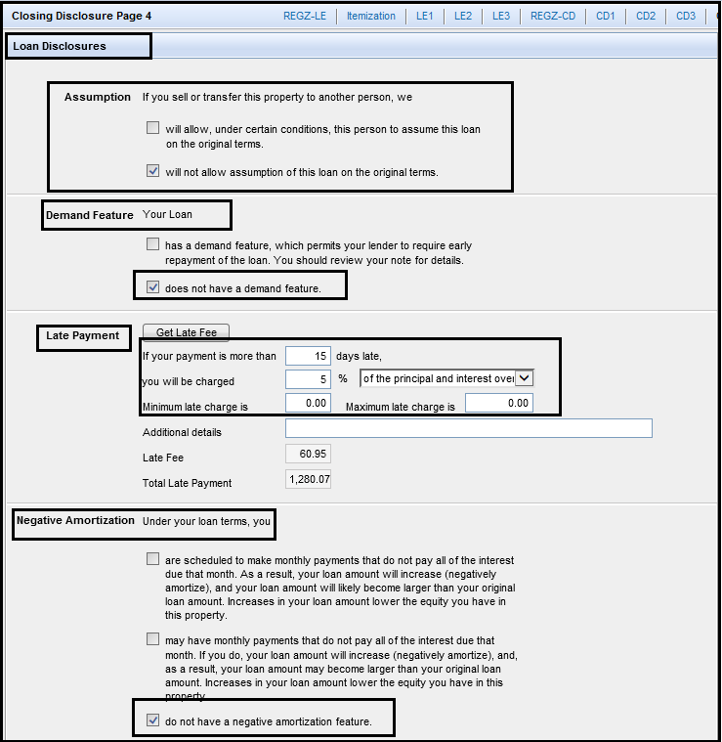

Encompass >> Forms >> Closing Disclosure – 4

This is very much important section to determine which boxes to be checked while reviewing **Loan Disclosures** section.

1. **Assumption**: Docs team to ensure which box to be checked as per the loan type;
2. For FHA, VA & USDA &Fixed Amortization– Always check “**Assumption will allow**” box.
3. For All Conventional & Fixed Amortization – Always check “**Assumption will not allow**” box.
4. For Conventional & Adjustable (ARM) Amortization locked with Chase, SGCP, Wellsfargo ,Caliber Non-Agency ARM, Rushmore & TIAA investors then “**Assumption will allow**” box must be checked. Assumptions will be NO on ARM loan with IMPAC, Galton Investor. DOCS team need to verify last LE as well if LE has correct box checked or not. If you find any new investor other than above list in ARM transaction then reach out to QC Manager if Assumption will be Yes or NOT before sending out Final Docs.
5. **Demand Feature**: This will always need to be checked as “**does not have a demand feature**” irrespective of any loan types.
6. **Late Payment**: Just verify if correct late payment information is updated or not:

If a payment is more than ______ days late – always ensure it reads 15 days.

You will be charged -

* 1. For Conventional – it is 5%
  2. For FHA, VA and USDA – it is 4%

Minimum & Maximum late charge – N/A or 0.00

1. **Negative Amortization:** This will always need to be checked as “**do not have a negative amortization feature**” irrespective of any loan types.

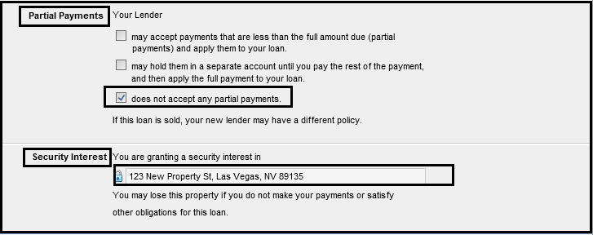

Encompass >> Forms >> Closing Disclosure – 4

1. **Partial Payments:** This will always need to be checked as “**does not accept any partial payments**” irrespective of any loan types.
2. **Security Interest:** Just ensure Property address is updated here correctly.

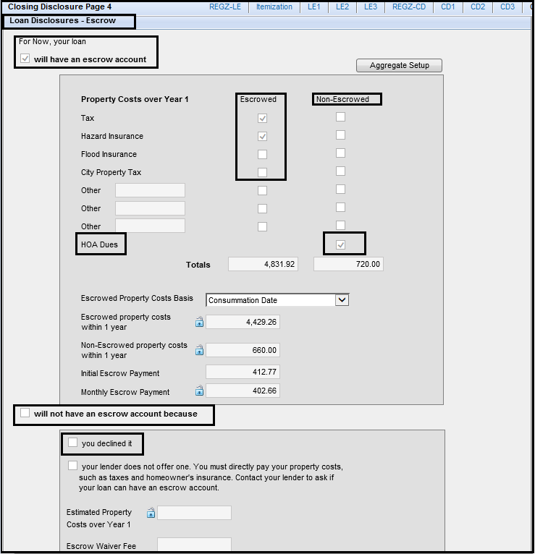Next Section to ensure correct boxes are checked while reviewing **Loan Disclosures-Escrow** section.

Encompass >> Forms >> Closing Disclosure – 4

1. **Will have an Escrow account**: Docs team to ensure this box will be auto-checked when Impounds are updated under Aggregate Escrow Account form. Team need to ensure correct fees is updated under “Escrowed” or “Non-Escrowed” section. This is directly related to 1003 page-2 form and Aggregate Escrow account form so you won’t be able to edit anything here. All other details need to be skipped in verification as they are auto-calculative.
2. **Will not have an Escrow account because**: This button will be auto-checked when there are no impounds updated under Aggregate Escrow account form. DOCS team need to ensure “**you declined it**” box is checked when there is no Impounds on the transaction. All other details need to be skipped in verification as they are auto-calculative.

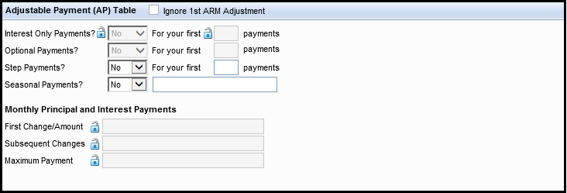Encompass >> Forms >> Closing Disclosure – 4

1. **Adjustable Payment (AP) Table:** This section will be auto-populated when transaction is Adjustable rate Mortgage (ARM) and will be mapped according to what has been updated under Reg-Z CD form. DOCS team need to verify this section with Last LE and Initial CD as well.

**STEP-26**: **Closing Disclosure – 5–** Next Form in Encompass where only highlighted details related to Loan is updated / verified with attached documents.

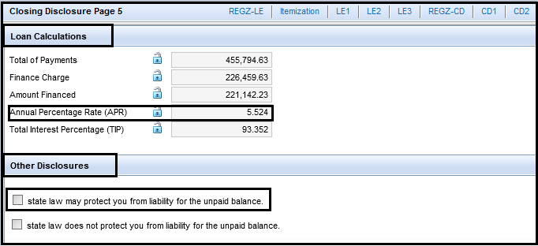

Encompass >> Forms >> Closing Disclosure – 5

1. **Loan Calculations:** This section is auto-calculated and Docs Team do not have to verify anything from it. There is **“Annual Percentage Rate (APR)”**that DOCS team will ensure APR is not hitting up more than 0.125 % on Final CD than what is on COC CD (if there is any). If it is increasing then there is additional 3 day waiting required before Closing Date. Please refer below notes related to it:
   * **There IS a required 3 day waiting period when**:

A COC (CIC) CD is issued that:

1. Renders the APR “inaccurate”

(increase in APR of >.125%)

1. Changes the loan “product” =
2. switch from Jumbo to Conforming (or vice versa), Conforming to Government (or vice versa), FHA to VA (or vice versa).
3. Any change to amortization: Fixed to Arm (or vice versa)

OR

1. Adds a prepayment penalty
2. **Other Disclosures:** This will always need to be checked as “**state law may protect you from liability for the unpaid balance**” irrespective of any loan types.

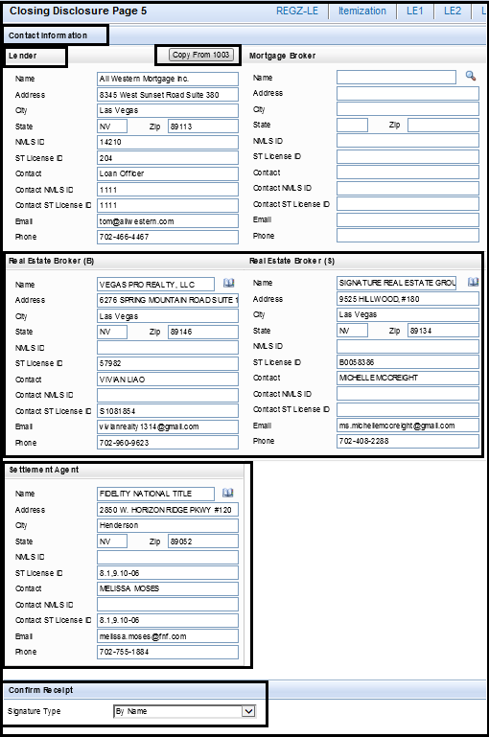

Encompass >> Forms >> Closing Disclosure – 5

1. **Contact Information:** Docs team to ensure Lender, Real Estate Broker (B & S – when required) and Settlement agent details are updated on this page. This will take this information from File Contacts where all this information are updated by Processing team or you can select it from Business contacts or it is free form of typing.

\*\***IMP NOTE**\*\* - Please click on “**Copy Form 1003**” button to get Lender information if it is updated blank. Mortgage Broker information will always blank as we do not deal in any Broker transaction.

1. **Confirm Receipt:** Docs team need to Select Signature type as “**By Name**” always.

**STEP-27**: **How to Run Mavent / Compliance Review Report before ordering Final Closing DOCS?**

1. Go to “**Tools**” and Click on “**Compliance Review**”

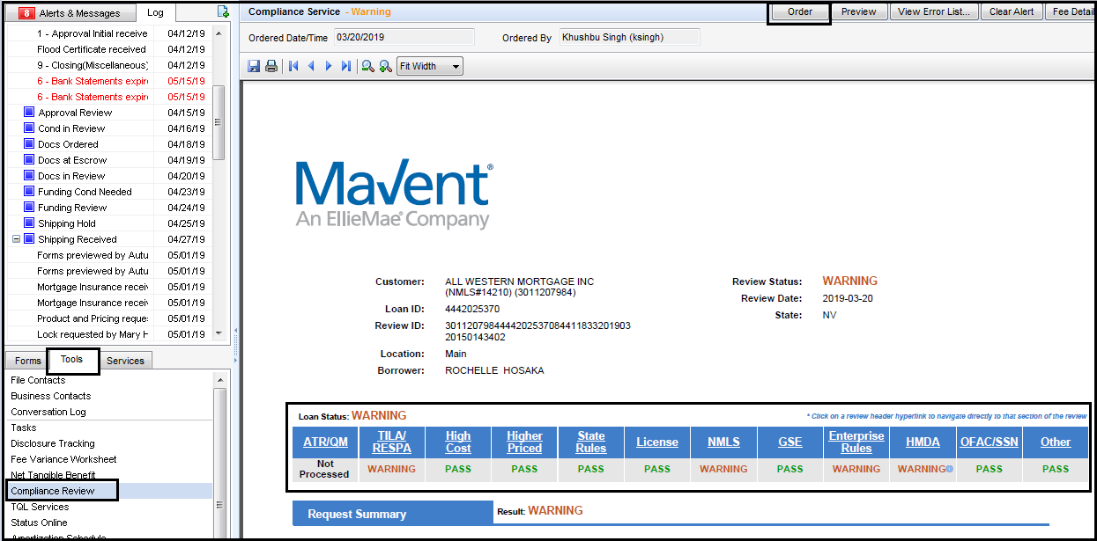

1. Click on Order button as show on above snapshot
2. Wait for few seconds to generate new Mavent report with your name populate on it.
3. Once Mavent report is generated, Check if we are failing on any stage or not. If you see fail on any Loan Status then inform your supervisor / team lead to review if fail is valid or not. Once it is confirmed by Team Lead, Proceed for Ordering Docs.

**STEP-28**: Update as “**Finished**” under Milestone Status “Docs Ordered” by checking on below box and update Comment under Milestone Comments “**DOCS Out on Date**”. If any error prevent to finish Docs order Milestone, It needs to be escalated and resolved prior to Order and send Closing DOCS to all parties. Please note that there should be not be any queries or Mavent issues pending before you perform this task and Closing Package must order and send out within few minutes after completing milestone.

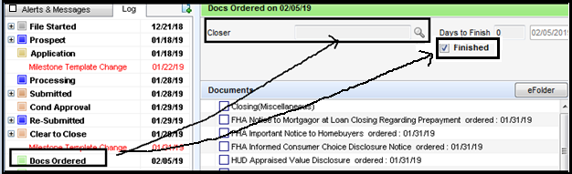

**STEP-29**: **How to Send Final DOCS to all parties (Escrow / Title , LO & Processors) ?**

1. Go to “Reg-Z CD” form and click on “Order Docs” button and wait for few seconds.



1. 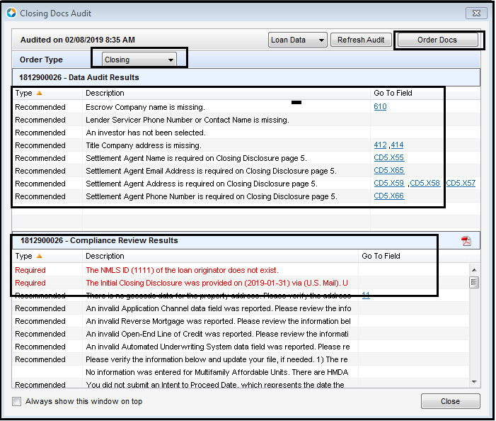Make sure you select Order Type as “**Closing**” always. Review Data audits and clear which are required to do so that are related to Final CD / DOCS only and Click on Order Docs button then.
2. Now, Select “All Closing Docs” and select preview if you want to see the document and to Save it as PDF to your desk , Click on Send button in order to send it to all parties i.e. Escrow / Title Company, LO & Processors.

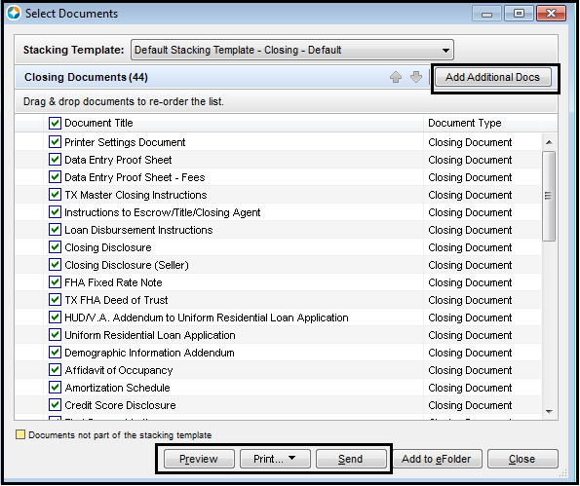

1. Remove / Uncheck Data Entry Proof Sheet, Data Entry Proof Sheet – Fees and Seller CD from Closing package before it is sent to all parties
2. If Property is under Nevada State then NV Repayment Ability Verification Worksheet doc needs to be unchecked from the closing package.
3. If file is draw without UW CTC then Final 1003 & 92900A is not need to be sent in the Closing package and need to uncheck.
4. When file is approved to draw without CTC as per Management request, Docs Team MUST need to attach “**Hold Harmless Disclosure and Closing Letter to Borrower disclosure”** with Closing package. Update AWM loan number and Borrower(s) name in form. (FYI – NO NBS & Only Borrower(s). Attach the same form in Additional documents and send it along with Closing package. Attached is the Hold Harmless disclosure blank sample for reference and Closing Letter to Borrower is available under Customs forms in Encompass which team need to use it when you receive DOCS request to draw without CTC.



1. Click **“ADD Additional DOCS”** and choose all the additional files which require to upload along with the closing package.
2. Additional docs to be signed(If Available under 9-Closing from Encompass)
3. Power of Attorney(If Applicable)
4. Attorney Package (Texas loans only)
5. Evidence of Insurance
6. Appraisal Invoice
7. Credit Report Invoice
8. Final Inspection Invoice(If Applicable)
9. Payoff’s (if any)

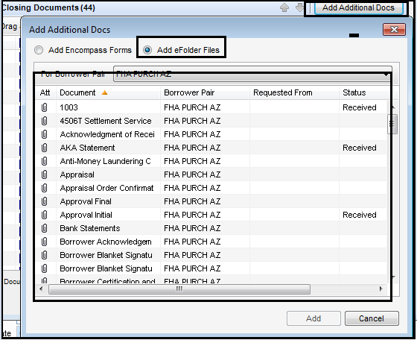

**\*\*IMP NOTES** -** Do not take Final 1003 / 92900A from e-folder as Additional DOCS. It has to go from what is generated in Closing package.

1. Now click on Send, You need to select highlighted details before you send it to all parties.

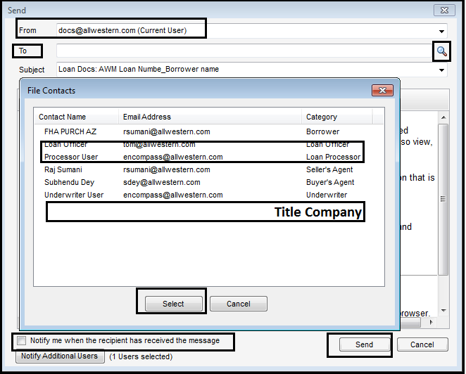

* To –Select on Search button and select LO, Processor, Title / Escrow Company and update [docs@allwestern.com](mailto:docs@allwestern.com) for monitoring purpose
* Subject – Loan Docs: AWM Loan number_Borrower name
* Click on Send and you will see successful Message.

**ADDITIONAL UPDATES:**

1. **Update on FLORIDA HHF DPA Program Loans**: Transfer tax / Documentary Stamp / Intangible TAX are exempted on both first & 2nd mortgages. We don’t have to charge this on CD even if it is disclosed on LE.

**REMEMBER – This is the guideline on FLORIDA HHF DPA Product only.**

1. **Update on Non-Borrowing Spouse(NBS) Requirement**: In community property states, on \***Refinance Primary – rescindable transactions**\*, the NBS must sign/acknowledge the CD’s, sign the NORTC and sign the security instrument.

If a QCD has already been executed and recorded, and vesting shows sole and separate, then the NORTC and the security instrument need NOT to be signed by the NBS.

A copy of the QCD must be identified on the prelim or a copy retained in our file.

\*\***IMP NOTES**\*\* - We have compliance confirmation that if there is a NBS that will NOT be on title (executing a QCD) to the subject property then the NBS does NOT need to sign/acknowledge the CD as the NBS is not considered a consumer on the transaction.So, the only time a NBS in a community property state needs to acknowledge the CD is if the NBS is going to be on title to the subject property. In Addition, If NBS name is not updated on Title report vesting in community states but now he/she is signing as Title only on DOCS, we still do not require NBS to sign the Initial CD. If NBS is vested in Title report and if he/she is signing as title only then signature must required for Initial CD by NBS.

Reach out to your Team lead immediately for further research if Non-Borrowing spouse name is not updated in Encompass or Initial CD is not signed by NBS

Here is the community property states list:

Arizona, California, Idaho, Louisiana, Nevada, New Mexico, Texas, Washington, Wisconsin

1. **UPDATE on DOCS Redrawn Request –** Whenever there is a request for redraw from LO or processor or any concerned person for any reasons,

You **MUST** need to verify **IMPORTANT** Points on the loan which should match with other documents (with CD / COC CD, Approval Final)

**IMPORTANT** Points to check will be:

* **LOAN AMOUNT,**
* **INTEREST RATE,**
* **LOAN TERM,**
* **PURCHASE PRICE,**
* **APPRAISAL VALUE,**
* **ORIGINATION FEES,**
* **LOAN DISCOUNT POINT,**
* **CREDIT FOR RATE** etc…

We won’t redraw Closing DOCS without checking these points.If anything from above points doesn’t match, **IT IS HARDSTOP and Reach out to your Team Lead**.

1. **UPDATE on US MRBP – NV HIP / HAL Products –**

Compliance fee has been changed on one of the program from HIP which is **HIP – First Time Home Buyers** – It has been changed from $275 to $225**BUT**All other Programs of HIP (Normal DPA , Heroes, Teachers) & HAL products are still the same which is - $275 Compliance fee.

Docs Team to make sure that they check the DPA Reservation form when we work on Closing DOCS on these programs.

REMEMBER – Admin / Compliance fee is only changed for **HIP – First Time Home Buyers** to $225 and not for any other HIP Programs and HAL programs which will still be $275.

* **Other NV HIP Programs – Compliance / Admin fee - $275**
* **NV HIP – First Time Home Buyer – Compliance / Admin fee - $225**
* **NV HAL Products  - Compliance / Admin fee - $275**

1. **Update on  VA IRRRL loan – Refinance only –** When you work on VA IRRRL loan program on refinance loan, You need to make sure all your Borrower charged fees must reflect under “Financed” section instead of “PTC”.

See attached for reference. Any fee that is itemized in lender credit or paid by Other won’t reflect in “Financed” section. It will stay in PTC only.This is only for Borrower charged fees – from Sec-A to Sec-H.

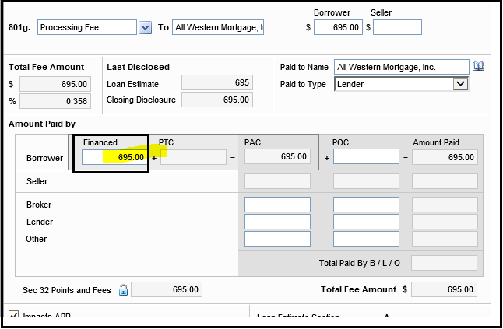

Your Mavent report won’t pass if you do not update this way on **VA IRRRL loans**

1. **Update on Early Release DOCS that are approved to Draw without CTC:**

Docs Team need to check this below box on any files that you complete an EARLY RELEASE DOC order for. Please make sure you check this BOX once DOCS are Completed & Send out to all parties and not before that.

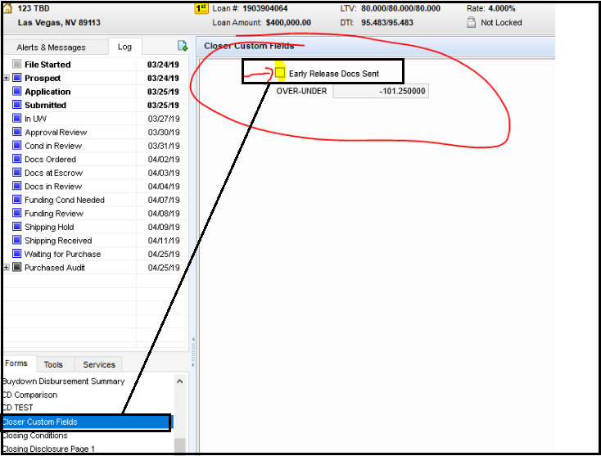Encompass >> Forms >> Closer Custom Fields

1. **Update on VA Cash Out Refinance Transactions:**

Docs Team to make sure to include “**VA Guaranteed Home Loan Cash out Refinance Comparison form**” and issue the docs. It’s is underwriters responsibility to put it in the file. You can find the document under e-Folder in Encompass under the Closing Section (9) as “Additional Docs to be signed at closing”.

1. **Update on FHA MIP Refund –**MIP Refund in case of FHA Refinance transactions should be considered on the basis of Funding date not on the basis of NOTE DATE. For example if we have a note date of 08/30/2019 and funding is on 09/05/2019 then we should consider MIP Refund amount for September 2019 from the REFI AUTH document.
2. **Update on Property TAX Collection –**Please note that collecting tax installments when they become due in the same month the first payment is due.  If we DO NOT have the tax bill because it is not available, then we should be collecting the upcoming tax installment in escrows Sec-G instead of making them prepaid in Sec-F.  Example: currently in the state of Arizona the tax bills are not out yet and the next tax installment is due 10/1.
3. **Update on MI Certificate –** Effective 03/15/2022, DOCS Draw will be hold for MI Certificate If the MI Certificate is not uploaded and Certified / Protected by UW. Docs Drawer need to complete the rest of the file review and hold the DOCS for MI Certificate if not available and request UW to ask for an ETA. Once MI Cert is received & certified by UW, DOCS Drawer will review MI Details in Encompass with attached MI Cert, Final Approval, verify APR with last disclosed CD and re-order Mavent.
4. **Update on Principal Reduction limit –** Please note that Principal Reduction Cannot be more than $2000 in the CD, if such is the case then you need to change the loan amount and COC CD or LE need to be done depends on the situation.
5. **Update on Adjustable Rate Loans (ARM)–**Please note that any ARM loans you complete; it must be cleared or reviewed by Lock Desk Team before they go out – NO EXCEPTIONS. You must need to inform Lock Desk team to review ARM Details in Encompass and take approval prior to release DOCS. Do not send DOCS Out until they say ok so.
6. **Update on Vesting –** Please note that vesting of the borrower should exactly match with the signature line or the name of the borrower in the system and UW’s Final Approval. Irrespective of any loan whether PURCHASE or REFINANCE this will not change. For Example, if borrower name in system is JOHN THOMAS DOE then vesting should also read as JOHN THOMAS DOE even if JOHN T. DOE is given on Title report will not be acceptable. You will need to add GBSD Condition in case vesting on title doesn’t match with our Vesting line but Borrower’s name on DOCS & Vesting must be the same.
7. **Update on HOI Current & Renewal Policy –** Please note that below steps are adhere when transaction is Refinance and HOI is being renewed within First Payment date:

* Ask Processor to provide Renewal policy if it is expiring within 30 days from Closing month and collect it in Sec-F once renewal policy is uploaded.
* If policy renews in the month of first payment date, then it needs to be collect from Impounds instead of Sec-F (If renewal policy is not given)

Ex; If the note date is in November 2019 and renewal policy is from January 2020 then update impounds as 01/01/2020 and it will be for 13 months and do not collect at closing from section 900. Please remember, this is only in case where renewal policy is not available.

* Docs Team to make sure that current year policy is also given in the file and in force till disbursement date in case of Renewal policy provided only which is effective after disbursement date.

1. **Update on VA IRRRL loan –Max Cash back limit –** Effective immediately, cash back to borrower in VA IRRRL needs to be updated as $500 maximum instead of $250 (which was the previous limit), if UW conditions reflecting $250 then let team lead know on this. The UW condition needs to be changed.
2. **Update on USDA loans–**A Technology fee of $25 is to be charged to borrower on those loans where USDA conditional commitment for single family housing loan guarantee is **on or after January 1, 2020**. USDA Conditional Commitment RD-3555-18E Form should be verified from your end and where it is on or after 1st Jan, 2020, this update applicable there.The fees should be disclosed in section B and under 0% tolerance. Paid to party will be lender ALL WESTERN MORTGAGE, INC. and this fee should be an APR fee.
3. **Update on Prosperity Branch for Impound Cushions** – If any file is from Prosperity Branch where subject property is located in state of Nevada, we will not add cushion of 2 months for any HOI, Taxes for Escrow. This is specific for this branch only. In Addition, We no longer collect SID Impounds for Prosperity Branch loans.
4. **Mavent Report** – Mavent report must be run after the DOCS are Issued.
5. **Update on Special Assessments** – CD Team always have to confirm with the processors if they found there are SIDS in the loans , whether it should be Impounded or not that should be confirmed from the Processors. Even if it is impounded in LE, Confirm with processors to add Impounds for SIDS in CD. Only for Prosperity Branch – we no longer Impound SIDS on Escrow but for other branches it is optional depend on the confirmation from Processor if they wants to Impound or not.**Please note** that if SIDS are due within 60 days of First Payment date, they must be collected under Prepaids Sec-F like we usually do.
6. **Update on Metro DPA loan with Lakeview Investor –** If file is locked as Metro DPA program with Lakeview Investor, Flood Certification fee and Tax related service fee need to be paid to **“Master Servicer”.**
7. **Update on CHFA & US MRBP Investor with Manufacture Home Loans** - If file is locked with CHFA or US MRBP Investor and if Property is Manufacture Home, DOCS Team must need to identify from Title report first if Real Property for Manufactured home is recorded or not. If it is recorded and if a recorded copy is not available in Encompass, DOCS team need to ask a record copy from Escrow Officer for reference and attach it to Encompass.

If MH property is recorded as Real Property, Docs Team need to ensure “**Affidavit of Real Property**” form is Completed & sent for recording if it was never recorded by Title.

If MH Property is not recorded as Real Property and do not have Affidavit or Real Property then “**Certificate of Permanent location document**” must be executed & sent for record / signing with DOCS package.

Team has to reach out to Team lead if any of the form needs to be filled up if Property is not recorded with county.

1. **Update on Pre-NOTE VVOE** – Pre-NOTE VVOE for Borrower who does job has to be dated within 3 Business days of NOTE Date and for Self Employed, it has to be within 10 business days of NOTE Date. Please note that we no longer ask Processor for updated Pre-NOTE VVOE if not available or within mentioned limit days, we will ensure that PTF is added for it which will be done by Funder and DOCS are out then.
2. **Docs Redraw Update** – We no longer redraw DOCS just for change in NOTE Date from one month to another. Borrower can sign DOCS next month on previous month dated DOCS. We will only redraw DOCS for next month if Branch wants it to be dated for next month because Borrower wants new First payment date otherwise not. Yes- Docs redraw will happen for other reasons like change in loan amount, rate, lock extension etc…
3. **Escrow Balance – ZERO or Positive –** Docs Team need to ensure Escrow Balance on CD Disclosure Summary Screen can’t be negative. If it is negative then team need to adjust the Escrow to make it Zero or Positive. Team has to increase cushion months by one or two months each for Tax and Hazard Insurance until Escrow balance becomes Zero or Positive.

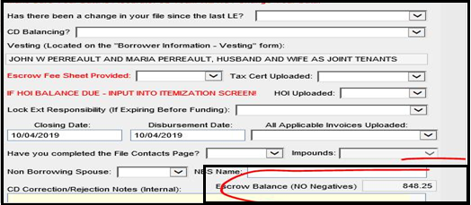

1. **Update on HOI for Purchase loans –** On Purchase loans**,** It is not necessary that HOI is effective in the same month file is Closing in. So Ex; If you are closing in October-2020 and your HOI is effective from September-2020, Your Impound date on HOI will be 09/01/2021 as per HOI Policy.

DOCS Team will not add condition for updated HOI to provide for current month effective. Whatever policy you have in file, Just follow the same expiration date for Impounds. Team will only add PTF Condition if available HOI is effective after updated Funding date otherwise not.

1. **Update on checking Approval Expiration dates:** Effective now**,** DOCS TEAM will check UW approval expiry date on all loans. Note date on DOCS cannot be beyond Approval expiration date. If you mistakenly violate this date then the milestone for docs won’t be changed and you have to redraw docs again. If Docs team see Approval is expiring before NOTE Date as per system then reach out to UW to update Approval Expiration date in Encompass before Docs are Out. See below location where team can check Approval expiration date:

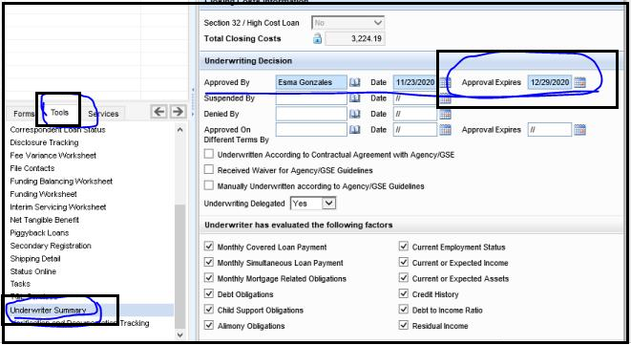

Encompass >> Tools >> Underwriter Summary

1. **Update on HOI or Flood Insurance Paid receipt requirement –** Effective now, On Refinance loans –Docs Team will ensure that the paid receipt for HOI or Flood Insurance is provided in e-folder by Processor if policy doesn’t state Premium status on declaration page whether it is paid in full or due or partial paid.

Policy or Invoice must show “Paid in Full” or “Zero balance” or written confirmation from Insurance agent stating Policy is paid in full. If Processor fails to provide either of this information, Ask Processor to provide Paid receipt before DOCS is drawn.

1. **Update on HOI / Flood Renewal Policy PTF for Refinance loans –** If the HOI or Flood Policy is expiring within 60 days of First Payment date and if Renewal policy is not available. DOCS Team will add PTF Condition of HOI / Flood Renewal pending within 60 days. Do not ever remove it even if any processor come and force to do so. Reach out to team lead if anyone is forcing to remove.
2. **Update on Florida Branch Loans –** Effective Now, Any file which belongs to **Florida Branch**, Credit report fee will only be charged up to $48.30 on CD even if Invoice has higher figure in file. You will only keep $48.30 on CD for all Florida branch loans.

If Invoice has lower amount than 48.30 then team will charge it as per Invoice but if Invoice has higher amount than $48.30, Team will only charge as $48.30 on CD.

**REMEMBER – This is only for Florida Branch loans. It doesn’t mean you will apply this logic for other branches who deals in Florida State.**

1. **Update on Trust Checklist requirement –** When any file is approved to draw in Trust, Docs Team must need to ensure that “TRUST CHECKLIST” filled up by UW must be in e-folder along with Trust paper work.

If TRUST Checklist is missing in the file, Docs Team will contact UW to attach it to e-folder before DOCS are drawn.

1. **Update on 1003-URLA-Lender Form –** DOCS TEAM need to make sure when docs go out that following box (Include Lender Information Pages in Borrower Package) is checked on the 1003 URLA – Lender screen in Encompass.

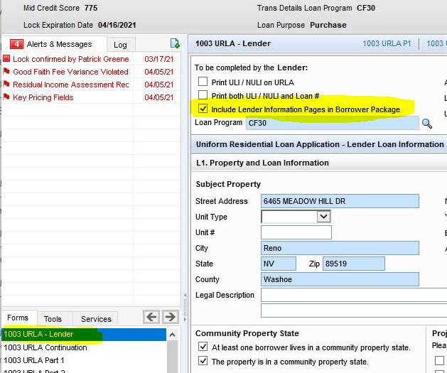

1. **Update on Conventional loans with 80% above LTV and having monthly MI –** If Number of units is 2 or more on 1003 page-4 then MI is required for the entire length of the loan. It will not automatically cutoff at 78%.

What you will do is, remove 78% Cutoff (Cancel At) from Mortgage Insurance section When Number of Units are 2 or more than that.

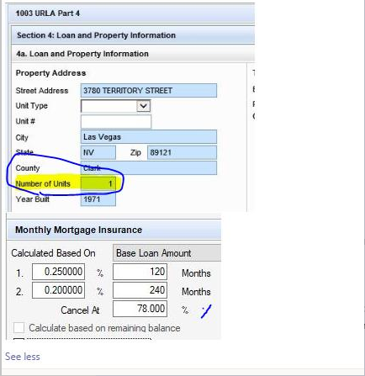

**Remember – Cutoff 78% (Cancel At) is only to remove when Number of Units are equal to 2 or greater. If it is “1” unit then we will keep 78% cut off on MI Section on Conventional loans with 80% above LTV.**

**Make sure Docs team checks Number of Units on 1003 page-4 before they remove / keep 78% cutoff on MI Section.**

1. **Update on HOI / Flood Policy expiring within First Payment –** if the HOI is expiring within First payment month then CD Team need to collect them at closing (under prepaid). In Addition, No need to collect additional 5%, collect the premium mentioned in current (previous year) policy.

DOCS TEAM needs to collect premium on the basis of current policy and no need to add additional 5%. Ask from processor on the renewal policy, if not available then proceed as said, if available then collect accordingly.

If the renewal is not available then collect premium and add PTF conditions for it.

1. **Update on FHA Streamline Refinances – ALL FHA STREAMLINE REFINANCES (Without Appraisal)** –

If file is FHA Streamline refinance on which Appraisal is waived then Appraised value in Encompass must match with Original Property Value from FHA CASE Refinance Authorization document.

Docs team will inform the processor and UW if value in Encompass doesn’t match with value on Refinance Authorization because it directly impacts the FHA monthly MI.

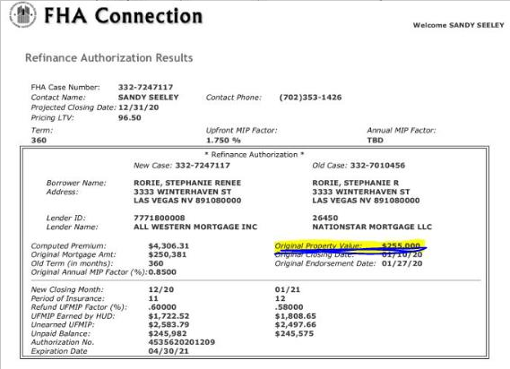

**Remember** – If there is an appraisal report in the file on FHA refinance loan then value in Encompass has to match with Appraisal report. It is fine if Refinance Authorization has old value in that case.

If Appraisal is waived on FHA Streamline without Appraisal – In that case, Origination value on Refinance Authorization must match with Encompass and Approval Final.

1. **Update on Random fees restriction on Lender fee Section – A –** Effective immediately, if in section 800 there are any random fees added by Processor apart from UNDERWRITING FEE & PROCESSING FEE, those files must be brought to Team lead or Manager’s notice. File won’t leave the queue without lead’s approval.

**For example** – If there is ADMIN or ADMINISTRATION FEE added then we should be informed and when we finalize then the file will be moved out of queue. Only Docs Team can work on it and keep it on HOLD until Team lead or Manager gives an approval.

1. **Do not allow Successor Trustee on Trust loans –** If fileis approved to draw in trust then Docs team to make sure that we do not allow a successor trustee on our Trust approved loans and Trust checklist.
2. **Update Purchase Contract date on FHA Purchase files** – Docs team need to ensure Purchase Contract date is updated under “FHA Management” in Encompass as attached below.

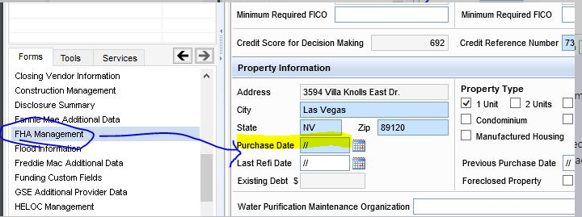This date can’t be blank. If Purchase Contract date is blank, Docs team need to update Contract date from Purchase contract or consider latest Contract addendum date if given.

**Remember** – If there is any contract addendum given in the file, Docs Team need to update Contract date from most recent addendum instead of Purchase contract. If there is no addendum in the file then team need to take date from Purchase contract.

See below location of Contract date;

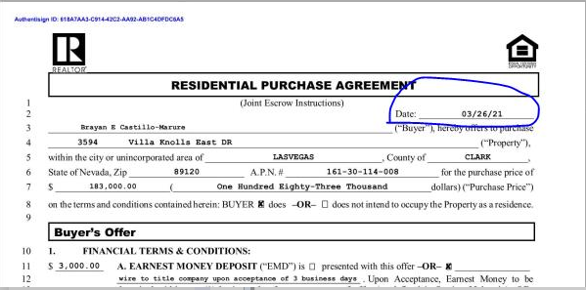

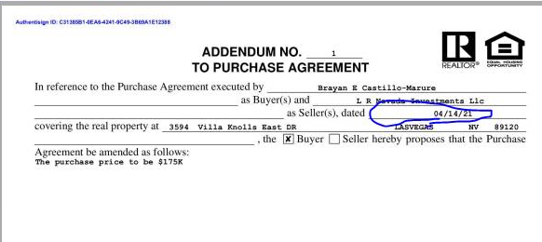

1. **Update On removal Unsigned copy of Initial / COC CD’s from Encompass E-folder** – Docs team will remove the unsigned Initial CD / COC CD which is uploaded in encompass. Once the Initial CD is acknowledged then there is no need of unsigned one. However, if the CD is not acknowledged and we are releasing docs after 7 days then in that case do not remove unsigned copy of CD / COC CD.

In Addition, if there are any COC forms attached with Initial / COC CD’s in the file, They are not to remove from the file. Only CD pages if signed copies are available

1. **Update On Property tax for Prepaids – 900 Series**– When Docs team came across with scenario where any Property taxes due and are to be paid at closing under 900 Series (Prepaids) as per County records however if they are shown as paid on approval CD as per LO/ Processor’s direction on email then team must need to make sure the Proof (Paid receipt for tax) has been attached already in file or provided on email. This Proof must be reviewed Managers before DOCS are released.

**Remember – Only check Proof of Paid receipt when Encompass and Approved CD is showing Tax amount as Paid but County website is still reflecting as Due.**

1. **Update On 4506-C Form to be send with Closing package** – Docs Team will need to check in every files in e-folder that if **Business Tax returns** are attached then team need to ensure 4506 I forms go in the Closing package.

**Remember** – If you see Personal Tax returns, we don’t have to verify anything on it but if you see Business Tax returns, below are the details that need to be updated in Encompass from attached Business tax returns in file.

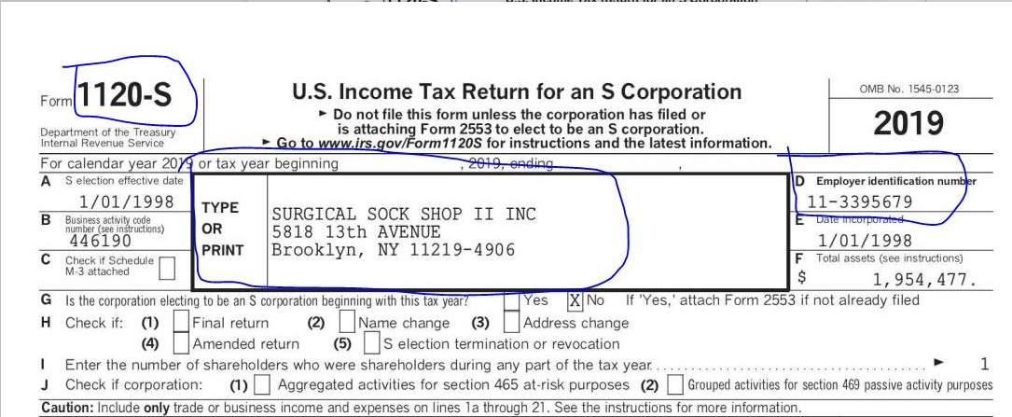Ex; of **Business Tax returns looks like;**

1. Go to this Highlighted Form in Encompass first

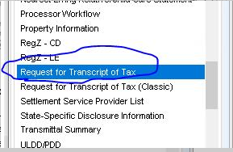

1. Crete a business and copy the generic data button (See Step – 1 and 2 on following screen shot) and then fill up following highlighted details from Business tax return (Step 4-8).

**Remember** – There will be one business for one Tax return. If you see multiple business tax returns in the file for different business that Buyer owns then you need to make sure all Business are created on this Encompass form separately. **1 Form per 1 Business!!**

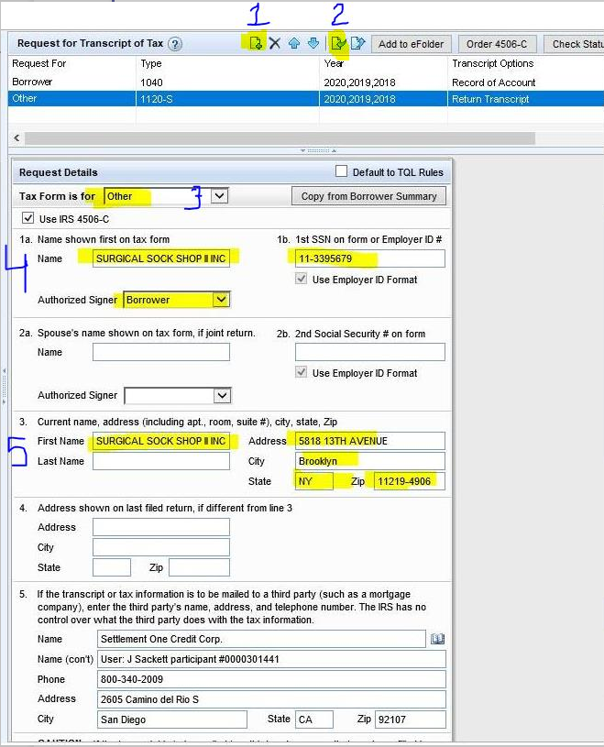

1. **Most Important** – Step-6 on following screenshot, you need to change Form number as per Business return. Every business Tax return will have Form number written on Top of the Title. Ex; On this file – It is 1120-S on Business tax return so you will need to update the same here on Step No.6 on following screen shot.

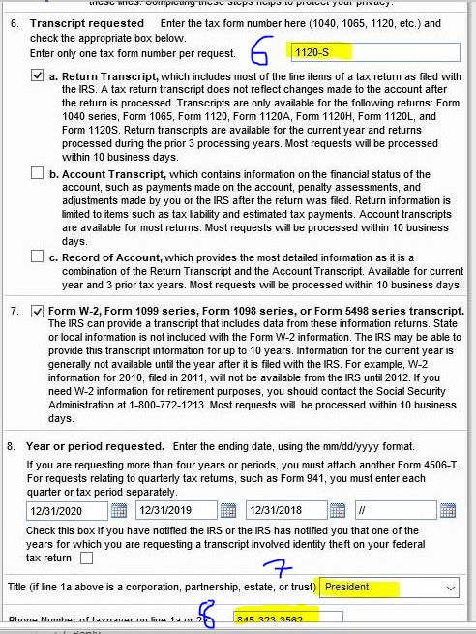

**NOTES**: Docs team needs to follow the above process for 4506-C however team need to check following points as well:

* Check if signed 4506-C for business firms are available in Encompass or not. Processors are attaching them under 4506-T category in E-folder so make sure you double check.
* If signed ones are not available then check in Additional docs to be signed category for the same. If unsigned ones are there then you do not need to generate them again.
* If above two points are meeting then team has to generate these forms and ensure it goes with Closing Package.

**IMP NOTES**: Whenever the investor is Pentagon Federal Credit Union then in 4506-C the address on line 5a will be updated as follows:

TALX Corporation, a provider of Equifax Verification Services

11432 Lackland Road  
Saint Louis, MO 63146  
800-247-562

1. **Update On to send Signature pages from Business / Personal Tax returns with Closing Package –**

Docs Team to make sure any Certified / Protected / Ready to ship Personal or Business tax returns attached in file, Team must need to extract signature page-2 from Personal Tax return and Page-1 from Business tax returns whenever it is available in the e-folder.

Team must need to upload those extracted pages under **“Additional Documents to be signed”** category in e-folder and need to send them with Closing package.

**REMEMBER** – TEAM will only do this task when Personal Tax returns / Business tax returns are attached to e-folder and MUST Certified / Protected and Ready to Ship button is marked.

If it is not checked as Ready to Ship which means Team can’t extract the signature pages from these returns. Team will only do it when they are marked as Ready to Ship.

In Addition, If Personal / Business tax returns are already signed then this task is not necessary. Dates are not sensitive and can be dated any time before or after Closing. If Processor has already attached Signature pages from returns under Additional DOCS folder then Team don’t have to extract them as Processor has already did it on their end.

1. **Update On Refinance loans to validate “Refinance with Original Creditor”-**

DOCS Team must to validate on all refinance loans under Reg-Z CD screen for “Refinance with Original Creditor” button either has to be marked “YES” or “NO” but it can’t be Blank.

**When to mark as YES** – If Recorded Deed of Trust on Title report shows Beneficiary name as **“All Western Mortgage, Inc.”** for previously recorded Mortgage.

**When to mark as NO –** If Recorded Deed of Trust on Title report shows Beneficiary name as “**Different Lender”** for previously recorded Mortgage.

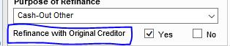

Encompass >> Reg-Z CD >> Purpose of Refinance

If Team come across that Box which is marked in Encompass has Incorrect and not meeting the above conditions while validating with Title report, Team must need to STOP and reach out to Team lead / Manager. **DO NOT MAKE CHANGES BY YOUR SELF IN ENCOMPASS UNTIL CONFIRMED BY LEAD / MANAGER.**

If Team sees that there are multi liens on Title report and Mortgage was recorded many times with different lenders and not just once, Team must need to check with their leads / Manager which one needs to be considered.

1. **Update On Texas loans for Attorney Package review-**

When file is closing in Texas State and DOCS Team receive attorney package from BM & G, they must need to review following information on Attorney package:

* Verify all Borrowers’ basic information like Note date, Borrower names, Loan number, and Property address. If any error on Attorney package, Escalate with BM&G Attorney for correction
* Verify and update Attorney fee with Final CD as per the Invoice given in Attorney package and attach the Invoice under 9. Invoices category and send with Closing DOCS.
* Review all Closing Conditions listed on Attorney package and if any condition is listed for Lender to complete, Team need to make sure those conditions has been met and supportive documents attached in E-folder (if not already) prior of releasing Closing DOCS.
* Team lead must do 2nd level review on Attorney’s closing conditions listed on package and guide the team members if there are any escalations required prior of releasing DOCS.
* If any Attorney’s condition is related with Texas specific Final disclosure, Team lead to check Texas State specific forms in Encompass where required Final disclosure can be checked and disclose with Final Docs.
* If any Attorney’s condition is related with Texas specific Initial disclosure and if it is not attached in E-folder and not executed already as per Attorney’s condition, escalate with Disclosure desk team on the same and co-ordinate with branch to fulfill it prior of releasing Docs.
* If there is any Co-Borrower or NBS added to the loan, his/her name must reflect in vesting of General Warranty deed that is provided by TX Attorney in their package on purchase loans and Purchase contract / addendum should have that co-borrower or NBS name added.

1. **Update On to check Elective Insurance Box “Yes or No” under Closer Custom Fields form in Encompass-**

**Elective Insurance to select as Yes** – When there is Master policy in the file showing **Walls in Coverage** and borrower still opt HO6 policy which is in the file and Impounded.

**Elective Insurance to select as No**- For all other reasons (Normal HOI only, Normal Master Policy with NO walls in Coverage + HO6 available, Master Policy with walls in Coverage but NO HO6) – **You will select as NO.**

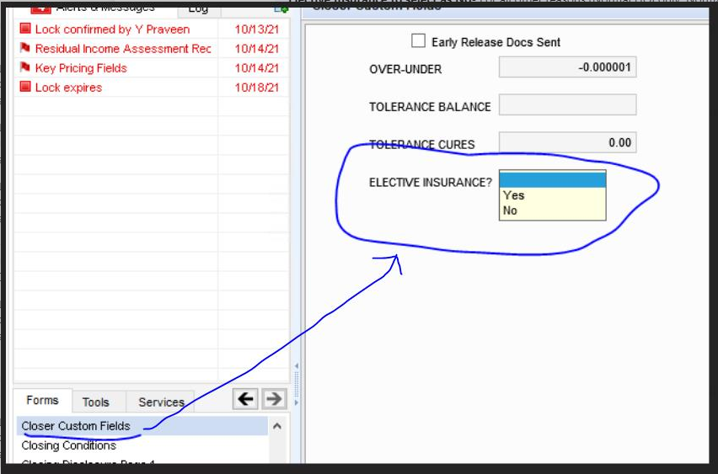

**NOTE** – Please note that Team will see Hard stop while finishing Milestone if Elective Insurance Option is not selected by DOCS Drawer. **IT CAN’T BE BLANK**.

1. **Update On Certify / Ready to ship Initial and COC CD’s-**

Docs Team will certify or check Ready to ship button on all Initial and COC CD’s after review which are available in Encompass >> E-folder.

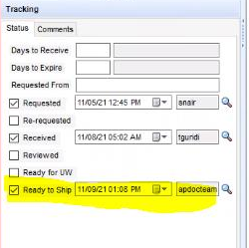

1. **Update On to verify “Use Simple Interest Accrual” on RegZ – CD Screen** – Docs Team to make sure and verify “USE SIMPLE INTEREST ACCRUAL” Section and ensure following highlighted options must choose correctly at Docs Draw stage. This needs to be updated before releasing Docs to all parties.

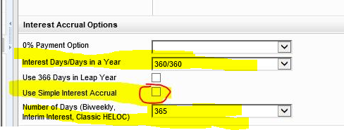

Encompass >> RegZ – CD >> Interest Accrual Options

* + 1. Interest Days / Days in a Year = 360 / 360 always
    2. Use Simple Interest Accrual button must be unchecked on all files
    3. Number of Days (Biweekly, Interim Interest, Classic HELOC) = 365 always

1. **Update On to ensure “MOM” box for MERS is checked on RegZ – CD Screen** – Docs team to make sure the following box **“MOM”** under Reg-Z CD form is always checked on all loans otherwise MIN Number will not print on Deed of Trust if it is kept unchecked.

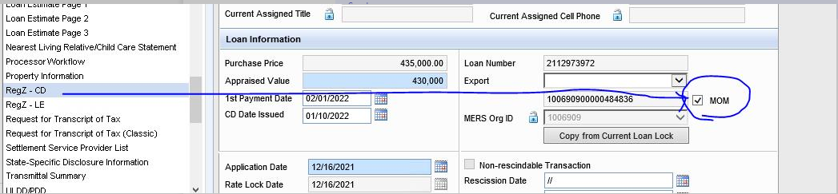

Encompass >> RegZ – CD

1. **Update on to verify “Prepayment Penalty” on CD Page-1 Screen** – if any file is locked with SGCP investor and if occupancy is “Investment”, Pre-payment penalty will apply on Closing DOCS / Final CD. Use this calculator to calculate Prepayment penalty for SGCP Investor with Investment Occupancy. Identify Not DC or DC state before calculating pre-payment penalty. DOCS Team will need to update loan amount and interest rate on attached calculator to calculate pre-payment penalty for specific loans.

Docs Team just have to verify the pre-updated amount on CD page – 1 in Encompass with Initial CD / COC CD and attached calculator. If there is a mismatch, then reach out to Lock desk to verify and request to update the correct amount.

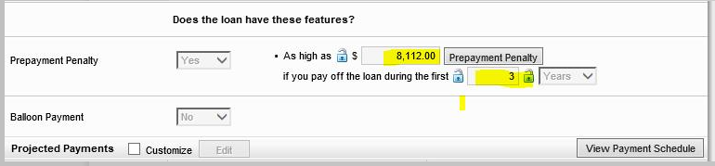

Encompass >> CD Page-1 >> Prepayment Penalty Section

1. **Update on to verify Closing Method from DOCS ORDERED QUEUE** – There is a new customized option added in Docs ordered Queue as Closing Method. This option will help DOCS Team to identify whether Loan docs will be send as Traditional Closing or E-Closing. If Closing method is blank, it will be considered as “Traditional (normal) Closing”.

E-Closing files needs to be priced accordingly that means Docs team to verify & confirm with Lock Desk team whether file is correctly priced or not for E-closing.

NOTE :- ALL E-CLOSING(RON) MUST GO THROUGH TORY’S APPROVAL.

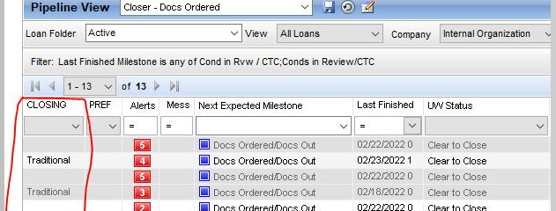

1. **Update on Borrower’s current address to verify on Final 4506-C for Personal Tax returns (1040)** – Docs team to verify “REQUEST FOR TRANSCRIPT OF TAX or REQUEST FOR TRANSCRIPT OF TAX (CLASSIC)” form in Encompass and to ensure that for Form 1040 (Personal Tax returns) where Borrower’s details like Name, SSN# and mainly current address is fully updated or not.

If any of these information are missing or partially updated then team have to update them from 1040 personal tax return if available, If personal tax return is not available in E-folder then take borrower’s current address details from 1003 Page-1 form in Encompass and update it on 4506-C form for 1040.

**IMP NOTE –** If 2 Borrower(s) are one Single 1003 application and not married to each other, Docs team need to make sure their 4506-C are created separately in closing package and can’t be combined in single 4506-C form.

1. **Update on Loan Modification Agreement Disclosure on any ARM loan files**- Docs Team to uncheck “Loan Modification Agreement Disclosure” from Closing check list while ordering docs on any Adjustable Rate Mortgage (ARM) files where this disclosure is generated with Closing DOCS.

Team need to make sure this disclosure do not go with Closing DOCS whenever generated on ARM loans

1. **Update on to verify MI Coverage % between MI Certificate and AUS** – When there is a requirement of Mortgage Insurance on any Conventional loans, Docs Team need to verify MI Coverage % from MI Certificate with uploaded AUS (DU/LP) in the e-folder.

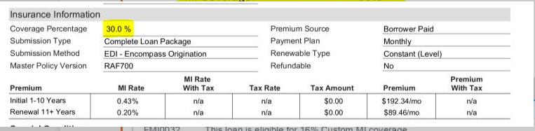If any discrepancy found between these documents, Docs Draw needs to put on hold and escalate an issue with branch/UW.

Encompass >> E-Folder >> MI Certificate

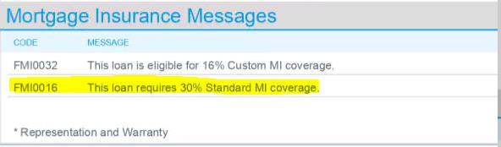

Encompass >> E-Folder >> AUS (LP)

**OR**

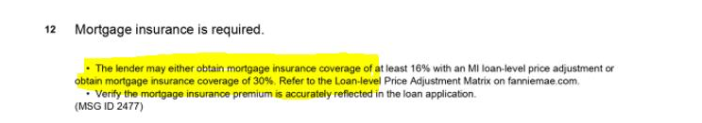

Encompass >> E-Folder >> AUS (DU)

1. **Update on to verify LE Issued dates:** DOCS Team need to ensure that two LE’s cannot be issued on same day. i.e. LE Issued date can’t be same on two different LE’s. If any found with such situation and CD team missed this review part, it needs to get corrected / escalated with branch before Docs team proceed for Docs draw.
2. **Update on** **“BUSINESS PURPOSE & OCCUPANCY AFFIDAVIT”:** The business purpose & Occupancy Affidavit disclosure must be generated on all investment properties, except for Wells Fargo and US Bank loans. Docs Team to verify the same in closing package and make sure it is getting generated on Investment Properties.   
     
   If Investor is “Bay view” and this disclosure is not getting generated, inform TL or Manager immediately.
3. **Update on** **“POA – Power of Attorney”:** Docs Team need to start checking following points for Power of Attorney to be used on DOCS or not:

* Docs Team to confirm with processor on each & every files whether the file is eligible to close with POA or not when Funding custom field in Encompass indicates as **“YES” for “Is this loan approved close with POA?”**
* If Funding Custom field indicates as **“NO”** to “**Is this loan approved close with POA?”** and POA document is also not available in Encompass, then no need to confirm with Branch.
* If Funding Custom field indicates as **“NO”** to “**Is this loan approved close with POA?”** butPOA document available in Encompass and processor confirms the same then only Docs Team will request UW to review and change the Funding Custom field option as **“YES”** to identify eligibility of POA based on loan transaction.
* Docs Team must add comments at “Docs Milestone” & at “Disclosure Summary” pages in both the cases, File closed with POA or File not closed with POA.
* The File must be reviewed and approved by TL’s or the Manager and only they are allowed to certify and protect the POA document in Encompass and clear or waive the POA conditions added by UW.

1. **Update on** **Additional review point on** **“4506-C” form in Encompass:** Docs Team start verify additional point on **“REQUEST FOR TRANSCRIPT OF TAX and REQUEST FOR TRANSCRIPT OF TAX (CLASSIC)”** forms, “**Line-4 – Address shown on last filed return, if different from line 3”** and update / verify former address (previous property address mentioned on Tax returns), only if address mentioned on Line# 3 is different than former address.

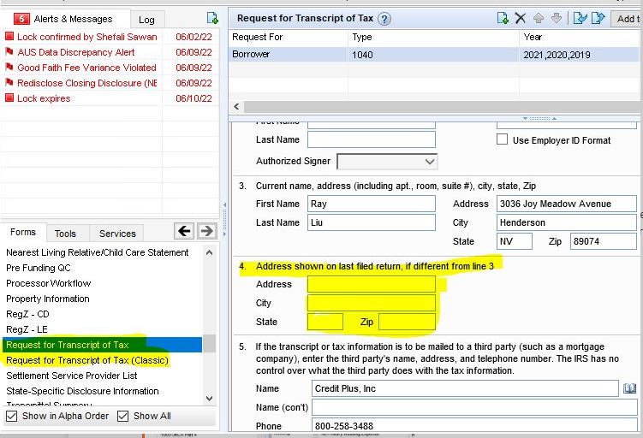

DOCS team to ensure following points are follow while reviewing this information and reach out to lead if any discrepancy found in the address between documents and Encompass:

* If 1003 page-1 shows “Former address” marked as – **doesn’t apply**, you will not update Previous address on line -4 on Request for Transcript of Tax forms.
* If there is a former address updated on 1003 page-1 and different than current address, update the previous / former address on line 4 on Request for Transcript of Tax forms.
* In case if there is a last year filed tax return available in E-folder or File manager, just verify the Former / Previous address from Tax return with 1003 page-1 and update / verify it on line 4 on Request for Transcript of Tax forms only if it is different than current address.

1. **Update on COC verbiages used on LE for any 0 or 10% tolerance fee increase:** If DOCS Team see any 0% or 10% tolerance fee increase from Initial LE to COC LE(s) and if any verbiage is updated on COC form, Check if CD team has added comment and took an approval from lead / manager that such Increase in _____fee is valid hence tolerance cure is removed. If not, Team lead must have to review and provide an approval if such verbiages are valid or not on COC forms before you apply / remove cost to cure from CD.

If you receive an approval from your lead / manager in TEAMS, make sure you add comment for your further departments that **“COC form verbiage is confirmed and approved by lead/manager for Increase in _________ fee, thus tolerance cure is removed”.**

1. **Update on Pre-Funding QC** – There are two new column added in Docs Pipeline. One is

**“PRE FUNDING QC”** and another one is **“PRE FUNDING RELEASED DOCS”**

-If there is **“X”** marked reflecting in **“PRE FUNDING QC”** columnthat means Docs needs to be on HOLD. Docs can be completed by Docs drawer however it can’t be released / send out.  
-If there is **“X”** mark reflecting in **“PRE FUNDING QC”** and also reflecting in **“PRE FUNDING RELEASED DOCS”** that means Docs can be worked and send out both.

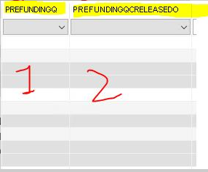

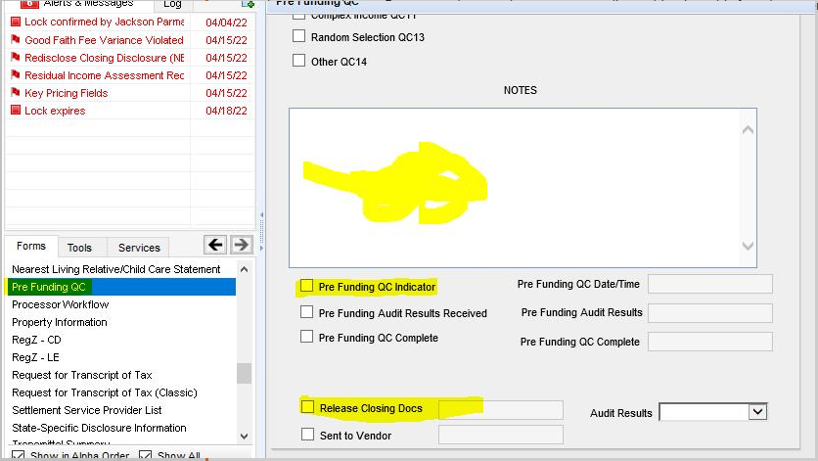Now, there is form available in Encompass called **“PRE FUNDING QC FORM”** which is mapped with above two columns. Docs team does not have access to edit anything into this form however Docs team need to review the conditions & notes added by QC Team.

1. “**PRE FUNDING QC INDICATOR**” is marked means Docs are not ready to go out. Inform your Lead to follow up with concern person on Pre-Funding Completion status.  
   **b) “RELEASE CLOSING DOCS”** is marked means QC is cleared and Docs are ready to go out.

**MOST IMP: -** Make sure to review all notes and conditions updated in above form in case if any condition affect the Closing DOCS. Reach out to Team lead / Manager on any added QC notes / Condition is not understandable.

1. **Update on any new title fees added after Initial CD / COC CD has been sent to borrower:** Docs team has to verify if any new Title fees added at correction stage on Sent files which were not disclosed on previous disclosed Initial CD / COC CD that was already sent to borrower, They need to review notes in Disclosure summary added by CD correction team for Docs team to follow.  
     
   **Attn Docs Team :- COC form to be attached with Docs for change in Settlement/Title Fees.**

If DOCS team see above comment, they need to attach COC form with DOCS for above reason.

1. **Update on 0 & 10% tolerance fee verification for DOCS Team:** Docs team to verify and update 0% & 10% cure by following below factors.
2. If no changes in 0% & 10% fees throughout LE and Initial / COC CD, Baseline to compare cost to cure will be with LE vs Current Itemization.
3. If any increase in 0% or 10% fees from Initial CD or COC CD, Baseline to compare cost to cure will be with last disclosed CD vs Current Itemization.

If any doubt in cure calculation, reach out to TL or Manager for assistance.

1. **Update on Private money loans**: DOCS Team to make sure following points on any private money loans:

* **Balloon Note & Balloon Rider** must go out with Closing Docs when there is Balloon payment loan program selected on Reg-Z CD. Reach out to team lead on how to print Balloon rider from Encompass.
* Credit report fee – If the invoice indicates that the requested amount has been paid already on Credit invoice, it means it has been by LO on behalf of Borrower and it has to be reimbursed to LO on CD. In order to do that, Change the amount to PAC (DUE) and update the payee name as “Richard Whelan” (LO).
* if the Credit invoice indicates that amount is due and not paid yet then follow the regular process to update fee as PAC(DUE) on CD and payee name will be as per invoice.

1. **Update on Cash to Close on CD page-3 to match with 2015 itemization screen for El Paso and Prestige branch**: DOCS Team to make sure that Cash to Close on CD page-3 must have to match with Cash to Close showing on 2015 itemization screen in Encompass. In order to balance Cash to Close on 2015 Itemization screen, Team needs to ensure any Tolerance cure/ Adjustment / pro-rations that are updated on CD page-2 and 3 should be listed on 2015 Itemization screen as well.

If DOCS team face any issues in matching the figures, reach out to Team lead / manager for help.

1. **Update on Texas State – NBS / NBP requirement:**

**ALL TEXAS STATE PRIMARY FILES (DO NOT APPLY FOR SECONDARY/INVESTMENT)** –

IF BORROWER IS MARRIED >> SPOUSE MUST BE IN VESTING AS NBS OR AS CO-BORROWER >> IF SPOUSE IS LISTED ON TITLE REPORT SCHEDULE A >> HE/SHE MUST BE ON CONTRACT/ADDENDUM OTHERWISE NOT.

IF SPOUSE IS ON TITLE REPORT BUT NOT ON CONTRACT >> REQUEST BRANCH TO PROVIDE ADDENDUM TO INCLUDE NBS. (THIS IS ALSO APPLIED FOR THE NBP – NON-BORROWING PERSON).

**TEXAS – SECONDARY/INVESTMENT PROPERTY** –

Identify the Vesting first >>If vesting is Sole & Separate, It is fine if NBS do not sign Deed of trust or vested and not required NBS to be on the contract.

If NBS name is in vesting and in Title Report’s SCHEDULE-A then and only NBS is required to be the contract.

**DOCS TEAM** – FOLLOW THE ABOVE STEPS HOW TO IDENTIFY IF SPOUSE IS REQUIRED ON CONTRACT / ADDENDUM OR NOT. REQUEST BRANCH ACCORDINGLY!!

**NOTE FOR DOCS TEAM**: If NBS/NBP is not on Title & contract, TX Attorney will not add him/her on Warranty Deed without Lender’s request so it is not necessary that borrower’s vesting on DOT will always match with Warranty deed but Seller vesting must have to match on Warranty deed with Title report.

1. **Update on 4506-C form:** Docs team to verify and update last two years requested date at line #8 at 4506-C Form. Date should be last day of the end of the year.

Ex:- Files are being closed in year of 2022 for now, Last two date will be 12/31/2021 & 12/31/2020 as shown in below snip. If there is any date prior to 2020, must be removed.

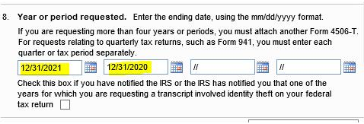

1. **Update on Buy-down Mortgage:** Docs Team to verify Buy Down details at Reg-Z CD screen as per below snip whenever applicable on the transaction and ensure that Buy down details are updated and Buy Down agreement to send with Docs.

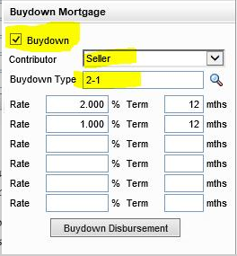

Points to remember:-

1. Buy Down Type can be 2-1 or 3-2-1, Buy Down contributor can be Seller or Lender or can be both.
2. Docs Team to use Buy Down calculator to update Buy down details on agreement. Instruction for How to use calculator has already been mentioned in the excel sheet.
3. Buy down Funds must be updated / verified in Sec-H of the CD on Seller side, Paid to as “All Western Mortgage, Inc.” and has to be itemized from Seller credit / Lender credit as per selected Contributor for Buy down Funds.

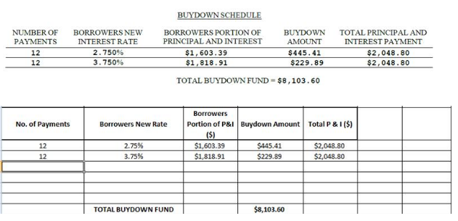

Here are the sample of word file of Buy Down Agreement and calculator for reference.

 

1. **Update on Credit report and Flood Cert fee:** Effective immediately**;**

**CREDIT REPORT FEE –** Paid to name should be “Company name mentioned on the invoice” and Paid to type as “Others”.

**FLOOD CERT FEE –** Paid to name should be “Company name mentioned on the Flood Cert” and Paid to type as “Others”.

1. **Update on CD Acknowledgement:** If borrower e-signed the CD on Presumed received date but viewed the CD before presumed received date, You can consider CD Acknowledgement date as viewed date to calculate 3 days waiting to determine Closing / NOTE Date.

Ex; Initial CD sent on 10/21/2022, Viewed date on 10/21 and E-signed on 10/24/2022, You can consider CD Acknowledgement date as 10/21/2022 on this scenario. Initial CD on TOP of the page-1 will reflect when borrower(s) has viewed the CD.

1. **Update on Construction to Permanent loan Type: Important points to remember –**

* If borrower is financing both property purchase and construction then the purpose on CD page-1 should be labeled as “Purchase”.
* if the borrower owns the property and is only financing construction then purpose on CD page-1 should be “Construction”.
* There are two ways to disclose construction loans, either the purchase/construction phase are disclosed together, or the phases are disclosed separately. If together then standard LE/CD should be used, if the phases are disclosed separately then the purchase should be disclosed as standard LE/CD as purchase, and construction phase disclosed with alternate forms and purpose as construction.

**Attached is the guidance from Encompass on Construction Loans: **

1. **Update on TEXAS Attorney review fee on VA loans:** Texas Attorney review fee is not allowed to charge to Veteran on any VA loans and not part of 1% loan limit. It is either has to be itemized from available Seller credit or Lender credit approval required for the same amount.
2. **Update on TEXAS Cash-Out Refinance Non-Homestead loans:** When transaction is with TX State – Cash out Refinance (Investment only), Docs drawer need to make sure 2 additional checkpoints
3. 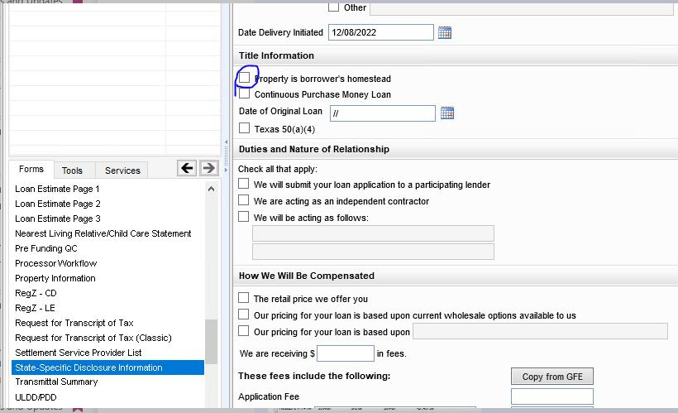State – Specific Disclosure Information form – Make sure “Property is Borrower’s Homestead” button is **unchecked** always – **Only when TX – Cash Out refinance – Investment occupancy.**
4. Go to Audit Trial – Search with code “142”= Make sure last result should be “Negative”

Once both these steps are verified, Deed of Trust page – 12 (Acknowledgement of Cash Advanced against Non-Homestead Property” box will be auto checked which is required in Non Home-stead transaction (Cash out Refi- Investment) .

Our attorney will not condition us if we follow above steps on this particular kind of transaction in Texas.

1. **Update on 4506-C forms:** 4506-C Form & Classic – Field #5D – Client name, address, & telephone number needs to be updated in all the files if they are blank.

Details should be as below –

Client Name – All Western Mortgage, Inc.

Address – 8345 W Sunset Road, Ste 380, Las Vegas, NV – 89113

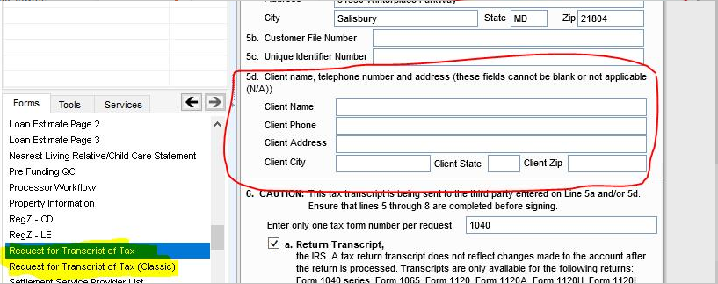Phone# - 702-369-0905

1. **Update on Appraisal details:** Docs drawerto ensure Appraisal Company’s e-mail & Phone# is updated in all files under File contacts. You will find these details in Appraisal report where you verify the Appraisal value. See attached for the reference from Appraisal report.

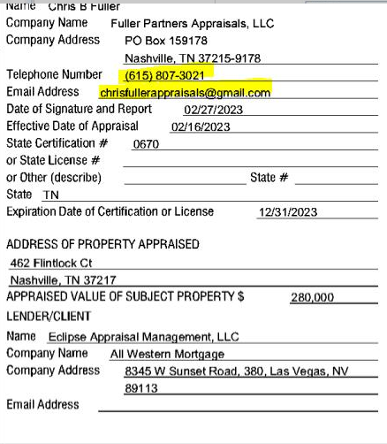

1. **Update on FHA ADP Code :** Docs teamto ensure if any file is FHA with Buydown funds applied on it, ADP Code with FHA Case number must be verified / updated as “796” in Encompass as well as on FHA Case assignment document. If not, request processor to correct ADP Code on FHA Case assignment and add required PTF Condition for it and proceed for DOCS draw but to ensure system and Final DOCS has correct ADP Code when buydown funds applied on any FHA files.
2. **Update on ARM loans:** Docs teamto ensure following check points must be followed in all ARM files at every stage of closing.

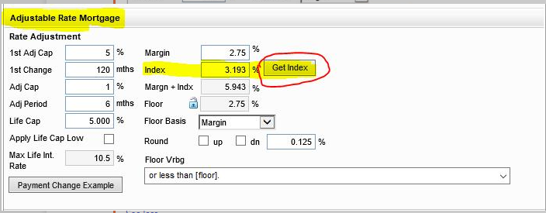1 – Each department needs to click on “Get Index” button while working on file and then inform Lock desk team to verify the rest of the ARM Details and loan program.

2 – Once Lock desk respond, each department needs to check whether APR is being increased by more than 0.250% or not. If it is increased, team lead and manager should be informed immediately.

3 – Once Lock desk respond, each department needs to check whether Pricing (credit for rate or Discount Fee) is being changed or not. If it is changed, team lead and manager should be informed immediately.

1. **Update on SHORT PAY:** If DOCS team see any requests from LO/processor or notes related to apply “Short pay” on Final CD where prepaid interest will be credit and in negative and File must have to Close & fund on or before 10th of same month with one month early First payment date than usual files.

Ex; Normal loans – May-2023 Close & Fund- First payment date is 07/01/2023 usually.

Ex; of **SHORT PAY loans-**May 9th NOTE Date and May 10th or before is Funding Date – First payment date can be changed to 06/01/2023. Once you change First payment date one month early, system will auto-calculate prepaid interest in negative on 2015 itemization. Make sure you re-verify your Escrow Set up and due dates for Tax, HOI and MI if any.

You must have to validate email chain for this and confirm with leads / manager. When file is SHORT pay transaction, It is mandatory for you to prepare Hardship letter (format shared already) and send it with DOCS for signing.

Team Lead / Manager’s approval must required when you apply Short pay transaction on any file. SHORT PAY can only happen if file closes and fund on or before 10th and such request must come from branch in written. If no such requests from branch, you will do as usual like normal loans where first payment date is one month after Closing month.

1. **Update on 4506-C forms (Personal or Business):** Additional check point – Section 5 -  Docs team need to ensure that all fields are pre-updated and should not be blank at all. If it is blank then reach out to lead / manager for advise before you send out DOCS.  This section also must be accurate on all loans.

Only 5b & 5c. – there are optional – They can be blank so do not hold for this if nothing is updated, you are good to go.

F**ollowing sections are mandatory to be there:**

5a (Name, Participant ID, Address , City , State & Zip Code)- All must be there. SOR Mailbox ID and Phone number can stay as blank.

5d. -  Lender’s name , Phone, address, City, State & Zip Code – Must be updated. Can’t be blank.

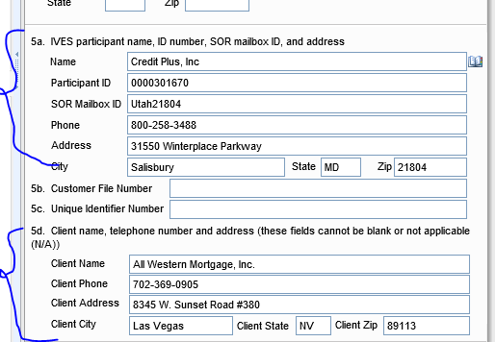

1. **Update on Texas state loans:**
2. **Only for Texas Manufacture loan** – Specific conditions and Endorsements to add on Closing docs when it is marked as **“yet to be converted to real property”** by UW in Encompass (This field is not created yet in Encompass so check this manual as explained on call until this has been created) . You will manually check if Conversion to real property is already executed and in the file or provided by title company then you do not required to add these specific conditions.  **BUT** if UW confirms that Property is “yet to be converted to real property” as well as title then you will need to add following specific conditions to our Closing set which is:

* Closing agent(s) must obtain the required documentation necessary to ensure that the manufactured home is attached to a permanent foundation system on the land, thus becoming part of the real property.
* If State Law provides that a manufactured home may be exempt from certificate of title requirements, and as such, the closing agent must ensure that the manufactured home qualifies for exception from certificate of title requirements, including monitoring of property installation procedures and the related documentation, and to provide the lender with documentary evidence of that for retention in our loan file.
* Title to provide a insured closing protection letter for the mortgage loan secured by a manufactured home.
* Title to ensure the final title policy will include the State of Texas T-31 Endorsement as well as ALTA Endorsement 7, 7.1 or 7.2 or any other endorsement required in the applicable jurisdiction for manufactured homes to be treated as real property.

1. **Only Texas loan** – You need to start identify from prelim report in Texas state whether it is Full or Short Policy under Schedule-A. If loan amount, borrower name and lender information is updated under Form “T-2” on prelim then we are good. **BUT** If it is updated under Form T-2 ®- Short form as explained on call, DOCS Team need to add required PTF Condition for title to correct it on Prelim and Final Title policy both.

**PTF:** Title Company to correct prelim report and Final Policy to show Borrower name, Loan amount and Lender name under Form “T-2” under Schedule-A

1. We need to use and update Texas Endorsements on our Closing instructions going forward. Below is the Endorsement list for Texas state only which you need to updated under Property Information tab >> Endorsements.  Do not use the normal endorsements which you are using for other states. Texas state has different Endorsements list.

**Texas Endorsements**

For SFR / Detached / Attached – T-19, T-36  
For PUD – T-19, T-36, T-17  
For Condo – T-19, T-36, T-28  
For ARM and Detached – T-19, T-36, T-33  
For ARM and PUD – T-19, T-36, T-17, T-33  
For ARM and Condo – T-19, T-36, T-28, T-33  
For Manufacture – T-19, T-36, T-31, T-31.1, ALTA 7  
For Manufacture and PUD – T-19, T-36, T-17, T-31, T-31.1, ALTA 7 For TEXAS Home Equity Endorsement – T-19, T-36, T-42, T-42.1

For TEXAS Home Equity Endorsement and PUD – T-19, T-36, T-42, T-42.1, T-17  
For TEXAS Home Equity Endorsement and Condo – T-19, T-36, T-42, T-42.1, T-28  
For TEXAS Home Equity Endorsement and Manufacture – T-19, T-36, T-31, T-42, T-42.1, T-31.1, ALTA 7  
For TEXAS Home Equity Endorsement and Manufacture + PUD- T-19, T-36, T-17, T-31, T-42, T-42.1, T-31.1, ALTA 7

1. **Update on CHFA DPA loans:**

The below update from CHFA should be followed without fail, CHFA 2nd DOT must reflect AWM mailing information on the upper left corner with the title **“When recorded, return to:”**.

You must make sure CHFA 2nd DOT has this details edited on left side of the corner of 1st page of 2nd DOT. Ex; It has to be exactly look like below. You can copy this verbiage from 1st Mortgage DOCS as well and add it to your notes.

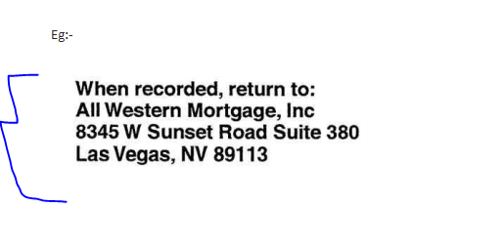

1. **Update on Proctor, Plano and P Moore branch loans:**

Please take your few mins to go thru following Important steps before you release Final DOCS to title company for Proctor branch.

Step 1- Finish your Initial Attorney review and then rest of the entire docs review.

Step 2- Run Final time Mavent which must be cleared / passed / approved by your lead – manager to proceed with.

Step 3- MOST IMPORTANT AND NEW STEP: Print Final CD from CD page-1 including COC form if any and email Final CD to LO and Processor(s) for review / approval prior to releasing DOCS .

Step 5- Once we receive an approval on Final CD then and only you will release Final Closing DOCS to all parties.  You will not release Closing DOCS for this branch without an approval on Final CD.

THIS IS ONLY FOR PROCTOR , PLANO AND P MOORE BRANCH WITH LISTED LO NAMES PROVIDED IN EXCEL SHEET.  Do not apply this update to any other branches or LO’s.

1. **Update on QC on Non-QM loans:** Any Closing DOCS are done on Non-QM loans, they must have to be reviewed by Eric Gut prior to release.

Here are the few tips how you can identify that file is Non-QM:

1. FHA and VA will never be Non-QM loans.  Only Conventional files with Occupancy as Investment can be Non-QM files (depend on assigned Investor loan product). You can ask us to re-verify.

B) Investors Like Acra , SG Capital, Onslow, Verus, Maxex, Deephaven – they offer Non-QM products

C) **IMP** – Go to ATR/QM screen >> ATR/QM Eligibility tab >> Check Ability to Repay Loan type – If it is marked as “Exempt” which means it is Non-QM loan product.

D)  Non-QM loans mostly fail with High cost file while running mavent and Compliance team can confirm with us if it is exempt from QM or not and if file is Non-QM. We will add few more tips when we get to know but you can follow an above tips for now to identify if files are Non-QM and ensure they are reviewed by Eric Gut before Docs are released to Title.

1. **Update on HOI Deductible limit to review on TDHCA or THDA loan products:** Effective now, If file is locked with TDHCA (Texas Department of Housing & Community Affairs) or THDA (Tennessee housing development agency) loan product, Docs team must need to review HOI Policy and ensure there is maximum limit on Deductible amount as per these Investor guidelines. If deductible amount on HOI is greater than following limits, You must need to request branch to provide updated HOI policy with deductible limit as per Investor guideline. Make sure you give them detail of the deductible limit as well when you email them.
2. TDHCA – 2% of Dwelling coverage or $2,500 whichever is higher = Maximum Deductible amount can be on HOI
3. THDA – 1% of loan amount or $2,500 whichever is higher = Maximum Deductible amount can be on HOI

**Remember** – These deductible limits are only for TDHCA and THDA Investor loan products, not for any other Investor loan files.

1. **Introduction of NOTE LLC and changes to be done in the Docs Draw process:** Following is the IMP details to share so Docs team can save it to their sticky notes or notepad.

Note LLC  
9435 W Russell Road, Suite 110  
Las Vegas, NV 89148  
Organization Type: a Limited Liability Corporation  
Jurisdiction: NV  
Phone: 702.592.9416  
Tax ID: 30-1320612  
NMLS: 2413481  
LIC ID: 5655

MERS ORG ID for NOTE LLC: 1017344

1. How to identify if file belongs to NOTE LLC or not? (File Contacts- All LO, Processor email address ends with notemortgage.com) and it will be in Yellow color in the pipeline.
2. Explain difference between FHA-VA and Conventional loans – FHA-VA loans- Must Close in the name of AWM because NOTE LLC do not have Mortgagee ID yet. Conventional Loans – Must close in the name of NOTE LLC. If file is Conventional, make sure ALT-Lender is selected as “NOTE LLC” under Reg-Z CD form. If it is Government loans (FHA / VA), Make sure ALT-Lender is NOT selected.
3. Communication – Must use [docs@notemortgage.com](mailto:docs@notemortgage.com) or TEAMS Channel for any files that is done for NOTE LLC (FHA or Conventional or VA)
4. Must Exclude Wire fraud disclosure and Shipping / Funding Letter when you send out Final DOCS to Title on NOTE LLC files. Replace provided NOTE LLC – Wire fraud and Funding letter instead if file is NOTE LLC.

5-MERS ORG ID & MIN Number:

If file is Govt. loans- MERS ORG ID will be “1006909” as it has to close in the name of All Western Mortgage, Inc. (AWM) and MIN Number must starts with 1006909 digits.

If file is Conventional loan- MERS ORG ID will be “1017344” as it has to close in the name of NOTE LLC as Alternate lender to select on Reg-Z CD screen and MIN Number must starts with 1017344 digits.

1. If closing in the name of NOTE LLC- Must use NOTE LLC Closing conditions from set which has already been added in Encompass starting with name NOTE LLC.  Do not mix up AWM Conditions sets and NOTE LLC Conditions sets. Use them cautiously.  On Govt loans, As file has to close in the name of AWM, You will use AWM Set of Closing conditions like any other normal files.
2. **Tax Update on TX Builder loans for Shelton Becnel and his LO’s:** When you see Shelton Becnel, Rivas Brandon, Maureen Powell as LO name at the time of CD request , Correction or DOCS draw and if file is Builder loan in the state of Texas only and if “Improved monthly Taxes” are updated in Aggregate Escrow set up,  You must need to show Total cushion months for taxes as **“3”.** In order to get “3” months Cushion, CD Team will need adjust Next Tax due date accordingly.

Make sure CD goes correct from the beginning to this LO for an approval. You do not have to wait for him to request changes.  Remember – This is only for this LO’s and If file is Builder loan in Texas and Only if Improved / Estimated Tax are updated in Encompass.

This will not be applied to Unimproved taxes. **IMP Notes:** For Other Texas LO’s, we will only update this way on Builder loans if they request us to do but keep your Team lead / Manager informed if you see any other Texas branch LO’s request like this.

**At Last**, we will practice this way only until New Taxes are disclosed for 2024 which won’t happen until Mid of the October or beginning of November-2023.

1. **Texas Attorney to use for Proctor, Plano and P Moore branch:** If you are using PPDocs, Inc. Attorney on TX loan for any Proctor, Plano and P Moore branch files.  The following information which is already added now in Business contacts and Trustee name.

Docs team just need to pick up from the contacts when you update DOCS Prepared by and Trustee for PPDocs, Inc. You do not have to manually copy and paste from now on.  Make sure we update right attorney details because currently we are working with both attorneys. PPDocs, inc (for Proctor, Plano and P Moore branch files )  and BM&G (for other branch loans).

**DOCS Prepared by:** PPDocs, Inc.  
2310 West Interstate 20, Suite 100, Arlington, Texas 76017

**Trustee under Closing Vendor Information:** Michael H. Patterson  
2310 West Interstate 20, Suite 100, Arlington, Texas 76017  
County: Tarrant

**Attorney review fee Paid to name will be:** Michael H Patterson, PC   - as per Invoice-  Purchase loans usually - $150 to borrower and $150 to Seller (If there is warranty deed). You will see 2 different Invoices in the PPDocs Attorney package.

Attached is the PPDocs, Inc. document checklist form. Fill it out and make sure you put it on top of it when you send documents to PPDocs, Inc.



1. **2nd level review to be done in DPA loans for Investor fees:** Any DPA related products for any Investors, Docs team must need to share screenshot of Investor Loan program with Reservation form and screenshot of Investor fees from Encompass in internal channel that you have updated on. These Investor fees must be reviewed by Team lead / Manager before you send Final DOCS to title.
2. **All Private money loans are non-MOM loans: A**ll private money deals will be closed as NON-MOM loans, there will be no MERS on private deals. Docs team must need to remove MIN Number from **Private money** loans only.
3. **Update on VA loans only – VA 26-1820 Loan disbursement form** Effective today, following data fields must be updated on every VA loans at the time of DOCS Draw whichever is applicable on this form.

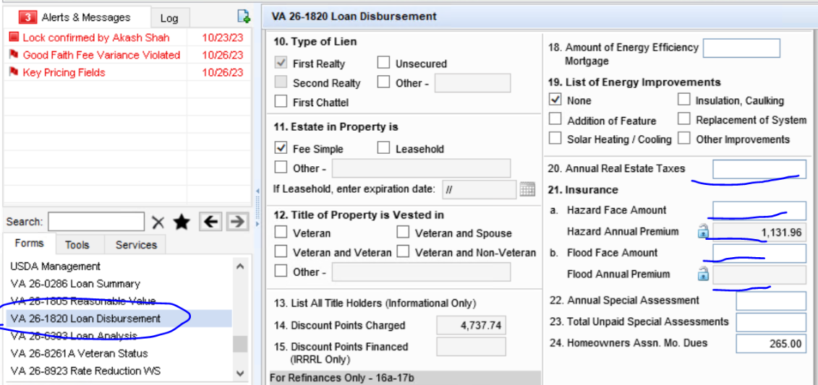

Line 20- Annual Real Estate taxes – The annual tax amount of Most recent year that is to be paid. If taxes are not disclosed for current year, You will update previous year tax amount that is paid already.

Line 21. Insurance – (a). -Hazard Face amount – This will be Dwelling Coverage amount including any replacement cost from HOI Policy, Hazard Annual premium – This will auto map from System, but you can verify it.

Line 21. (b)Flood Face amount (only if applicable)- If Flood Insurance available, This will be Dwelling Coverage amount including any replacement cost from Flood Policy, Flood Annual premium – This will auto map from System but you can verify it if applicable.

1. **Update on Temporary Buydown Agreement disclosure:** Thisdisclosure form for “Temporary Buydown Agreement” has been added to the custom forms which needs to send along with the Docs. MOST IMP :- No matter who is contributor for buydown funds, this specific disclosure must be sent along with the Docs. Temporary Buydown Disclosure Form to be printed by following steps,

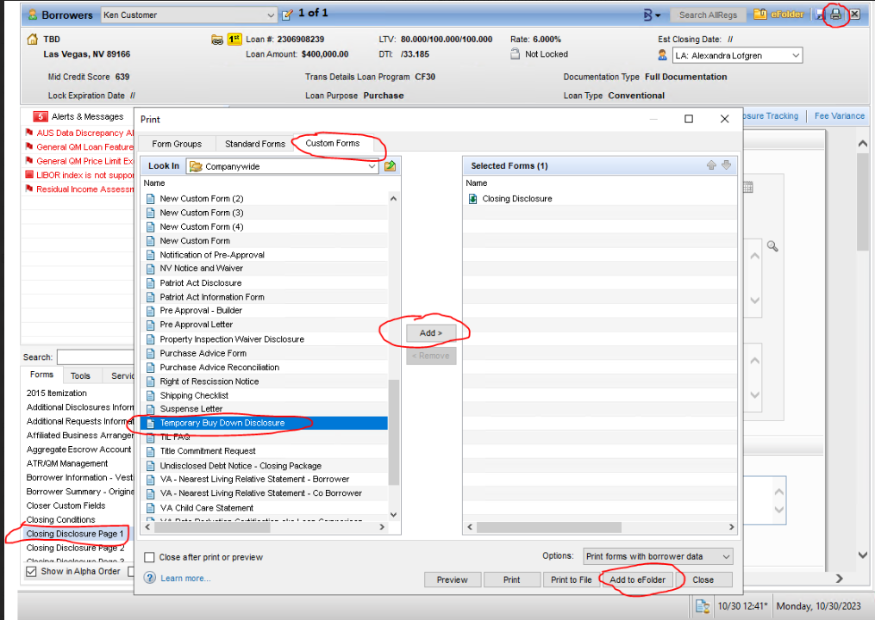**CD Page 1 >> Print Options >> Custom Forms >> Add Temporary Buydown Disclosure >> Add to E-folder.**

1. **Update on Non-QM Builder Transaction for Taxes:** AnyNON-QM builder / Newly built property are not allowed to close with Unimproved taxes. We must go by UW’s calculation or estimated tax rate provided by Branch.  If you find any loans and branch says to go with Unimproved taxes on Non-QM Builder transactions. reach out to lead / manager immediately.
2. **Update on Borrower paid full / Partial Buydown loans:** Any loans with borrower paid full or partial buydown funds must be reviewed by Eric Gut prior to releasing the Docs. You can complete the review and then post it to him for review in lock desk channel.
3. **Update on NOTE LLC Lender for Government Loans (FHA, VA and USDA Only):**

NOTE LLC Govt Loans - Lender will of course AWM on all government loans however below are the pages or forms where NOTE LLC and AWM both details to be updated after you complete full review and ready to order Final DOCS :

**Do not come out from the file when you update following details hence do it at last when file is ready to send out on NOTE LLC GOVT LOANS.**

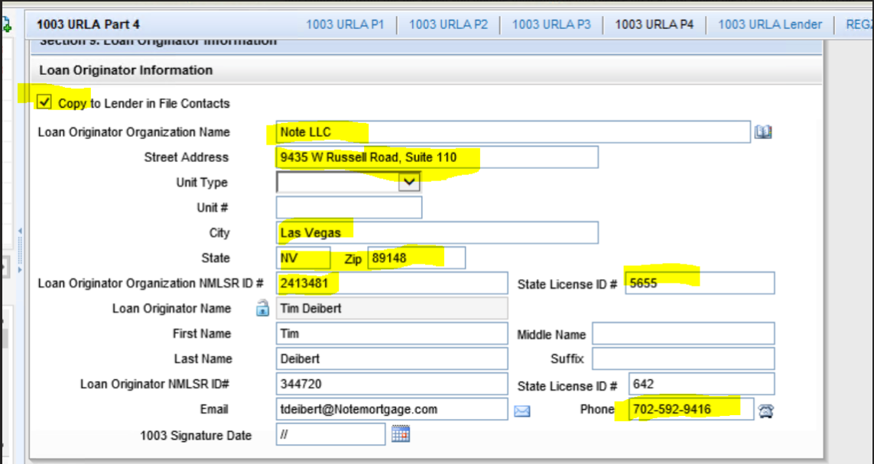1- 1003 page-4 -  Uncheck Copy to Lender button first and then change Loan Originator Organization name to NOTE LLC and it's address, NMLS and State LIC ID only and Phone number.

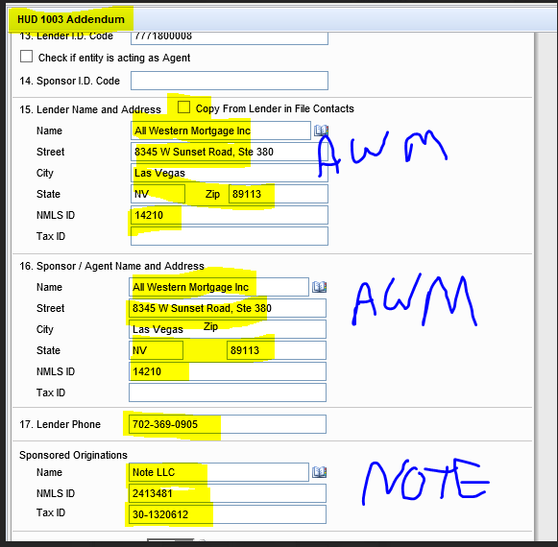2- Go to HUD 1003 Addendum - Make sure Sec- 15 , Sec- 16 and Sec- 17 is updated as below snip shot

3- Only for FHA- Conditional commitment form. make sure Mortgagee is also listed as AWM as below snip.

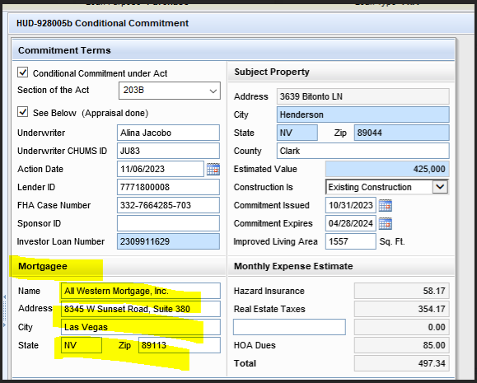

4- Re-run Mavent to ensure NMLS fail is passed.

1. **Update on Draw Schedule for Property Construction loans:** Docs team will need to check the draw schedule prior to docs on all Construction loans.  here is the new condition will be added on Construction loans by UW as template.

**Property Construction Loan - Draw Schedule:**Program allows a maximum of 6 draws.  Provide a DETAILED draw schedule, identifying work details (material and labor costs) for each draw.  Draws exceeding 6 require Executive Management approval.  Please note each draw exceeding six (6) also come at a cost of $375 per draw; the additional costs must be included in the Total Cost to Construct.

Draw schedule is different than the budget /bid and it should list itemized numbers of draws required to complete the project.  We must have an itemized draw schedule in the file before docs.

If the draw schedule lists more than 6 draws, Tory and James must review and approve. We would be adding additional fees for additional draws exceeding 6

Construction Completion date must be validated under Construction management screen by Closing team. It will be - 12 months from Closing date (if loan term is 12 months).

Ex;  If Closing date is 03/01/2024 then Construction completion date will be 02/01/2025.

1. **Update on Bayview / Lakeview DSCR loans:** No Closing docs will be out without Closing manager’s 2nd level review on this transaction . We do not have Plan code available for bayview DSCR loans.

1- Business loan rider is mandatory to go with DOT and DOCS - Use Bayview format only (whether file is to draw as LLC or Individual)

2- There must be Guarantor signature on business loan rider sample that is shared and It always should have "Individual" signature line even though file is closing in the name of LLC and has LLC signature line on the 1st block. Guarantor signature line should only have "Borrower name" only and not LLC.

2- PPP rider and PPP Addendum -   Use Investor based documents instead of using Encompass format as they wrong due to non-availability of Bayview DSCR Investor Plan code.

1. **Update on Pre-Payment Penalties:** if a loan has a prepayment penalty a team member from Secondary or Lock Desk has to review and approve the prepayment penalty documents before the closing package can be released. Pre-Payment penalty documents will be NOTE, PPP Addendum, and PPP rider from Closing package.
2. **Update to review Property type on Flood insurance policy if given and when applicable.** Docs team will need to toughly review the Flood Insurance policy to make sure it matches the subject property type accurately. This step is crucial before we proceed with closing.

if you see Flood policy then make sure you must verify Property type on it if given and it must match with Encompass and appraisal report otherwise Flood policy correction is required.

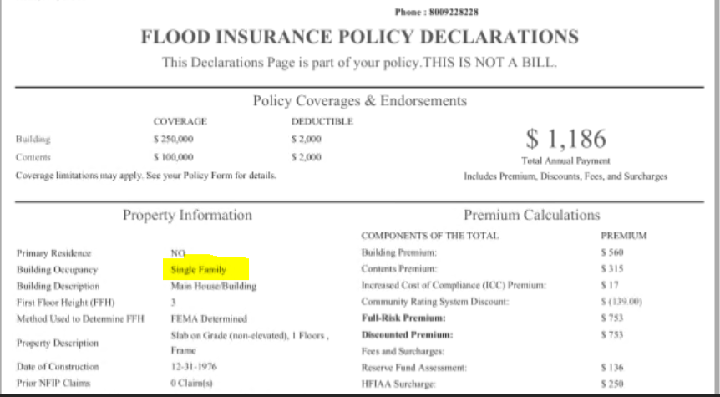

1. **Update on Construction loans:** Attached form must be sent with Closing docs on all Construction loans that comes to our pipeline. Do not forget to send this document for signing without miss.  Save this Update and document to your desk.

Only Contractor name and Borrower(s) names needs to be updated on the form at bottom before you send it with DOCS on Construction loans.





1. **Updated Buydown agreement to use:** Please use the following revised version of buydown agreement to prepare on any files which has Buydown. There is minor change done on specific language in specific paragraph.  Rest is all the same.



1. General Lender credit must be on the following line only - M4 under 2015 itemization form nowhere else with credit name pre-selected as "Lender Credit".

In case updated in different line by processor or anyone else, move it to correct line M4.  If you do not find "Credit name" and if it is Hard Coded with blank.  Let managers know immediately.

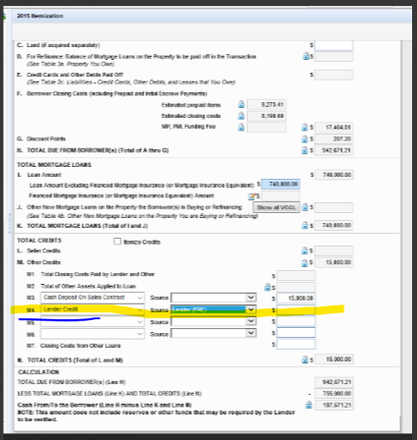

1. **Update on Bridge to sale / Private money loans with small term:** When term of the loan is like 3 or 4 months (Private Money and Bridge to sale loan with very short loan term of 3 or 4 months), We need to send attached sample form with Closing DOCS without missing.

ONLY WHEN TERM IS 3 or 4 MONTHS (PRIVATE MONEY / BRIDGE TO SALE LOAN).  Please do not use this form for full-loan term loans.

Below Information to edit on form:

1- Loan number

2- Note date

3- Property address

4- Due date of the last EMI Instalment (Update it as per Amortization schedule, last instalment month)

1. Borrower / Co-borrower's signature line- Do not include NBS ever.



1. **Update on ARC Investor - Only for DSCR loan product and when it closes as LLC name then Business loan rider is required to add.**

Attached is the sample for to use for business loan rider of ARC investor - DSCR product and guarantee agreement. Save it on your desk. We have one file in the line for this product





1. **Update on CHFA Investor Product:**
   1. CHFA loan has a limit on HOI Deductible. Maximum is $5,000 so please verify deductible amount on HOI when you do CHFA DOCS
   2. Non-Borrowing spouse are not allowed to add on CHFA DPA loan program loans.
2. **Buydown letter of Servicing:** We need to update required details and add one more letter with DOCS for signing whenever any file has Buydown funds. Attached is the letter for Servicing to be send with DOCS when buydown funds are applicable on any loans.



1. **Update on Credit report fee with “Xactus” only**: Docs Team will pull Final Credit invoice from now on for “XACTUS’ company only if Initial disclosures were sent after November 1, 2024 and update Final amount on Final CD at Docs draw stage.  You need to make sure that Xactus portal reflects "Bundled charges" amount as $260.00 - You have to verify invoice amount and required charges on Xactus carefully and update it accordingly on the Final CD.

We will hide couple of costs from Credit invoice such as - **Pre-qualification fee, Supplemental RUSH fee,  Flood fee,  VOE , Rescore fee and  Lexis Nexis Liens & Judgements fee**.

If you see any of these fees while verifying Credit Invoice, please do not include them on Final Credit invoice amount and hide them before you print. These fees are not part of the final invoices.

**RAY LOCKERY BRANCH**: We will not charge a credit report cost exceeding $195.00 for files where the credit report was obtained prior to January 6, 2025, and $260.00 for files where the credit report was ordered on or after that date for this particular branch.

Pulling the updated credit report invoice from the Xactus site still requires the same steps. If the charges fall below the above limit, you must keep that amount; if the charges exceed the above limit, you must keep the fixed sum of $195.00 or $260.00 as stated above.This exception only applied to the **Ray Lockery Branch** and in cases where XACTUS was the credit report firm.

The LO’s who follow Ray Lockery are listed below.  Make sure to include their names in your sticky notes and DO NOT MISS OUT on this update.

Jonathan Hunter Ross  
William Denight  
Jennifer Mims  
Ray Lockery  
Jeanne Leach  
Heather leach  
Hunter Ross

1. **Update on PATRICK MOORE BRANCH** - Below are the list of LOs.

**Jennifer Staff**  
**Patrick Moore**  
**Anderson Goodridge**  
**Raul Frausto**  
**Tuoc Dinh**  
**Marsha Delgadillo**

1. Verify the cash to close after completing docs review along with the last balanced CD.
2. If there are any major changes in cash to close then you've to mention about the changes in details while sending Final CD for LO approval.
3. Do not ever reduce seller credit, if cash to close short to meet with minimum requirement, then reach out to managers to find out the solutions but do not reduce seller credit.
4. PATRICK MOORE must be copied in all e-mail chain and his approval must required to send out DOCS to the borrower and Title company. Even if LO Approves the Final CD, you still ask for Patrick's approval.
5. **Update on HOI / Flood / Master Policy:**

Any person who is on vesting line whether borrower or non-borrowing spouse or NBP (Non-borrowing person) listed on our DOT / Vesting, that person must be on HOI / Flood policy / Master policy as Insured. if you do not see it then PTF Condition to be added to list that person as co-insured on policy.

Only Co-signer (who is not going to be on vesting and title) is not required to be listed on policy as Insured.

1. **Update on TX Attorney to use branch wise:**

TX state for El Paso branch - We will use 100% BM&G attorney if file is in TX state and if branch is El Paso (Files will be sky blue color to identify this branch name) - $225 - Black, Mann & Graham LLP is the payee’s name.

Rest of all other branches (Proctor, Plano (Mortgage lab) and Patrick Moore)- Use Cain & Kiel attorney - $325

1. **Update on DSCR Loan programs only:** If Loan program is "DSCR" on any loans, You need to remove 8821 and 4506-C forms both from Request of Transcript forms and Classic forms . It is no longer required to send these 2 forms only in DSCR Loan programs only.

Make sure they are still there for other loan programs. Only to be removed if loan program is "DSCR".

1. **Update on CHASE Investor: Update** if any file is locked with CHASE Investor , please make sure when you order closing docs after selecting Chase investor plan code and if you see the following documents with name starting with "CHASE" when you order docs and in the list, Please exclude these 3 documents before you send out docs. These 3 docs should not go out with Closing package.

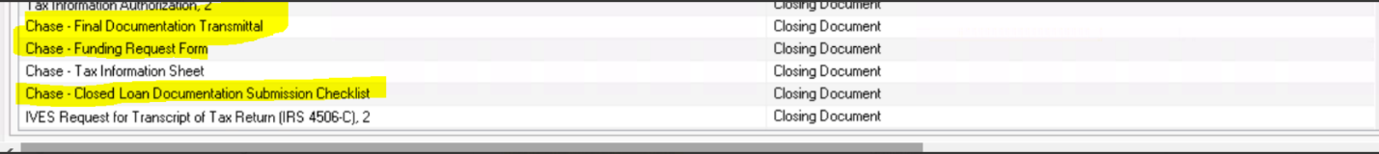

1. **Update on Appraisal Acknowledgement Verification:** we must verify Appraisal Acknowledgement date (Delivery Date) from Appraisal acknowledgement receipt given in e-folder and to make sure that Appraisal delivery date is prior to 3 business days of Note date (Sunday & Holidays are excluded) -   
     
   Try to identify this at beginning of Docs review, so if note date confirmed by branch is within 3 days of Appraisal Acknowledgement date, we should ask them to reconfirm New Note date as per Reg-Z compliance.   
     
   Important note that It will be not be applicable in case if PIW (Property inspection Waiver) is there or for loans which do not require Appraisal such as FHA Streamline without Appraisal, VA IRRRL or Notice of Written for Appraisal disclosure - Box is marked as "Waived" for 3 days waiting on appraisal delivery
2. **Update on ILLIONOIS State only:** We must send an e-mail in below template and to below mentioned contact person in all IL State loans after Docs Out. This should not be miss ever.

To: LO Only

CC: Processor(s), LOA's , DOCS Team , Funding Team & [licensing@allwestern.com](mailto:licensing@allwestern.com)

Subject: Action Required – Illinois Anti-Predatory Lending Update for Loan # & Borrower name

Hello [LO Name],

This is regarding Loan #............., which is an Illinois (IL) state loan. Since we are not exempt from the Illinois Anti-Predatory Lending Database (ILAPLD), it is necessary to complete the required steps in the ILAPLD portal.

Please log in to <https://www.ilapld.com/> using your credentials and update the necessary information under the "New Application" section.

If you do not have login access, please contact licensing@allwestern.com for assistance.

**MOST IMP**:- If LO is Eric Gut, then Do not send an e-mail to Eric. You need to email it to Licensing team instead to complete IL Anti-Predatory Lending update.

1. **Update on Credit report fee for VA loans:** You no longer need to ask for lender credit approval on Credit report fee if it is charged more than $100 on Final Invoice on any VA loans.

There is no limit cap now on Max Credit report fee on VA loan as per updated VA guideline so if Final amount is $260 on Credit invoice, You can charge this amount to borrower him self and no need to ask branch for Lender credit approval.

1. **Update on Hybrid E-signing fee:** Hybrid e-Doc Fee (also labelled as Hybrid e-Signing Fee in Section B) should be updated to $58.

When issuing a COC with Final CD , the Hybrid e-Signing Fee increases from $48 to $58, the COC reason should be used as follow:

“Hybrid e-Signing fee increased due to change in third-party charges.”

**IMP:** We do not charge Hybrid E-Signing fee for the following branch. If you see Hybrid E-Sign fee is charged on LE - You've to remove it while processing the file at any of the CD stage.

For other branches which is not mentioned in excel sheet, we must charge Hybrid E-sign fee in the CD and COC must be prepared if it was not disclosed in LE.

IMP: If any other branch reach out to us and ask us to remove Hybrid Fee then we must ask whether Branch will be paying for Hybrid fee or not and accordingly we have to record that file in shared excel sheet - If doubts, take 2nd opinion or confirmation from Managers.

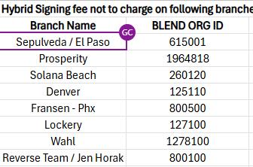

HOW to identify branch as per ORD ID - See below instructions and snip of it.

GO TO ENC >> FORMS >> PROCESSOR WORKFLOW >> ORGID

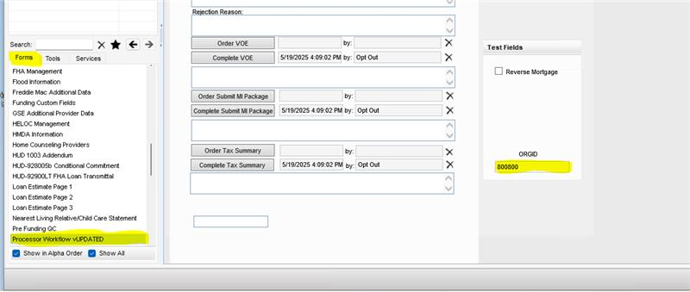

*****Thank you*****